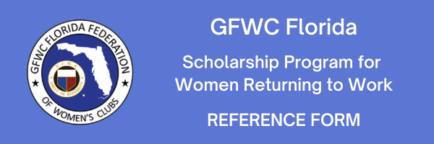
The applicant named below is applying for a GFWC Florida Scholarship, which provides financial assistance for Women Returning to Work to attend an educational or training program. The award is intended for women who need educational training to obtain employment or enter a new career field.
The Scholarship Committee would appreciate you answering the questions below and also providing a brief statement on behalf of this applicant. Please be specific and candid. Your reference must be received by March 1, 2024. Be sure to sign your recommendation. Thank you for your willingness to support this applicant and our scholarship program.
Note: This reference form will only be accepted if it is emailed by the person completing the reference form. References received from anyone else will cause the applicant to be disqualified.
You may email your completed reference form to
Margaret Brugman, Ed.S.
GFWC Florida Scholarship Chairman
Scholarships@gfwcflorida.org
Applicant's Name: Click here to enter text.
Applicant's Address: Click here to enter text.
City, State, Zip: Click here to enter text.
How long have you known the applicant? Click here to enter text.
In what capacity have you known the applicant? Click here to enter text.
Your Name: Click here to enter text.
Your Address: Click here to enter text.
City, State, Zip Click here to enter text.
Your Phone #: Click here to enter text.
Your Email Address: Click here to enter text.
Your Relationship to the Applicant: Click here to enter text.

Please rate the applicant in the following areas, based upon your knowledge of her achievements and strengths. Place an x in the appropriate box on each line.
 | Mostly Disagree | Somewhat Disagree | Mostly Agree | Strongly Agree | Don't know
Is motivated
Demonstrates responsibility
Has clear educational and career goals
Demonstrates strength in character
Would serve as a role model
Please provide your statement/thoughts, including any specific examples:
- Describe the applicant's strengths in her personal, educational, or professional life.
Click here to enter text.
- Describe your knowledge of her educational and/or career goals, and progress toward those goals. Consider any barriers or difficulties that she has overcome.
Click here to enter text.
- Provide any additional information that you feel we should know about this applicant in regard to this award.

Click here to enter text.

Signature: Click here to enter text.
Please accept our thanks for your reference, and your support of financial assistance
to obtain necessary education for returning to work.

