Website update procedure outline
for common requests to change most usually changed
type of pages
Send an email to webmaster and CC president.
1. State the location of the page to be modified.
Example – On the Member Center. Bottom of the page
Or member center:
forms, reporting, and more:
Officer Manuals – Club and District

2. Identify the section of the page as currently By Selecting a slightly larger area and copy
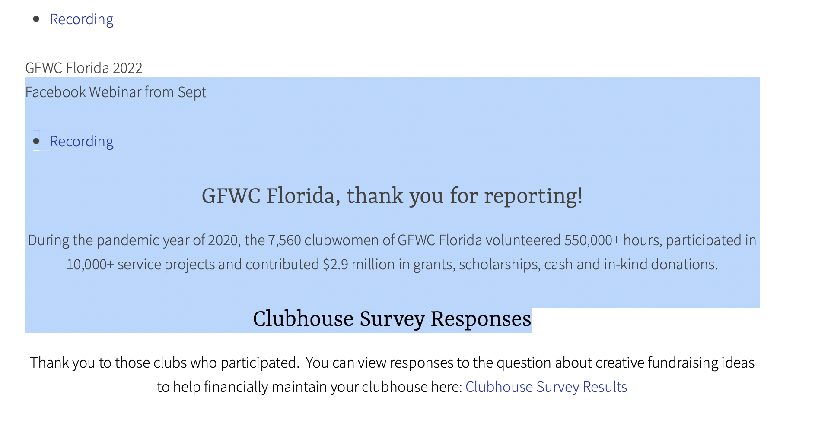
And paste into the email or a word doc as in this doc below this line.

Facebook Webinar from Sept
- Recording

GFWC Florida, thank you for reporting!
During the pandemic year of 2020, the 7,560 clubwomen of GFWC Florida volunteered 550,000+ hours, participated in 10,000+ service projects and contributed $2.9 million in grants, scholarships, cash and in-kind donations.

Clubhouse Survey Responses

3. Add or Delete the changes you want made. Detail in words to clarify:
Change 2020 to 2525
Change 7,560 to 17,560
…

Facebook Webinar from Sept
- Recording

GFWC Florida, thank you for reporting!
During the year of 2525, the 17,560 clubwomen of GFWC Florida volunteered 1,550,000+ hours, participated in 10,900+ service projects and contributed $12.9 million in grants, scholarships, cash and in-kind donations.

Clubhouse Survey Responses

Or take a chance with:
Change the text in this section for the year 2525 using the information above.

4. Provide the additional files or information to be included in the new presentation.
In this example Provide:
If the changes are in a word doc, This.Docx and 2525.jpeg as attachments to an email to webmaster@gfwcflorida.org
Identify yourself. Explain your authority for the update.
Request the update. Give any Timing. Explain your contact information.

5. After notice that the changes have been completed, Proof the new view of the page and provide feedback.

