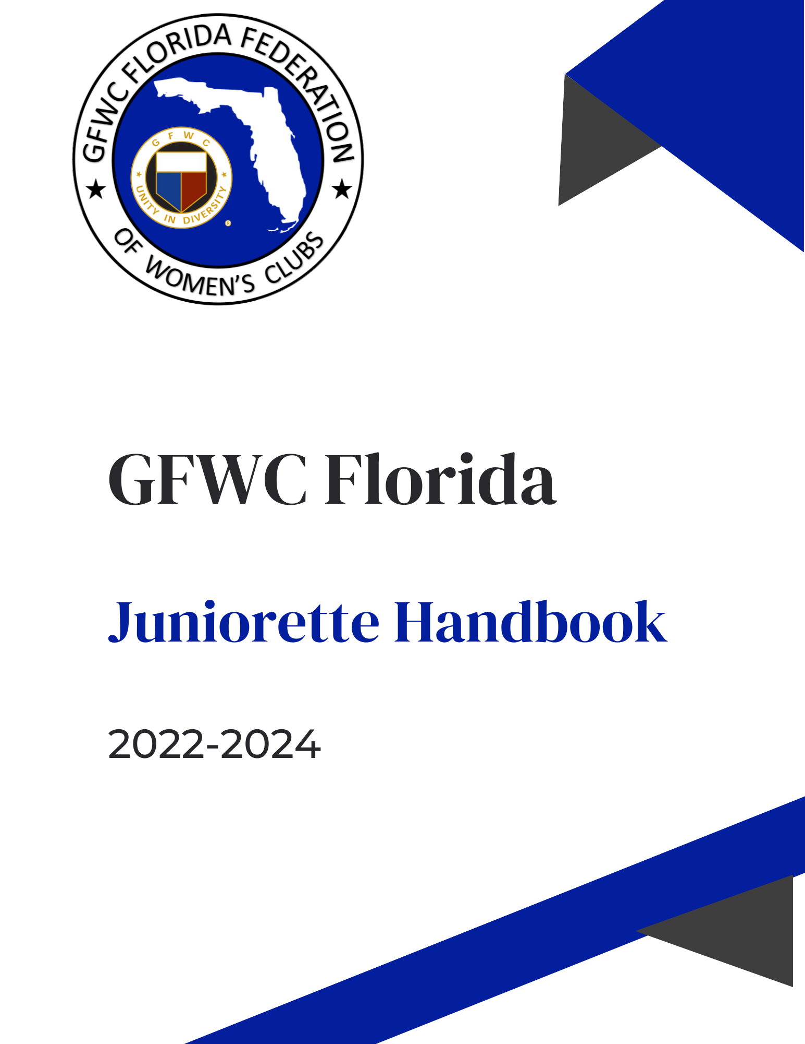

#### 

#### Table of Contents

#### 

#### Welcome 3

#### The GFWC Juniorette 4

#### Juniorette Advisory Committee 5

#### Juniorette Planning Committee 6

#### Role of Sponsoring Club 7

#### Role of Advisor 7

#### Role of Chaperone 8

#### Glossary of Terms 9

#### GFWC, GFWC Florida & and Southern Region 11

#### GFWC Florida Bylaws and Standing Rules 12

#### Running for Juniorette State Position 16

#### Duties of Officers and Chairmen 17

#### Juniorette Pledge and GFWC Collect 18

#### Juniorette Awards 19

#### Carolyn Pierce Outstanding Juniorette Form 21

#### Bobbie Smith Outstanding Juniorette Advisor Form 22

#### Juniorette Honor Score 23

#### Juniorette Achievement Award 25

#### Scrapbook Guidelines 27

#### Booster Club Application 29

#### Juniorette Agreement 30

#### Permission/Medical Authorization & Release Form 31

#### Medical & Insurance Questionnaire 32

#### Photo Release Form 33

#### Juniorette Membership Application Form 34

#### Juniorette Nomination for State Officer Position Form 35

#### Juniorette Planning Committee Application Form 36

#### Juniorette Club Information Form 37

#### Graduation Survey Form 39

#### Our Legacy 40

#### Online Forms and Documents 41



Congratulations on accepting the responsibility of serving your Juniorette club as President or Advisor. This handbook has been prepared to provide contact information for Juniorette officers, committee members and clubs in Florida.

You’ll also find necessary forms, reporting information and award details. Please also regularly check the Juniorettes page in the Member Center on gfwcflorida.org for updated information.

Another source of information is our weekly *GFWC Florida Clubwoman* electronic newsletter. You can subscribe on gfwcflorida.org . We hope you’ll encourage all your club members to subscribe, read and contribute to it.

The Juniorette Advisory Committee is a group appointed by the GFWC Florida President to offer support and guidance to your Juniorette Planning Committee (JPC). We all welcome your questions and suggestions, and are here to assist you and your Juniorettes.

Juniorettes have an annual weekend convention called “Juniorette Annual State Meeting” (JASM). Please mark the date on your planning calendars early and watch for registration details.

Have a wonderful year, and let’s stay connected! Interested in starting a Juniorette club? Contact the GFWC Florida 2nd Vice President at secondvp@gfwcflorida.org.

#### 

**THE GFWC JUNIORETTE**

**“LIFE’S MOST PERSISTENT AND URGENT QUESTION IS, WHAT ARE YOU DOING FOR OTHERS?”**

* **Dr. Martin Luther King Jr.**

The GFWC Juniorette Membership category was introduced during the 1966-1968 Administration of GFWC International President Carolyn Pearce (GFWC Florida), who stated, “I can think of no better means of assuring the continuity of Federation work and influence for community good that we represent than by encouraging the formation of GFWC clubs for Juniorettes. Mrs. Pearce noted the purpose of a Juniorette club would be:

* + To contribute to a meaningful community life,

To become aware of community problems and how they could be met, and

* + To learn the pleasures and rewards of working with a group.

GFWC’s Juniorettes are examples of how the call to do community service can be answered at any age. Juniorettes have school, extracurricular activities, and social lives to juggle, but they find time to make positive changes in their communities. Look for GFWC blog posts where we will discuss project suggestions for the Juniorette age group and their club advisors.

According to GFWC Bylaws, Juniorette Clubs are comprised of young students in middle schools, junior high schools, and high schools. Experience has shown, due to differences in interests, abilities, and maturity, that clubs are most successful when organized for either middle/junior high schools or high schools, but not both.

Federating a Juniorette Club requires a commitment from a sponsoring club, which must be an active GFWC Woman’s Club or Junior Woman’s Club in good standing, and a dedicated club advisor. It is required that sponsoring club members accompany Juniorette Club representatives to all levels of GFWC meetings, including State Federation, Region, and/or GFWC.

#### Juniorette Advisory Committee

|  |  |
| --- | --- |
| Kay Taylor, Chairman | [Juniorettes@gfwcflorida.org](mailto:Juniorettes@gfwcflorida.org)[kaytaylorgfwc@gmail.com](mailto:kaytaylorgfwc@gmail.com) |
| Linda Mitchell, Co-Chairman | [lindagriffeymitchell@tampabay.rr.com](mailto:lindagriffeymitchell@tampabay.rr.com) |
| Kerry Brazzell | [kbrazzell70@gmail.com](mailto:kbrazzell70@gmail.com) |
| Jeri Lyn Cancel | sunshine07061960@yahoo.com |
| Laura Connelly | [secondvp@gfwcflorida.org](mailto:secondvp@gfwcflorida.org) |
| Jasdeep Cook | [jdhotar@hotmail.com](mailto:jdhotar@hotmail.com) |
| Haadhaq Lawrence | [bhaadhaq@gmail.com](mailto:bhaadhaq@gmail.com) |
| Joy Post | [Jpost1208@gmail.com](mailto:Jpost1208@gmail.com) |
| Terry Reese | tryreese2@aol.com |
| Carol Renick | [carolarenick@gmail.com](mailto:carolarenick@gmail.com) |
| Bradlee Swanson | [bradleep6@gmail.com](mailto:bradleep6@gmail.com) |
| Jeanne Takeda | [jeannet901@gmail.com](mailto:jeannet901@gmail.com) |
| Stephanie Vasbinder | [stephanievasbinder@gmail.com](mailto:stephanievasbinder@gmail.com) |

**Juniorette Planning Committee**

Samantha Squires

Director of Juniorette Clubs

GFWC New Tampa Juniorettes

[Sammi82505@gmail.com](mailto:Sammi82505@gmail.com)

813-392-9989

Paulina Giraldo

Vice Director of Juniorette Clubs

GFWC New Tampa Juniorettes

[paulina.gircat@gmail.com](mailto:paulina.gircat@gmail.com)

813-895-4930

Racheal McCoy

Secretary/Treasurer

GFWC St. Petersburg Juniorettes

[mccoyr846@gmail.com](mailto:mccoyr846@gmail.com)

727-400-5879

Isabella LeCain

Parliamentarian

GFWC St. Petersburg Juniorettes

[isabellal2024@gmail.com](mailto:isabellal2024@gmail.com)

727-644-2169

Kaylie Boeck

GFWC Signature Program: Domestic

Violence Awareness & Prevention

GFWC Juniorette Club of Jupiter-Tequesta

[2muchodrama@gmail.com](mailto:2muchodrama@gmail.com)

561-346-7695

Jordan Abraham

GFWC Juniors Special Program:

Advocates for Children

GFWC New Tampa Juniorettes

[jordanabe2114@gmail.com](mailto:jordanabe2114@gmail.com)

813-808-5155

Sienna Squires

GFWC FL President’s Project

GFWC New Tampa Juniorettes

[Siena11410@icloud.com](mailto:Siena11410@icloud.com)

813-394-0180

Lily Kathrine Warren

Arts & Culture

GFWC Juniorette Club of Jupiter-Tequesta

[lilykatewarren@gmail.com](mailto:lilykatewarren@gmail.com)

561-812-4282

Kate Frederick

Civic Engagement & Outreach

GFWC Little Women of Lutz

[katelfr29@gmail.com](mailto:katelfr29@gmail.com)

813-701-7498

Delaney Miller

Education a& Libraries

GFWC Juniorette Club of Jupiter-Tequesta

[Dkm5972london@gmail.com](mailto:Dkm5972london@gmail.com)

561-215-7880

Sarah Vasbinder

Environment

GFWC Juniorette Club of Jupiter-Tequesta

[sarahvasbinder29@gmail.com](mailto:sarahvasbinder29@gmail.com)

561-260-3779

Kira McClard

Health & Wellness

GFWC Temple Terrace Juniorettes

[kiramcclard@gmail.com](mailto:kiramcclard@gmail.com)

813-336-9312

Natalie Parratto

Communications & Public Relations

GFWC Juniorette Club of Jupiter-Tequesta

[natalie.parratto@gmail.com](mailto:natalie.parratto@gmail.com)

561=635-1974

Ava Frederick

Leadership

GFWC Little Women of Lutz

[avamf08@icloud.com](mailto:avamf08@icloud.com)

813-455-9907

Makayla Miller

Membership

GFWC Juniorette Club of Jupiter-Tequesta

[makaylagrace0617@gmail.com](mailto:makaylagrace0617@gmail.com)

561-260-9104

Gabriella Pincus

Fundraising & Development

GFWC Juniorette Club of Jupiter-Tequesta

[gabi.pincus@yahoo.com](mailto:gabi.pincus@yahoo.com)

561-401-2848

Anabelle White

Historian

GFWC Juniorette Club of Jupiter-Tequesta

Anabelle.wh6@gmail.com

561-319-0425

**THE ROLE OF THE SPONSORING CLUB:**

* + Accepts responsibility for ensuring the success of the Juniorette club.
  + Works with club advisor(s) to deliver GFWC and GFWC Florida orientation
  + Serves as a model of leadership, cooperation, and understanding; and provides leadership support and mentoring to Juniorettes and advisors
  + Ensures that the Advisor of the Juniorette club is also included in the sponsoring club’s Directors and Officers Liability Insurance Policy.
  + Understands that homework and school activities come first.
  + Provides guidance and advice – when asked.
  + Allows Juniorette club to assume and practice as much autonomy as possible.
  + Keeps lines of communication open.
  + Assumes some (optional) financial obligations, including:
* Providing seed money to organize the club and/or support club projects,
* Paying for or providing the club’s liability insurance, if not included in sponsoring club’s policy,
* Assisting the club in establishing an annual budget and opening a bank account,
* Providing other financial assistance as needed.

**THE ROLE OF THE CLUB ADVISOR(S):**

* + Attends all Juniorette meetings and activities.
  + Shares knowledge about GFWC and GFWC Florida.
  + Holds recruitment events and collects membership forms.
  + Serves as a model of leadership, cooperation, and understanding.
  + Works to ensure the progress and development of the Juniorette Club.
  + Provides guidance and advice on an ongoing basis.
  + Encourages the Juniorette Club to assume and practice as much autonomy as possible.
  + Understands the principles of leadership and helps meetings run smoothly.
  + Provides workshops for officers and assists with agenda development
  + Serves as a liaison between the sponsoring club and the Juniorette Club.
  + Enjoys mentoring young people and is patient and flexible.
  + Encourages clubs to submit year-end reports, dues, contributions and member lists on time
  + Ensures a smooth transition of knowledge and documents to next advisor

**THE ROLE OF THE JUNIORETTE CLUB MEMBERS:**

* Attend meetings.
* Participate in projects.
* Promote membership in the club.
* Are positive and enthusiastic about the club.

**THE ROLE OF THE JUNIORETTE CLUB CHAPERONES:**

* Behave in a positive manner and serve as a role model.
* All chaperones must be at least 21 years of age.
* Always Carry Medical Release Waiver/Emergency Contact information for each Juniorette member (provided by club advisors).
* Report any illness of members to the Lead Chaperone.
* Arrive at any meeting place at or before the assigned time.
* Monitor and stay with your assigned group. Do not allow any Juniorette to leave without permission and only if accompanied by another member. Remember — they travel in pairs!
* Keep the focus on the members, not on other adults.
* Watch and assist all the members in your small group, not just your own children
* Inappropriate language and behavior is unacceptable for adults and Juniorette members.
* Drinking of alcoholic beverages and/or use of tobacco products by a chaperone at any time during an outside community project is prohibited.
* Overnight chaperones may not retire until all group members are in their rooms, all visiting between rooms has stopped, and the chaperones are sure the members are secure.
* If transporting Juniorettes to and from an event, you must have a valid driver’s license and a registered/insured vehicle. Ensure all Juniorettes have a seat in the vehicle and wear seatbelts.

#### GLOSSARY of TERMS

**ADVISOR:** The person who acts as the liaison from the sponsoring club to the Juniorette club. She may work by herself or she may have a committee, and she is sometimes also called a sponsor.

**CALL:** The written notice of state meetings that is sent before those meetings including the Juniorette summer meeting and GFWC Convention. It includes the preliminary schedule and registration forms.

**COMMUNITY SERVICE PROGRAMS (CSP):** Our organization operates in five CSPs for its areas of service:

**Arts and Culture -** includes all forms of creative and performing arts.

**Environment -** includes conserving natural resources and other environmental issues.

**Education and Libraries -** includes working with literacy and school issues.

**Health and Wellness –** includes nutrition, disease prevention, and physical and emotional care

**Civic Engagement and Outreach -** includes citizenship, crime prevention, safety, and disaster preparedness; the needy, hungry and homeless; military personnel and veterans

**DISTRICT:** Florida is divided into 14 geographical regions known as districts, which consist of one or more counties.

**DIRECTOR OF JUNIOR CLUBS:** The highest elected Junior officer in the state. She oversees all the statewide junior activities.

**DISTRICT DIRECTOR** and **JUNIOR DISTRICT DIRECTOR:** The elected representatives from the district's membership, one from a GFWC Florida Woman's Club and one from a GFWC Florida Junior Woman's Club, who serve as the liaison between her district and the state federation.

**FEDERATION:** A term that refers to our united organization.

**GFWC FLORIDA PRESIDENT:** The highest elected officer in the state federation. She oversees the state's activities (Women, Junior, and Juniorette) and serves as the state's representative to GFWC.

**GENERAL FEDERATION OF WOMEN'S CLUBS:** (GFWC) The international organization, to which each active club in our state belongs. Its membership is worldwide, and it is one of the world's oldest and largest women's volunteer service organizations. GFWC Headquarters is in Washington, DC. The GFWC International Theme is Unity in Diversity.

**GFWC FLORIDA FEDERATION OF WOMEN'S CLUBS:** (GFWC Florida) Our state organization which includes clubs from all around the state. GFWC Florida Headquarters is in Lakeland, Florida.

**JUNIOR CLUBS:** Federation clubs whose members usually join between the ages of 18 and 40. However, membership may continue after age 40.

**JUNIORETTE ADVISORY COMMITTEE: (JAC)** The committee appointed by the GFWC Florida President which is responsible for Juniorette clubs and Juniorette activities on a state level.

**JUNIORETTE ADVISORY COMMITTEE CHAIRMAN:** The leader of the Juniorette   
Advisory Committee  
  
**JUNIORETTE ANNUAL STATE MEETING (JASM):** Annual planning meeting for Juniorette Club Officers and Advisors.

**JUNIORETTE CLUBS:** Federation clubs whose members are young women ages 12-18.

**JUNIORETTE HANDBOOK:** Published at the beginning of each year. It contains various forms and resource information.

**JUNIORETTE PLANNING COMMITTEE: (JPC)** The Juniorette planning committee is composed of the state director of Juniorette clubs, the vice-director, the secretary-treasurer, the state Juniorette community service programs and standing committee chairmen as appointed by the GFWC Florida president and the chairman of the Juniorette advisory committee.

**REPORTING:** Compiling a written record of the projects and programs completed by a club during the year. Reports are written once a year and awards are given for the best activities completed by the clubs.

**SPONSOR:** The club that serves as the official supporter of the Juniorette club. It may or may not be the club that originated the Juniorette club. The Juniorette club advisor should be a member of the sponsoring club. (Note: Sometimes the words 'sponsor' and 'advisor' are used interchangeably. For clarity, 'sponsor' should be used to refer to the sponsoring club and 'advisor' should be used to refer to the member of the sponsoring club who serves as the liaison and advisor to the Juniorette club).

**WOMEN'S CLUBS:** Federation clubs with members age 18 and above.

##### General Federation of Women’s Clubs (GFWC) Headquarters

1734 N Street NW Washington, DC 20036

[gfwc@gfwc.org](mailto:gfwc@gfwc.org)

[gfwc.org](C:\\Users\\Laura\\Downloads\\gfwc.org)

**GFWC Florida HQ**  
4444 Florida National Drive Lakeland, FL 33813

(863)647-2642  
[gfwcfloridahq@gmail.com](mailto:gfwcfloridahq@gmail.com)   
[www.gfwcflorida.org](http://www.gfwcflorida.org/)

**GFWC Southern Region**

Alabama, Florida, Georgia, Mississippi, South Carolina,

Women’s Club of Aruba and Belize  
[www.gfwc-southernregion.org](http://www.gfwc-southernregion.org/)

#### GFWC Florida Bylaws and Standing Rules Pertaining to Juniorettes

**From the GFWC Florida Bylaws:**

**ARTICLE XIV JUNIORETTE CLUBS**

**SECTION 1. DEFINITION**

Juniorette clubs are clubs whose membership is composed entirely of young women ages 12 to 18. Such clubs shall hold associate membership in GFWC Florida and shall undertake one or more projects of volunteer service.

**SECTION 2. SPONSORSHIP**

A Juniorette club shall be sponsored by an active club in good standing in GFWC Florida. The Juniorette club shall have an advisor who shall be a member of the sponsoring club.

**SECTION 3. STATE DIRECTOR OF JUNIORETTE CLUBS**

There shall be a state director of Juniorette clubs. She shall serve on the GFWC Florida board of directors as the official representative of the Juniorette clubs.

**GFWC Florida Standing Rules:**

**F. JUNIORETTE CLUBS**

##### State Director of Juniorette Clubs

* 1. Eligibility

The state director of Juniorette clubs shall:

* + 1. be a member in good standing of a Juniorette club; 2) have served as a Juniorette club officer or chairman; 3)have served on the state Juniorette planning committee; 4)be endorsed by the club of which she is a member.
  1. Election
     1. Election shall be by ballot at the annual Juniorette business meeting and a majority vote shall elect.
     2. If there is only one candidate, the vote may be by voice.
  2. Term of Office
     1. The term of office shall be for one year or until her successor is elected and shall begin at the close of the meeting at which she is elected.
     2. She shall be ineligible for a succeeding term.
  3. Duties

The state director of Juniorette clubs shall:

* + 1. preside at the Juniorette meetings;
    2. recommend Juniorette chairmen for approval by the chairman of the Juniorette advisory committee, for appointment by the GFWC Florida president;
    3. perform such other duties as are necessary and as directed by the Juniorette advisory committee;
    4. serve as a member of the GFWC Florida board of directors.

##### Juniorette Meetings

* 1. Annual meeting
     1. The annual meeting shall be for the purpose of election of officers and other necessary business.
     2. The time and place of the meeting shall be approved by the GFWC Florida executive committee upon recommendation of the Juniorette advisory committee.
     3. A club shall be represented by the club president, or her alternate, and three additional representatives.
     4. Members of Juniorette clubs who are not representatives may attend and speak but shall not make motions nor vote.
  2. Special meetings

With the approval of the GFWC Florida executive committee, special meetings may be called by:

* + 1. the state director of Juniorette clubs with the approval of the Juniorette advisory committee;
    2. the chairman of the Juniorette advisory committee.

##### Juniorette Planning Committee

* 1. Composition

The Juniorette planning committee shall be composed of the state director of Juniorette clubs, the vice-director, the secretary-treasurer, the state Juniorette community service programs and standing committee chairmen as appointed by the GFWC Florida president and the chairman of the Juniorette advisory committee.

* 1. Duties

The Juniorette planning committee shall, in cooperation with the Juniorette executive committee and the Juniorette advisory committee, coordinate plans for special activities and projects for Juniorette clubs.

* 1. Meetings

The Juniorette planning committee shall meet at the call of the state director of Juniorette clubs, with the approval of the chairman of the Juniorette advisory committee.

##### Juniorette Advisory Committee

* 1. Composition

The Juniorette advisory committee shall be composed of seven members, the second vice-president, a chairman and eight members appointed by the GFWC Florida president.

* 1. Duties

The Juniorette advisory committee shall:

* + 1. serve as liaisons between Juniorette clubs and the GFWC Florida; 2) oversee the needs of the Juniorette clubs;

3)hold an orientation for all Juniorette sponsors/advisors at the state meetings;4) perform such other duties as are necessary to assist the Juniorette clubs and sponsors.

##### Juniorette Executive Committee

* 1. Composition

The Juniorette executive committee shall be composed of the chairman of the Juniorette advisory committee and the three elected state Juniorette officers; the director of Juniorette clubs, the vice-director of Juniorette clubs, and the secretary-treasurer.

* 1. Duties

The Juniorette executive committee shall:

* + 1. interpret the GFWC Florida program to the Juniorette club members;
    2. plan projects and special activities for the Juniorette clubs in cooperation with the Juniorette planning committee and the Juniorette advisory committee.
  1. Meetings
     1. The Juniorette executive committee shall meet at the call of the state director of Juniorette clubs with the approval of the chairman of the Juniorette advisory committee.
     2. Meetings may be conducted by mail or electronic transmission.

##### Juniorette Budget

* 1. The Juniorette advisory committee shall prepare a proposed annual budget for the Juniorettes.
  2. The budget shall be submitted to the GFWC Florida finance officer one month prior to the annual convention for approval by the GFWC Florida executive committee.
  3. The budget shall provide for a hotel room from the Juniorette fund for:
     1. the Juniorette executive committee at the GFWC Florida annual convention; 2)the state director of Juniorette clubs at the GFWC Florida fall board of

directors meeting.

3)the Juniorette advisor has one (1) hotel room paid for, charged to JASM account 2C-279.

* 1. Any expenses unanticipated by the Juniorette budget shall be the responsibility of the Juniorette incurring the expense and her parent or guardian. The Juniorette and her parent or guardian shall be notified in advance of the amount of these expenses.

##### Juniorette Club Officers' List

* 1. The president of each Juniorette club shall send the names and mailing addresses with zip codes of the newly elected officers of the club to the state director of Juniorette clubs and the chairman of the Juniorette advisory committee.
  2. The state director of Juniorette clubs shall forward these lists to GFWC Florida headquarters and the GFWC Florida corresponding secretary no later than June 1 of each year.

### RUNNING FOR A JUNIORETTE STATE POSITION

**PLANNING COMMITTEE NOMINATIONS**

The three elected officers of GFWC Florida Juniorettes are: Director of Juniorette Clubs, Vice Director of Juniorette Clubs, and Secretary/Treasurer. Nominations for these three positions should be made in writing and submitted to the Juniorette Advisory Chairman by April 1. See nomination form included in this handbook. Each candidate must be endorsed by her Juniorette club and be a paid GFWC Florida member in good standing. In addition, candidates for Director of Juniorette Clubs are encouraged to have previously served on the Juniorette Planning Committee for at least one year.

**OFFICER ELECTIONS:**

Elections are held at the business session of the Juniorette Annual State Meeting each year. Each Juniorette club is allowed four voting delegates: the club President (or her representative) and three additional delegates. By custom, JPC members are permitted to vote in addition to the club delegates. Nominations may be made from the floor for elected positions. However, the nominee must present a letter of endorsement from her club at the time of her floor nomination. Each candidate can give a two-minute presentation on why she would be the best choice for her respective office. Contested elections are held by written ballot. Elections for office which have only one candidate are held by voice vote.

**APPOINTED CHAIRMEN:**

The state Juniorette chairmen are appointed by the GFWC Florida President with input from the newly elected Director of Juniorette Clubs and the Juniorette Advisory Committee representatives. The Juniorette chairmen include the five CSP chairmen (Arts & Culture, Environment, Education & Libraries, Health & Wellness, Civic Engagement & Outreach) and any standing chairmen *(EX:* Fundraising, Leadership, Programs, Chaplain, Historian, Public Relations)*.* **Forms for chairmanships will be made available during the annual Juniorette meeting (JASM).** Once completed, the forms will be collected and given to the newly elected Director of Juniorette clubs. She will notify chairmen of appointments.

The Juniorette officers, together with the chairmen make up the **Juniorette Planning Committee (JPC).** Elected officers will be installed and appointed chairmen introduced during JASM. Their official term begins upon installation. All members of the Juniorette Planning Committee will be expected to attend at least one state planning session for JASM.

That session may involve traveling to a central location, the location of the next Juniorette Annual State Meeting or a location convenient to the Director of Juniorette Clubs. It may involve an overnight stay. A small stipend is budgeted to help with expenses. See budget page.

### DUTIES OF OFFICERS and CHAIRMEN

**DIRECTOR:** She will preside over Juniorette meetings. She will work closely with the Juniorette Advisory Committee helping to plan the Juniorette annual meeting. She will oversee promoting the Juniorette special project as needed. She will attend GFWC Florida Fall Board & GFWC Florida Annual Convention to provide a report to Federation during the business session. She will prepare an annual report to submit to the Juniorette Advisory Chairman. She will communicate with Juniorette Advisory Chairman regularly.

**VICE DIRECTOR:** She will oversee Juniorette membership promotion and write membership bulletins. She'll welcome new clubs. She will also assist the Juniorette Advisory Committee and Director of Juniorette clubs in planning meetings. She will assist with any state Juniorette fundraising. She will prepare an annual report to submit to the Juniorette Advisory Chairman.

**SECRETARY/TREASURER:** She will keep minutes of all Juniorette state meetings and the Juniorette Planning Committee meetings. She will oversee registration check-in at JASM. She will process correspondence as needed and assist in any Juniorette fundraising done on the state level.

**CSP CHAIRMEN, LEADERSHIP, PROGRAM AND FUNDRAISING CHAIRMEN:** They will prepare

information on projects in their areas and write bulletins for distribution at the Juniorette annual meeting and any other time requested. If asked, they will present workshops at Juniorette state meetings and prepare an annual report. They will also read and judge clubs' reports for awards and report results to Juniorette Advisory Committee Chairman in timely manner.

**COMMUNICATIONS & PR CHAIRMAN:** She will write articles about Juniorette activities and she will prepare other promotional materials for club use. She will judge Public Relations reports and forward results to Juniorette Advisory Committee Chairman in timely manner.

**CHAPLAIN:** She will present any devotionals or blessings at Juniorette functions.

**HISTORIAN:** She will oversee putting together a Juniorette scrapbook that will be presented to the outgoing Director of Juniorette clubs. She will review and determine scrapbook judging criteria with Director of Juniorette Clubs and Juniorette Advisory Committee Chairman.

***NOTE:*** *Both these elected and appointed positions are ones of responsibility and as such their duties should not be taken lightly. JPC members are expected to meet their deadlines and to attend any state Juniorette meetings. Juniorette clubs that have members who are on the JPC are encouraged to support them both financially and with their attendance at Juniorette state meetings.*

**THE JUNIORETTE PLEDGE**

#### I pledge my loyalty to the Juniorette Clubwomen by doing better than ever before what work I have to do; by being prompt, honest, courteous; by living each day, trying to accomplish something, not merely to exist.

**THE CLUBWOMAN COLLECT**

Keep us O God, from pettiness;

Let us be large in thought, in word, in deed.   
Let us be done with fault-finding and leave off self-seeking.

May we put away all pretense and meet each other face to face,

without self-pity and without prejudice.

May we never be hasty in judgment and always generous.

Let us take time for all things;

make us grow calm, serene and gentle.

Teach us to put into action our better impulses,

straight forward and unafraid.

Grant that we may realize

it is the little things that create differences;

that in the big things of life, we are at one.

And may we strive to touch and to know

The great common human heart of us all;

and O Lord God, let us forget not to be kind.

--Mary Stewart, 1904

### JUNIORETTE AWARDS

*Awards are presented annually at the Juniorette Annual State Meeting (JASM). Club awards are based on the information in the annual reports submitted by the Juniorette clubs. Individual awards are based on the information contained in the application/nomination forms for those awards. Download the reporting forms from the Member Center on* [*gfwcflorida.org.*](http://gfwcflorida.org)

##### CSP/Advancement Area Awards

First, second and third place award certificates will be given in each of the five CSP’s and five Advancement areas: *Membership, Leadership, Programs, Fundraising and Juniorette Special Project.* These awards will be given in two categories, which are determined by the number of annual dues-paying members. The categories will be set annually by the Director and Advisory Chairman and will be based on the number of clubs reporting.

##### Honor Score

Each club scoring **50** or more points on the Honor Score form will be recognized.

##### Membership Increase

Clubs showing a membership increase over the previous year will be recognized.

##### Outstanding Juniorette Club – Juniorette Achievement Award

This award recognizes GFWC Florida’s Most Outstanding Juniorette Club. To be eligible for the Juniorette Achievement Award, a club must have completed the Honor Score and must have participated in all five Community Service Programs. The club with the highest overall point total will be the recipient of the Juniorette Achievement Award.

##### Bobbie Smith Outstanding Juniorette Advisor of the Year Award

This is based on the nominations received from Juniorette clubs stating the outstanding contributions and leadership of their advisors. The award represents an advisor who has a love of life, has mastered the art of listening, sees the potential in everyone, and is willing to invest her time and talents to help our Juniorette young women achieve their goals. Winners will be chosen by the Juniorette Advisory Committee. **Deadline – April 1, 11:59 pm EDT.**

1. **Carolyn Pearce Outstanding Juniorette of the Year Scholarship Award**

This scholarship award is named in honor of Carolyn Pearce, GFWC Florida President (1954-1956), who was instrumental in starting the Juniorette program in Florida. It is awarded to a graduating Juniorette senior. It is based on the criteria stated on the application form. Winner will be chosen by the Juniorette Advisory Committee.

##### Deadline – April 1, 11:59 pm EDT.

1. **Joyce Johnston Junior/Juniorette Interaction Award**

This award is named in honor of Joyce Johnston, GFWC Florida Director of Junior Clubs (1992-1994), to recognize outstanding federation interaction between a Junior and Juniorette club for the period January 1 – December 31, and the Junior clubs are responsible for submitting nominations. It is determined based on the interaction activities described in the award narrative as well as how interaction has strengthened relations and recognition of the Federation within the community.

Nominations are submitted by Junior Clubs. Working together, the award is selected by the GFWC Florida Director-elect of Junior Clubs and the GFWC Florida Juniorette Advisory Committee Chairman. The winning clubs are announced at the GFWC Florida Convention and at JASM. **Deadline –February 1, 11:59 pm EDT.**

##### Marcia Bright General/ Juniorette Interaction Award

This award is named in honor of Marcia Bright, GFWC Florida President (1992-1994) to recognize outstanding federation interaction between a Woman’s Club and a Juniorette club for the period January 1 – December 31. It is determined by the information contained in the Woman's Club's membership report and the Interaction Award nominations submitted by Woman’s Clubs. The GFWC Florida Second Vice President and the GFWC Florida Juniorette Advisory Committee Chairman work together to judge and declare a winner. The winning clubs are announced at the GFWC Florida Convention and at JASM. **Deadline –February 1, 11:59 pm EDT.**



### CAROLYN PEARCE OUTSTANDING JUNIORETTE SCHOLARSHIP AWARD

**This Scholarship is awarded to a graduating Juniorette Senior.**

**NAME: EMAIL:**

**PHONE: GRADUATION DATE**

**JUNIORETTE CLUB:**

**HIGH SCHOOL ATTENDING:**

**OVERALLGPA: RANKING IN CLASS:**

**ACT TEST SCORE: SAT TEST: SCORE:**

**COLLEGE YOU PLAN TO ATTEND:**

**INTENDED MAJOR:**

**NAME OF PARENT(s) OR GUARDIAN (s):**

**EMAIL:**

##### Students who desire to be considered for this Award must:

* **Complete this form**
* **Submit Narrative identifying activities in Juniorette club. (2 page maximum)**
* **Submit Listing of school, church, and community activities (1 page maximum)**
* **Include Written endorsements from the following:**
  + **One from a school faculty member, teacher, or guidance counselor**
  + **One from a community resource**
  + **One from a sponsoring Juniorette Club Advisor**

***On the basis of the above, the award recipient will be selected on the following:***

* ***Scholastic standing***
* ***Citizenship, leadership, and character***
* ***Participation in GFWC Florida Juniorette Club activities***
* ***Participation in any special activities of sponsoring GFWC Florida Club***
* ***Participation in any other volunteer opportunities.***

***Email by April 1, 11:59 PM to:***

***GFWC Florida Juniorette Advisory Chairman:*** [***juniorettes@gfwcflorida.org***](mailto:juniorettes@gfwcflorida.org)



# BOBBIE SMITH OUTSTANDING JUNIORETTE ADVISOR OF THE YEAR AWARD

**Advisor’s Name:**

**Advisor’s Email:**

**GFWC Florida Juniorette Club Submitting Nomination:**

**Name of Person Submitting Application:**

**Email of Submitter:**

**Use a 2-page (maximum) narrative to describe the nominee’s strengths as an advisor, number of years served as an advisor, what she may have done that was “above and beyond” her role, what amount of support she may have given, any special workshops or programs she conducted or helped, etc. You may also want to include her involvement with her own club, her community, her family, etc. Be creative.**

***Submit this application along with the narrative to the GFWC Florida Juniorette Advisory Chairman:*** [***juniorettes@gfwcflorida.org***](mailto:juniorettes@gfwcflorida.org)

#### DUE: April 1, 11:59 pm (EDT)

##### Has this Advisor ever previously received this award? _

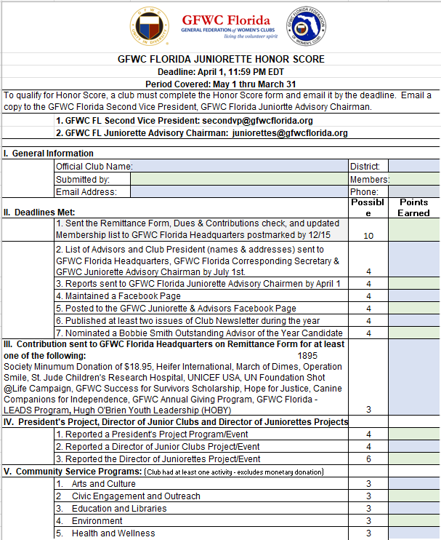

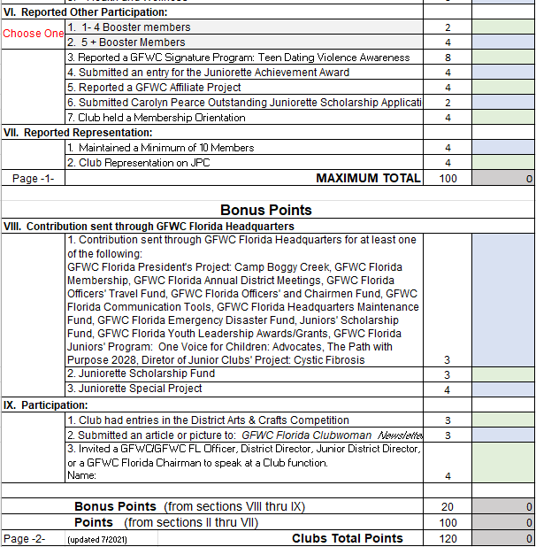

|  |  |  |  |  |  |
| --- | --- | --- | --- | --- | --- |
| |  | | --- | |  | | | | | |
| **GFWC FLORIDA 2022** | | | | |
| **JUNIORETTE ACHIEVEMENT AWARD** | | | | |
|  | | | | |
| **Deadline/Postmarked by: May 1, 2022** | | | | |
| **Period Covered: May 1, 2021 thru April 30, 2022** | | | | |
| To be eligible for the Juniorette Achievement Award, a club must have completed the Honor Score and must have participated in all five Community Service Programs. Email a copy to the GFWC Juniorette Advisory Chairman and the GFWC Florida Second Vice President. | | | | |
| Please include your club name in the saved Excel file.  Example:   JAA2022 (insert club name).xls.  When emailing your file, in the email subject line/area, please include report name and club name (e.g. JAA- Anytown Juniorette's). Keep a copy for your club files. **Remember: Email this report to the below Chairman and Officer. Deadline/Postmarked by: May 1, 2022** | | | | |
|  | **1.  GFWC FL Juniorette Advisory Chairman: Kay Taylor: juniorettes@gfwcflorida.org** | | | |
|  | **2.  GFWC Florida Second Vice President:  Laura Connelly: secondvp@gfwcflorida.org** | | | |
|  | | | | |
| **I.  General Information** | | | | |
|  | Official Club Name: |  | District: |  |
| Submitted by: |  | Members: |  |
| Email Address: |  | Phone: |  |
|  | | | | |
| **II. Club Participation/Activities:** | | | **Possible Points** | **Points Earned** |
| 1 | Joint Project held with another GFWC Florida Club | | 3 |  |
| 2 | Joint Project held with another community organization | | 3 |  |
| 3 | Club Activity involving Director of Juniorette's Project | | 4 |  |
| 4 | Start or maintain existing website/ Update Club Website/ Facebook/ Social Media Page | | 3 |  |
| 5 | Held an Orientation for New Members and/or for all Club Members | | 3 |  |
| 6 | Club participated in a Federation Day Project (April 24th) | | 3 |  |
| 7 | Held or attended Teen Dating Violence Awareness Project | | 5 |  |
| 8 | Club submitted article to *GFWC Florida Clubwoman* | | 3 |  |
| 9 | Held or attended a program about Human Trafficking | | 3 |  |
| **III. Membership growth/retention (Select only one from items 1-3)** | | |  |  |
| 1 | Club Membership remained the same as previous year | | 2 |  |
| 2 | Club Membership increased by 5% from previous year | | 5 |  |
| 3 | Club Membership increased by 10% from previous year | | 10 |  |
| **IV. Honor Score (Select only one from items 1-2)** | | |  |  |
| 1 | Honor Score totaled 80 - 100 Points | | 10 |  |
| 2 | Honor Score totaled 100+ Points | | 15 |  |
| 3 | Reports Submitted to GFWC Florida by May 1, 2022 | | 5 |  |
|  |  |  |  | |
|  | **TOTAL** | | 60 | 0 |
|  | | | | |
| **GFWC FLORIDA 2021** | | | | |
| **JUNIORETTE ACHIEVEMENT AWARD** | | | | |
|  | | | | |
| The Club with the highest overall point total will be the recipient of the Juniorette Achievement Award. This award recognizes GFWC Florida's Most Outstanding Juniorette Club. | | | | |
|  | | | | |
| **V. Additional Points:** | | | | |
|  | | | | |
|  | Additional points will be awarded to clubs receiving certificates of merit for outstanding GFWC Florida reports. Points will be given as follows: | | |  |
|  | | | |  |
|  | **Each of the Five Community Service Programs, Membership, and Leadership** | | |  |
|  | First Place Certificate - 10 points | | |  |
|  | Second Place Certificate - 7 points | | |  |
|  | Third Place Certificate - 5 points | | |  |
|  |  | | |  |
|  | **Fundraising & Development, Communications & Public Relations, President's Project, GFWC Signature Program, Human Trafficking, Legislation & Public Policy, Juniors' Special Program: Advocates for Children** | | |  |
|  | First Place Certificate - 8 points | | |  |
|  | Second Place Certificate - 5 points | | |  |
|  | Third Place Certificate - 3 points | | |  |
|  |  | | |  |
|  | **Joyce Johnston Junior to Juniorette Federation Interaction Award** | | |  |
|  | **Marcia Bright Women/Juniorette Award** | | |  |
|  | Winning Clubs - 5 points | | |  |
|  |  | | |  |

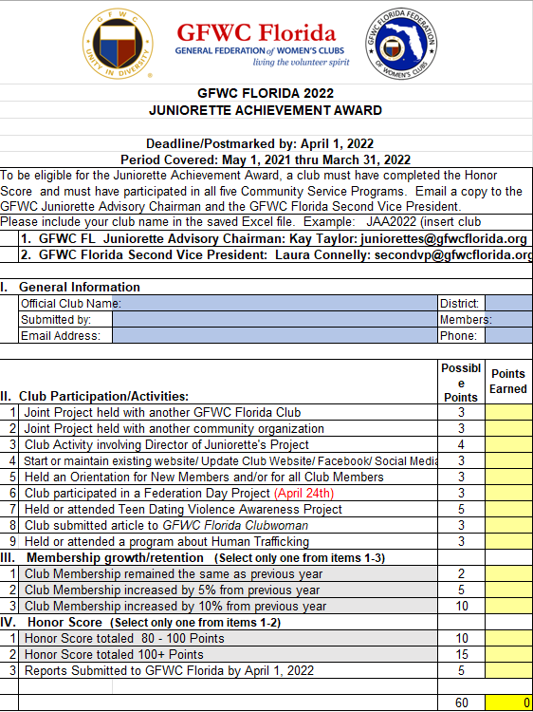

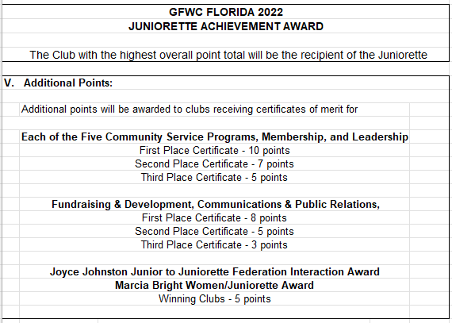



**GFWC Florida Juniorettes - GUIDELINES FOR SCRAPBOOK COMPETITION**

A scrapbook is a historical documentation of what your club has done in a given year. Clubs create scrapbooks for future members to see what the club did during the year. Clubs use photos, news articles, memorabilia from events and journaling to describe events to create unique historical records.

Scrapbooks will be judged on artistic presentation, content, merit and completeness. Certificates of participation will be awarded for each entry. A point system has been created and judges will be giving points for each area of judging.

1. Size of scrapbook:
   1. Page shall not be more that 12 x 12 inches or less than 8 x 8 inches. Pages may not be larger than 12 x 12 but any size within those guidelines is acceptable. For example

8.5 x 11, 9 x 9, 10 x 10, etc… are acceptable also.

* 1. Scrapbook shall ***not*** include more than 100 pages, 50 pages front and back. (The title page, table of contents, and rosters of GFWC, FFWC, District and Club officers do ***NOT*** count in the 100 pages)

**Select the best 100 pages of your activities (50 pages front and back). Book will not be disqualified for more than 100 pages**

1. Contents of each Scrapbook will be judged on creativity, organization, presentation, and Completeness and must contain the following:
   1. Title Page must include the name of the club, address, district, and your club year dates.

For example: Juniorette club year is:

**One year April 2022 to March 2023**

**Two years April 2022 to March 2024; these may only be entered one time, at JASM.**

* 1. Club Membership Roster. (Names are sufficient; contact data not required)
  2. List of club officers, Juniorette EC, JPC and advisory committee names. (Names are sufficient; contact data not required)
  3. List of State and District Officers (Names are sufficient; contact data not required; this information is available at [gfwcflorida.org](http://gfwcflorida.org).
  4. GFWC Officers and Southern Region officers (Names are sufficient; contact data not required, this information is available at [gfwc-southernregion.org](http://gfwc.org)).
  5. Each page must have event information and date somewhere on the page.
  6. Journaling should provide meaningful information about the subject/ activity should be on each page or set of pages.

1. Handmade, known as Traditional - The Cover must include the club name, district, and club year dates. Scrapbooks will be judged on creativity, design and sturdy construction. The cover should stand up to much handling in the future.
2. Club scrapbook shall ONLY include data for the club year listed on the Title Page.

(For example: If the club year is from June 2022 to May 2023, including items outside these dates will cause the scrapbook to be DISQUALIFIED. Your dates may be different from the example dates used here. You will use YOUR club year. You may include your Installation of Officers for the club year even though the Installation occurred prior to your club year starting).

1. The scrapbooks will be judged on creativity, organization, presentation, and completeness.
2. All materials shall be entered chronologically by month. Collage pages with multiple dates on pages are allowed. (Such as Department pages or event pages covering several dates from planning to event).
3. Judging: Scrapbooks will be judged based on the following maximum point (**Maximum of 100 Points**):

5 points Cover

35 points Organization and Contents 35 points Artistic

25 points Overall Appeal

The Juniorette Advisory Committee will judge the scrapbooks and award 1st, 2nd, and 3rd place awards. Each registered Juniorette club at JASM will have two votes for the Juniorette Choice Award, eand each JPC member will receive one vote.

First, second and third place certificate will be awarded in the following combined categories:

* 1. **Traditional**– No digital pages
  2. **Digital, totally digital**- NO ‘handmade’ embellishments or additions. Must be printed in book form.

1. A certificate will be awarded for the Juniorette Choice Award (both traditional and digital books are judged in the same category).

**GFWC Florida**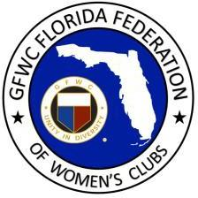

# Booster Club Application Form

GFWC Florida has a Booster Club! This offers you an opportunity to invite your husband, significant other, friends and family to join and support our Federation family.

Membership cost is $10.00. Membership is valid from May 2022-May 2024 and may be renewed. New members receive a booster pin.

BOOSTER’S NAME:

CLUB MEMBER’S NAME:

CLUB MEMBER’S STREET ADDRESS:

CITY/STATE/ZIP:

PHONE:

EMAIL:

CLUB NAME:

DISTRICT #:

IS THIS A RENEWAL?

**Make $10.00 check payable to GFWC Florida and mail to:**

GFWC Florida

4444 Florida National Drive Lakeland, FL 33813

**Thank you!**

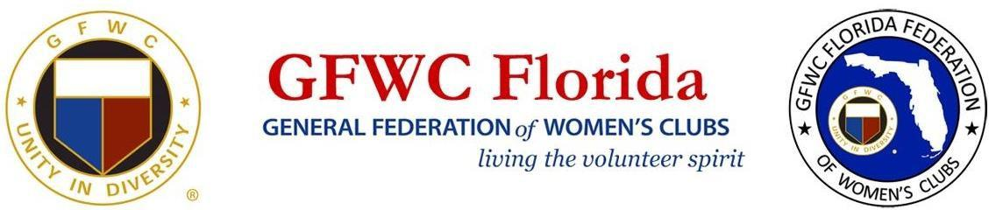

**GFWC FLORIDA JUNIORETTE AGREEMENT**

I, pledge to abide by

the following agreement while I am attending the, (meeting/event)

(place)

(date)

I will not leave the hotel premises without a chaperone or advisor.

I will abstain from the use of illegal drugs and alcohol.

I will check in with my chaperone at an agreed upon time.

I will behave in a manner that will reflect a positive image of the Juniorettes.

I will attend the meetings and share the information with my club members.

I will follow any rules set by my advisor.

I understand that failure to abide by this agreement can result in my having to leave the meeting immediately and that my parents will be called and responsible for returning me to my home. I further understand that there might be other disciplinary action taken.

Signed

Club

Date Cell number

Parent

Home Phone Cell number

Advisor/ Chaperone Cell number



### PERMISSION/MEDICAL AUTHORIZATION/RELEASE

I, , as parent/legal guardian of

**(Name, Please Print)**

, hereby give my permission

**(Student’s Name, Please Print)**

for my daughter’s attendance and participation at the

(Event / Meeting)

From To In the event of illness or injury, I authorize to give consent for any necessary emergency medical

treatment on behalf of my daughter. I understand that the GFWC or GFWC Florida, it’s members or chaperones are not liable for expenses incurred, including hospital or emergency transportation, for the treatment of any such injury or illness and that I am liable for all such expenses. In the event of a medical emergency, I further authorize GFWC Florida’s Juniorette Advisor / Chaperone

to provide the medical services provider with insurance information. A copy of my child’s insurance card is attached for that purpose, as well as a list of any known allergies and any medications my child may be taking at this time. My emergency contact phone numbers are:

Home and cell number .

As consideration for allowing my daughter to attend and participate in the above mentioned

meeting/event, I release and forever discharge the GFWC, the GFWC Florida Federation of Women’s Cubs, it’s members and chaperones from any and all claims, actions, or liability which I or my daughter have or may have against the GFWC, the GFWC Florida Federation of Women’s Clubs, it’s members and chaperones concerning or in any manner connected with or arising from my daughter’s attendance and participation in the above mentioned event, including any and all acts of negligence occasioned by the GFWC, the GFWC Florida Federation of Women’s Clubs, its members and chaperones.

Date

**Signature Parent/Legal Guardian of**

Student / Juniorette Name State of Florida County of

On this day of , 20 , before me personally appeared

(Name of signer), whose identity was proved to me on the basis of satisfactory evidence to be the person whose name is subscribed to this document, and who acknowledged that he/she signed the above/attached document.

Notary Public



**Please use document below when attending a Juniorette event**

**Original copies must be sent with registration form to attend Convention or Fall Board**

**GFWC FLORIDA JUNIORETTE**

**MEDICAL AND INSURANCE QUESTIONNAIRE**

Any allergies (food, drugs, plants, insects):

Special health and/or behavioral considerations:

**Insurance Information:**

Please attach a copy (front & back) of your insurance card

Parents Signature Date

Parents Phone Number

Juniorettes Name

Juniorettes Phone Number

Club

The applicant is under the care of a physician for the following conditions:

Physician’s Name

Physician’s Phone Number

Any medically prescribed meal plan or dietary restrictions:



**Please use documents below when attending a Juniorette event Original copies must be sent with registration form to attend Convention or Fall Board**

# GFWC FLORIDA JUNIORETTE PHOTO RELEASE

I hereby grant permission to the GFWC Florida Federation of Women’s Clubs and the GFWC Florida Juniorette Club named below, the right to use, reproduce and/or distribute photographs, films, videotapes, and sound recordings of my child, without compensation or approval rights, for use in materials created for purposes of promoting the activities of the GFWC Florida Federation of Women’s and GFWC Florida Juniorettes.

**Juniorette’s Name**:

Date

**Parent / Guardian Signature**

Home Phone Cell Number

Juniorette Club

Date Phone Number

Advisor/ Chaperone

Home Phone Cell Number



### SAMPLE GFWC (CLUB NAME) JUNIORETTE MEMBERSHIP APPLICATION

First Name: Last Name: City: State: Zip: Email: Phone: DOB: Age: School: Grade: Graduation Year:

Parent Name:

Address: City: State: Zip: Email: Phone: Cell Phone:

Second Emergency Contact:

Phone:

Example - You must attend at least three meetings, complete at least five hours of community service and participate in at least one fundraising activity during the club year.

The notarized medical release form, and copy of medical insurance card, photo release form and dues of $__________ for this application to be accepted. Forms will not be accepted without parent signatures. For all events, you will need to present a signed copy of the GFWC Florida Juniorette agreement.

I fully understand that by signing this application, I am to act in a responsible, mature and respectful manner. Inappropriate behavior may serve as grounds for dismissal from the club. It is also my responsibility to notify the Juniorette Advisor and/or the club President when I will be unable to attend a volunteer opportunity that I have signed up for.

Signature Date



# Nomination Form for Juniorette State Officer Position

**nominates Your official club name**

**Name:** Phone#

Email: _ Grade in September

Address: City: Zip Code:

**as a candidate for the following checked (X) position.**

☐Director of Juniorette Clubs

☐Vice Director of Juniorette Clubs

☐Secretary/Treasurer of Juniorette Clubs

We confirm she is a current, dues paying GFWC Florida Juniorette Club member in good standing and our club endorses her candidacy.

|  |  |
| --- | --- |
| **Juniorette Club President’s Printed Name** | **Club President’s Signature and Date** |
| Phone #: | Email: |
|  | |
| **Juniorette Club Advisor’s Printed Name** | **Club Advisor’s Signature and Date** |
| Phone #: | Email: |

Please attach nominees resume including previous GFWC positions held and grade the nominee is entering in the fall.

Additional comments about why your candidate would do a good job if elected to the checked position. Continue on the back or add an additional page.

Email completed form to Juniorette Advisory Committee Chairman at [juniorettes@gfwcflorida.org](mailto:juniorettes@gfwcflorida.org) by April 1.



##### GFWC Florida Juniorette Planning Committee Application

|  |  |  |  |
| --- | --- | --- | --- |
| Name | | Grade (in Sept.) | |
| Address | City | | Zip |
| Phone (home) | Cell | | |
| Email | | | |
|  | | District | |
| Advisor’s Name | | Phone # | |

***Please indicate your interest by numbers beginning with #1 as first choice; indicate 1-5 options:***

|  |  |  |  |
| --- | --- | --- | --- |
|  | Arts and Culture |  | Membership |
|  | Civic Engagement and Outreach |  | Chaplin |
|  | Education and Libraries |  | Historian |
|  | Health and Wellness |  | Fundraising |
|  | Environment |  | GFWC Juniors Special Program: Advocates for  Children (if needed for reporting purposes) |
|  | GFWC Signature Program: Domestic and Sexual Violence Awareness and  Prevention |  | Juniorette Special Project  (if needed for reporting purposes) |
|  | Leadership |  | Communications / PR |
|  | Parliamentarian |  | GFWC Florida President’s Project |

Please tell us why you feel you should be appointed to serve on the JPC and why you selected the position that you did for #1 (use back of page or separate page if needed):

Chairmen will be responsible for posting information and updates to their areas on our Facebook page, attending meetings to plan JASM (typically at GFWC Florida State meetings), and judging GFWC Florida Juniorette Reports (at end of May) in their areas within the deadlines provided.

Responsibilities at JASM will be determined during planning sessions. We are seeking statewide representation!

Email completed form to Juniorette Advisory Committee Chairman at [juniorettes@gfwcflorida.org](mailto:juniorettes@gfwcflorida.org) no later than April 1.



**Club Information Form**

Please email the completed form to **both** the GFWC Florida Juniorette Advisory Committee Chairman ([juniorettes@gfwcflorida.org](mailto:juniorettes@gfwcflorida.org) ) & GFWC Florida Second Vice President ([secondvp@gfwcflorida.org](mailto:secondvp@gfwcflorida.org))

Legal Juniorette Club Name: Click here to enter text.

Juniorette Club Mailing Address: Click here to enter text.

Address where you meet: Click here to enter text.

Sponsoring Club’s Name: Click here to enter text.

Sponsoring Club’s Contact Name: Click here to enter text.

Contact Phone Number for Sponsoring Club: Click here to enter text.

GFWC Florida District: Click here to enter text.   
# of Juniorette club members: Click here to enter text.

Year club organized: Click here to enter text.

Club meeting day & time: Click here to enter text.

Months of year club meets: Click here to enter text.

***Club President Contact Information***

Name: Click here to enter text.

Address: Click here to enter text.

Cell phone: Click here to enter text.

Home phone: Click here to enter text.

Email address: Click here to enter text.

***Club Treasurer Contact Information***

Name: Click here to enter text.

Address: Click here to enter text.

Cell phone: Click here to enter text.

Home phone: Click here to enter text.

Email address: Click here to enter text.

***Club Advisor Contact Information***

Name: Click here to enter text.

Address: Click here to enter text.

Cell phone: Click here to enter text.

Home phone: Click here to enter text.

Email address: Click here to enter text.

***Club Advisor Contact Information***

Name: Click here to enter text.

Address: Click here to enter text.

Cell phone: Click here to enter text.

Home phone: Click here to enter text.

Email address: Click here to enter text.

***Club Advisor Contact Information***

Name: Click here to enter text.

Address: Click here to enter text.

Cell phone: Click here to enter text.

Home phone: Click here to enter text.

Email address: Click here to enter text.

***Club Advisor Contact Information***

Name: Click here to enter text.

Address: Click here to enter text.

Cell phone: Click here to enter text.

Home phone: Click here to enter text.

Email address: Click here to enter text.

Approved by: Click or tap here to enter text. Date: Click or tap here to enter text.

GFWC Florida

**Club Information Form**

**Attention Club Presidents**

**(Juniorette, Junior and Woman’s Club)**

This information is needed to ensure information is correct in the GFWC Florida Online Manual and for mailing of the Call to GFWC Florida State Meetings. Please return the completed form no later than **June 30th of each year** to:

**Julia George AND GFWC Florida Headquarters AND Your District Director**

**6770 Ridgewood Ave #901** **4444 Florida National Drive**

**Cocoa Beach, FL 32931 Lakeland, Florida 33813**

[**gfwcjulia@yahoo.com**](mailto:gfwcjulia@yahoo.com)[**gfwcfloridahq@gmail.com**](mailto:gfwcfloridahq@gmail.com)

## Club Information

Legal Club Name: Click here to enter text.

Club Mailing Address: Click here to enter text.

Do you own a clubhouse? Click here to enter text.

If yes, clubhouse address: Click here to enter text.

If no, address where you meet: Click here to enter text.

Club phone number: Click here to enter text.

Club website: Click here to enter text.

Club email address: Click here to enter text.

GFWC Florida District: Click here to enter text.   
Number of club members: Click here to enter text.

Year club organized: Click here to enter text. Year club federated: Click here to enter text.

Club meeting day & time: Click here to enter text. Months of year club meets: Click here to enter text.

## Club President Contact Information

Name: Click here to enter text.

Address: Click here to enter text.

Phone: Click here to enter text.

Email address: Click here to enter text.

## Club Juniorette Advisor Contact Information

Name: Click here to enter text.

Address: Click here to enter text.

Phone: Click here to enter text.

Email address: Click here to enter text.

## Club Treasurer Contact Information

Name Click here to enter text.

Phone Click here to enter text.

Email address Click here to enter text.





Are you going after graduation?

In an effort to “track” our graduating Juniorettes, please complete the form below to tell us the schools in Florida and elsewhere that your graduating seniors are applying to and/or attending. If you have graduating seniors staying within your community, please let us know that as well. It is our hope to supply Federated club information to these communities so that your graduating seniors will be able to stay with Federation.

Juniorette

Club: _ # of Graduating Seniors: _ Year Graduating:

Please list schools applying/attending (If not in Florida, please list city/state.) Please use back of form, if needed.

#### Our Legacy

Have you looked into the Juniorette world? Have you looked in the world of this girl?

She must have courage to begin her day without a prayer, Otherwise, she wouldn’t even dare.

The Juniorettes confronted with humanism everywhere…

Drugs, abortion, pollution, children’s hungry cries. But like the Phoenix bird from the ashes, she will rise.

A girl full of hope, earnest desires, pursuing without fear To make her place in this sphere.

Can’t you help? Don’t you hear?

She needs you and me, a safe haven we can be.

Teaching lost arts – decency, Kindness and duty to God and man She is your Legacy –

The girl can carry your club banner in your kind of manner. But how is she to know if you don’t embrace her as your child to guide, to grow, godly and mild.

For when our generation is gone

Will the clubhouse stand silent – as dead? The decision is ours; we’ll make the bed.

But I tend to guess – that when the door of the future is open, we’ll rest

For the Juniorettes will now have the key But, of course, how wise of you and me They are our Legacy!

**Betty Jean Gadd**

**GFWC Woman’s Club of Ocala, Inc**.



**Login to gfwcflorida.org Member Center for the latest version of**

**Juniorette Handbook and Forms**

