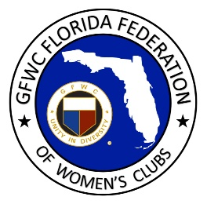
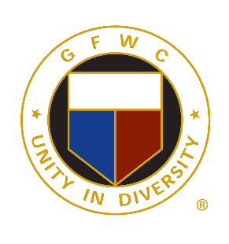
GFWC Florida

Booster Club
Application

Become part of our Boosters! GFWC Florida has a Booster Club that offers an opportunity to invite your husband, significant other, family and friends to support our Federation family by filling out the membership form and sending $10 to GFWC Florida Headquarters. Membership runs from May 2022 - 2024 and may be renewed each administration. New members will receive a GFWC Florida Booster pin.

BOOSTER’S NAME:

CLUB MEMBER’S NAME:

CLUB MEMBER’S STREET ADDRESS:

CITY/STATE/ZIP:

PHONE:

CLUB MEMBER’S EMAIL:

CLUB NAME:

DISTRICT #:

IS THIS A RENEWAL?

Make $10.00 check payable to GFWC Florida and mail to:
GFWC Florida
4444 Florida National Drive
Lakeland, FL 33813

Thank you!

