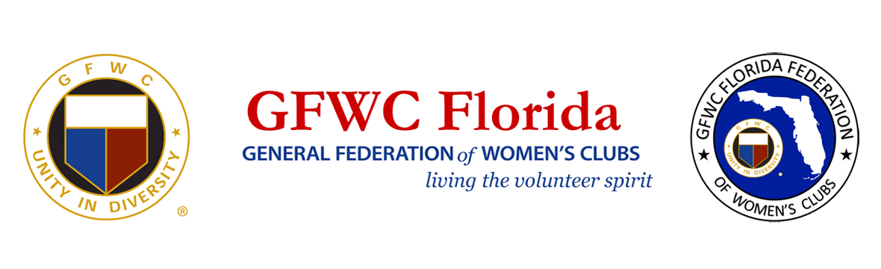
PRESS RELEASE
For Immediate Release
Inquiries: Laura Connelly
GFWC Florida Communications & Public Relations Chairman
communications@gfwcflorida.org

GFWC Florida Announces 70+ Graduates from Leadership Training Program

With a rich history of leadership development for its members, the General Federation of Women’s Clubs (GFWC) Florida Federation has completed its 2022 leadership training program with 70+ future leaders from across the state in attendance.
The GFWC Florida’s Leadership, Education, And Development Seminar (LEADS) identifies club members who have the potential and desire to assume leadership positions at the local club level, District, State, and/or GFWC National level. Participation helps up-and-coming leaders gain the capabilities, confidence, and commitment necessary to pursue and achieve higher offices and serve the organization of volunteers with distinction.
The 2022 program was led by GFWC Officer Jolie Frankfurth and GFWC Florida Immediate Past President Sharon Oliphant, with workshops delivered by several GFWC state leaders.
Frankfurth commented, “There was so much energy in the room, doesn’t matter what our personal and professional experiences are, you should never stop growing and taking advantage of leadership training. Each candidate has multiple tools to hone and share in their grassroots efforts in local communities. This is how GFWC volunteers make good things happen.”
Oliphant stated, “This is what our organization does and excels in—training leaders and encouraging them to use the skills they already have. Also, to challenge and motivate them as they continue to have an impact in their own clubs and communities. “

About GFWC Florida
GFWC Florida is a volunteer, non-profit 501(c)(3) organization comprised of 193 Women’s Clubs, Junior Women’s Clubs, and Juniorette clubs (12-18 years old) across the state whose members are dedicated to community improvement by enhancing the lives of others in their local communities. Inclusive and unified in their diversity, the 7,500 members across the state attend to the needs of their communities through hands-on service projects, fundraising, education, leadership and friendship.

About the General Federation of Women’s Clubs
The General Federation of Women’s Clubs is a unifying force, bringing together local women’s clubs, with members dedicated to strengthening their communities and enhancing the lives of others through volunteer service. With over 80,000 members in affiliated clubs in every state and more than a dozen countries. GFWC members are community leaders who work locally to create global change by supporting the arts, preserving natural resources, advancing education, promoting healthy lifestyles, encouraging civic involvement, and working toward world peace and understanding.

******

