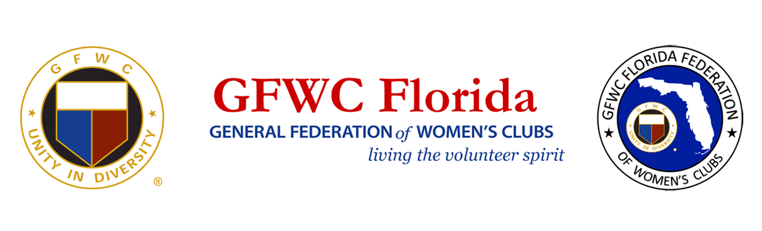
PRESS RELEASE
For Immediate Release
Inquiries: Patricia Fisher
GFWC Florida Environment Community Service Program Chairman
environment@gfwcflorida.org

GFWC Florida Celebrates America Recycles Day
With Programs to Eliminate Use of Single-Use Plastics

With a rich history of diligence in its efforts to preserve the environment, the General Federation of Women’s Clubs (GFWC) Florida is encouraging Floridians to take action to prevent damage to marine and wildlife caused by single-use plastics.

Single-use plastics are generally not compostable or biodegradable, but instead are ingested by terrestrial and marine life, and can make their way into the human food chain, posing a serious threat to the natural environment and water supply, marine and wildlife, and human health. The Florida Department of Environmental Protection cites data that indicates 90% of the trash in the ocean is made from plastic which pollutes most marine habitats including deep sea, coral reefs, beaches and rivers; and harms sea life, with about 90% of seabirds and 30% of turtles having plastic found in their stomachs.

Many county and city businesses have taken alternative steps to reduce or eliminate single-use, non-recyclable plastics. GFWC Florida clubwomen across the state are working with local officials to implement campaigns to educate the public and regulate their own communities in an effort to alleviate the harms caused by single-use plastics. GFWC Florida clubs and their members are undertaking a review of their own purchasing policies in order to limit or eliminate the use of single-use plastics at their events and in their daily lives.
GFWC Coconut Grove Woman’s Club is leading the way with the formation of a collaborative partnership known as the Plastics-Free Initiative Coalition (www.plasticsfreeinitiative.org). Established to minimize the amount of plastics collecting on Florida’s shores, the coalition includes the women’s club, as well as local businesses, non-profits and government entities. They have launched an awareness campaign to educate the public, provide information on environmental news, upcoming events, outreach, and committees. The coalition’s goals are to (1) reduce or ban, where possible, the use of single-use plastics; (2) organize a grassroots coalition to develop educational programs and materials for elementary and secondary students and community members; and (3) promote goodwill with merchants to encourage use of eco-friendly alternatives to reduce pollution.

About GFWC Florida
GFWC Florida is a volunteer, non-profit 501(c)(3) organization comprised of 193 women’s clubs, junior women’s clubs and juniorette clubs across the state whose members are dedicated to community improvement by enhancing the lives of others in their local communities. Inclusive and unified in their diversity, the 8,400 members across the state attend to the needs of their communities through hands-on service projects, fundraising, education, leadership and friendship.

About the General Federation of Women’s Clubs
The General Federation of Women’s Clubs is a unifying force, bringing together local women’s clubs, with members dedicated to strengthening their communities and enhancing the lives of others through volunteer service. With over 80,000 members in affiliated clubs in every state and more than a dozen countries, GFWC members are community leaders who work locally to create global change by supporting the arts, preserving natural resources, advancing education, promoting healthy lifestyles, encouraging civic involvement, and working toward world peace and understanding.

******

