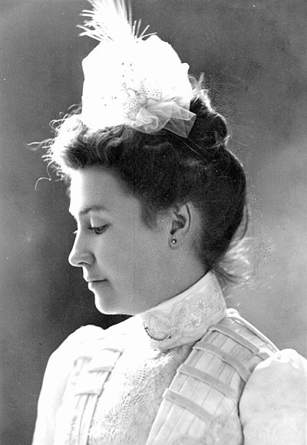
Though born in New Jersey on April 25, 1872, she quickly relocated to Florida just two years later. The family settled in the Crystal River area, establishing themselves in Brooksville. May’s mother died when she was only nine, and both May and her younger sister were sent to the St. Joseph’s Convent in St. Augustine for their education. May was valedictorian of her class and graduated in 1889.
May Austin Elizabeth Mann Jennings
Her father was Florida State Senator Austin Mann, and May went to Tallahassee to serve as an aide to her father. She was responsible for his appointments, correspondence, and hosting social events. May met Judge William Sherman Jennings in their home. William followed them back to Tallahassee and the two were married on May 12, 1891. May is credited in some circles with William’s meteoric rise within the state Democratic party, due to her knowledge of state politics and her vast network of relationships throughout the state among the Florida Federation of Women’s Club members. She was obviously no stranger to politics.
May was a prominent leader in the women’s club movement, serving as president of the Florida Federation of Women’s Clubs from 1914-1917, and then as Florida director and vice president of the General Federation of Women’s Clubs from 1918-1920. She was a co-founder of The Florida State League of Women Voters, and was active in a number of civic organizations as well as social and political groups. May championed a number of causes that she believed needed the public’s attention. She was an early conservationist and used her platform as president of the Florida Federation of Women’s Clubs to have Royal Palm State Park established in 1915. She was appointed to the Everglades National Park Commission in the late 1930s, and pushed for the creation of a national Everglades Park. During her time in the Governor’s mansion, she was affectionately labeled “Mother of Forestry”. In addition to conservation, she was an advocate for the Seminole Indians, women’s rights and suffrage, prohibition, child welfare, education, and public health.
Following their time in the Governor’s mansion they moved to Jacksonville, which was Florida’s largest city at the time, and Governor Jennings established a law practice. They also had a farm close to Middleburg, and owned timber in Clay County. He died in 1920. She lived a life of caring for others and concern for the community, until at the age of 90, on April 24, 1963, May Man Jennings was laid to rest in Evergreen Cemetery in Jacksonville, FL.

