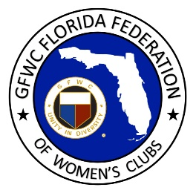
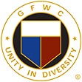
GFWC Florida
International Awards
GFWC International Convention 2021

Community Service Programs
Education & Libraries Community Service Program – GFWC Florida - 1st place
Environment Community Service Program – GFWC Florida – 1st place
Health & Wellness Community Service Program – GFWC Florida – 1st place
Advancement Areas
Communications and Public Relations – GFWC Florida – 1st place
Epsilon Sigma Omicron (ESO) – GFWC Florida – 1st place
Leadership – GFWC Florida – 1st place
Club Award for Communications and Public Relations
GFWC Fort Walton Beach Woman’s Club – Honorable Mention
Club Award for Newsletter
GFWC North Pinellas Woman’s Club – 2nd place
Club Award for Website Contest
GFWC Naples Woman’s Club – 1st place
The Woman’s Club of Stuart – 3rd place
Signature Program Fundraising - GFWC Florida – 4th place
Club Award-Signature Program Fundraising-GFWC Viera Woman’s Club–10th place
Millie Crom award for Excellence in Junior State Leadership – Platinum Level – Candice Postel, GFWC Florida Director of Junior Clubs
Poetry Contest – Betsy Fisher, GFWC North Pinellas Woman’s Club – 1st place

Shot@Life in recognition of their work toward increasing access to life saving vaccines for children everywhere
GFWC Florida Federation of Women’s Clubs State HQ - 1st place
Club Award – GFWC Marianna Woman’s Club – 2nd place
St Jude Children’s Research Hospital
2020
2021
GFWC Florida Juniorette clubs recognized for reporting:
Little Women of Fernandina Beach
GFWC Little Women of Lutz
GFWC Juniorettes of Pasco
GFWC Temple Terrace Juniorettes
GFWC Juniorette Club of Jupiter-Tequesta
GFWC St Petersburg Juniorettes
GFWC Pinellas Juniorettes

