GFWC Florida Juniors
2021 Reporting Handbook

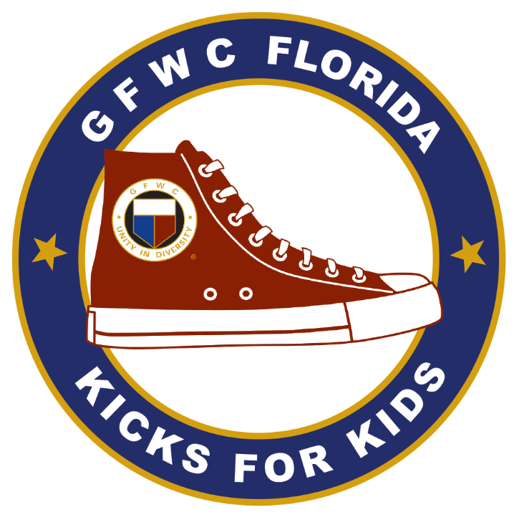

Contents:
- Reporting Form Instructions & Procedures
- Honor Score Tab Instructions
- GFWC Florida Remittance Form & Instructions
- Frequently Asked Questions
- Reporting & Awards Due Dates
- GFWC Florida Junior Awards
- Where to Report It
- Copy/Paste Directions
Reporting Form Instructions & Procedures
Thank you for reporting!! GFWC Florida Junior Clubs do fantastic work in our communities and make a huge impact! By reporting, you allow us to include your great work in reports that go to GFWC, which translates to grants and advocacy. We also get to recognize you for your outstanding work through the awards given at our Annual Convention. We know that careful reporting takes time and we continue to strive to simplify and improve the reporting process. Please give us your feedback!
1. To be eligible for your reports to be judged, your club must submit the GFWC Florida Remittance Form by the new deadline of 12/15/21. Please also email a copy of the form to the GFWC Florida Junior Finance Director at jrfinancedirector@gfwcflorida.org and to fljuniorsreports@gfwcflorida.org . This will allow us to easily verify Honor Score credit for contributions. If the club member submitting your Remittance Form is not the club member filling out your reports, provide a copy of the completed Remittance Form to that member because it is needed to complete the Honor Score.
2. Complete the highlighted boxes on the Instructions tab of the reporting form, which will auto-fill through the rest of the form.
3. Other guidelines:
-- Do not use abbreviations or acronyms that the chairman will not understand.
-- Round minutes up to the next hour and monies to the next dollar amount.
-- Cash donations are monies or gift cards sent directly from the club whereas in-kind donations are items purchased by the club or donated by club members.
4. Please save your form (and include the name of your club in the title) and email it to the following addresses by copy and pasting them: fljuniorsreports@gfwcflorida.org , juniordirector@gfwcflorida.org , jrvicedirector@gfwcflorida.org . Copy/Paste the email addresses because they are like OLD email addresses that may auto fill in your email if you type them in. We will not accept reports that were sent to an incorrect email address. The email MUST be sent by 11:59PM on 1/15/2022. If it is sent after that you can still get Honor Score credit and we can use your reports for GFWC Florida, but your reports will NOT be eligible for awards. If you have questions about the form, please contact the GFWC Florida Vice Director of Junior Clubs, at jrvicedirector@gfwcflorida.org . Please do NOT wait until the last minute and risk having technical difficulties. There are NO extensions granted!
REASONS FOR DISQUALIFICATION OF REPORTS
-- Late Federation Dues – Dues and Remittance Form must be sent by the deadline of 12/15.
-- All reports and Honor Score not submitted before January 15th
-- Reduced copy or print smaller than 10 pt. minimum.
-- Correct Reporting Form was not used.
If a report has been disqualified, the Director of Junior Clubs will contact you by phone and in writing.

DOUBLE REPORTING
There are very few areas in which a club can report a project in more than one area. These exceptions are:
- Fundraising -- On the Fundraising tab, report the fundraiser and the money raised, you report the donation or project the money was used for on the appropriate tab). For example, if you do a car wash to raise funds for Operation Smile, report the hours spent doing the fundraiser on the Fundraising tab along with the amount raised (money coming into the club). On the Civic Engagement & Outreach tab, you will report the donation to Operation Smile (money going out of the club). The hours should not be double reported.

- Communications – On the Communications tab, report the specific communications and public relations you do for your club or projects. If your club does a large annual event such as a community safety festival and club members spend 10 hours posting on Facebook, writing and emailing press releases, doing a live appearance on a local new station and posting flyers at local businesses then you would report these activities and hours on the Communications tab but the other hours for the safety festival would be reported under Public Issues. The same hours should not be reported more than once (so the 10 hours spent on communications in this example would not be counted again in the hours reported on the Public Issues tab).

- Interactions with Woman’s Clubs, Juniorettes, or other Junior Clubs (section to report interactions is on the Membership tab). There is not a section to report the stats of these events because they should be reported under their respective Community Service Program.
These areas are marked within the reporting spreadsheet.

Honor Score Tab Instructions
Honor Score points are given “on your honor” for your reporting efforts, monetary donations, adhering to deadlines, Federation involvement and award nominations. For every report with complete narratives you will give your club Honor Score points. After your club completes all the entries on the 11 reporting tabs, you will give your club Honor Score points on the last tab titled “Honor Score”. Each report submitted on the Junior Reporting Spreadsheet is valid for a pre-determined amount of points. Be sure to go back and check each tab of the reporting worksheet to verify that all projects/events/tasks have been captured. **If you have entered any information on a tab then you are eligible to claim Honor Score points for the corresponding category.
You will need a copy of your club’s remittance form to accurately claim honor score points for money submitted to GFWC Florida. The remittance form will be sent to clubs in October by GFWC Florida and will be due December 15th. 70 out of 197 (36%) points come directly from the remittance form.
If you are unsure if your club is eligible for Honor Score points, give your club credit for the points. Upon final verification from all chairmen, additions and deductions will be made to your final total.
Common mistakes made resulting in Honor Score points being deducted include the following:
- Missing narratives for projects; narratives are essential for judging. If narratives are missing there is no way to determine how valid the project/event actually is.
- Missing member names in attendance at state and district meetings. There are many opportunities for club members to attend state and district meetings and workshops. Do not forget to include these members’ names in the appropriate fields under the Membership tab.
- Updated member list received after the deadline; follow all deadlines closely. Honor Score points cannot be awarded for items received late such as updated member list and addresses, dues and remittance, and award nominations.
Your club’s total Honor Score points are used to calculate a portion of points for the Mary Clark Award:
1-125 points…5 points 126-150 points…10 points
151-170 points…15 points 171+ points…20 points

Total Honor Score points are also used in the event of a tie for the Mary Clark award.

The following is a copy of the honor score page as seen on the reporting spreadsheet:

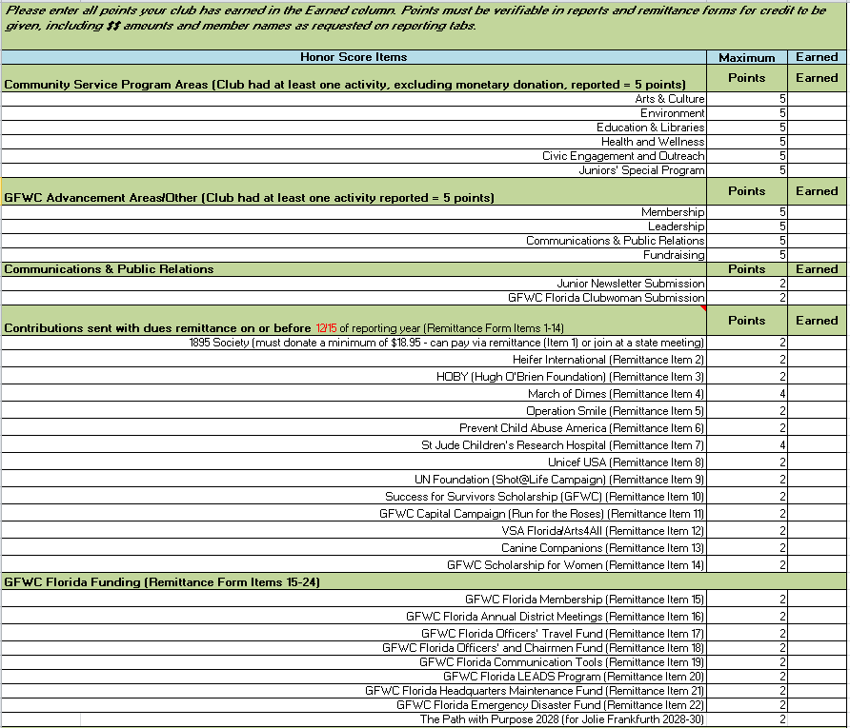
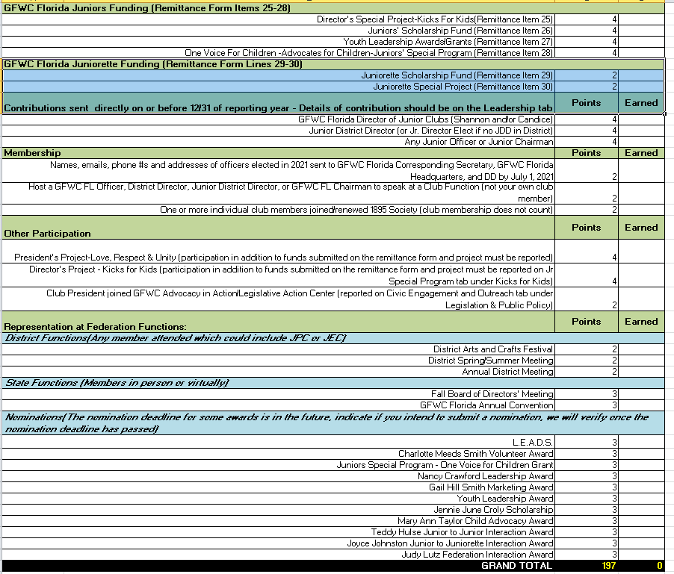

GFWC Florida Remittance Form & Instructions
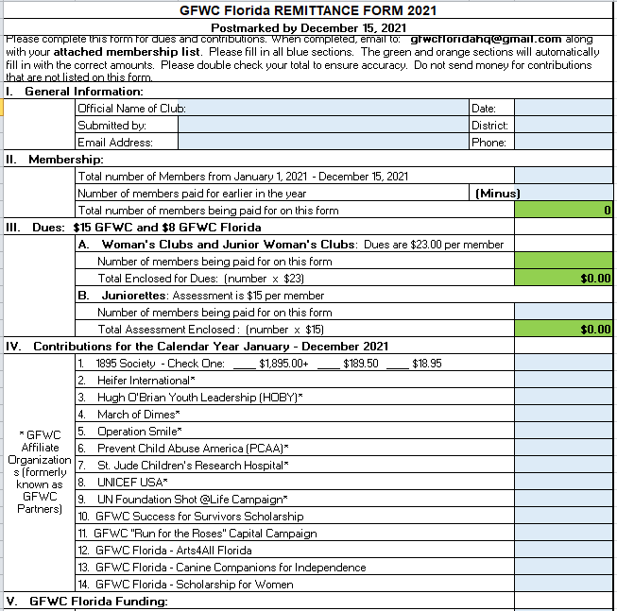
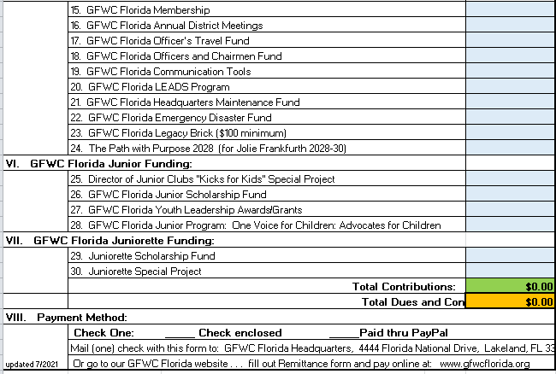
EXPLANATION OF CONTRIBUTIONS

1. 1895 Society: GFWC Florida’s Society is designed to “Preserve our Past and Ensure our Future.” by supporting the building of Capital Reserves and Endowment Funds, Headquarters Maintenance, and History and Resource Center.
2. Heifer International: Provides gifts of livestock and environmentally sound agricultural training to improve the lives of those who struggle daily for reliable sources of food and income.
3. HOBY (Hugh O’Brian Youth Leadership): Funds sponsor high school sophomores to a weekend leadership training seminar in Florida. Full scholarships are $350.00, but any amount is appreciated.
4.*March of Dimes: To improve the health of babies by preventing birth defects, premature birth, and infant mortality.
5. Operation Smile: Provides operations worldwide to people who were born with clef pallets
6. Prevent Child Abuse America (PCAA): their sole mission 'to prevent the abuse and neglect of our nation's children.'
7.*St. Jude Children’s Research Hospital: Leading the way to treat, defeat childhood cancer and other deadly diseases.
8. UNICEF USA: is a non-profit, non-governmental organization in the United States that supports the United Nations Children's Fund.
9. UN Foundation: Shot @ Life Foundation: A campaign to educate, connect and empower Americans to champion vaccines in order to save children in developing countries.
10. Success for Survivors Scholarship: To lend a helping hand to those impacted by intimate partner violence who are pursing higher education.
11. GFWC “Run for The Roses” Capital Campaign: A fund established to secure and sustain the property and programming of GFWC. To stimulate philanthropic activity and financial planning that will encourage members and their families to leave a legacy that supports the great works time, and honored traditions of clubwomen.
12. Very Special Arts: VSA –To provide support and champion Arts Education for and by people with disabilities.
13. Canine Companions for Independence: Enhances the lives of people with disabilities by providing highly trained assistance dogs and ongoing support.
14. GFWC Florida Scholarship for Women
15. GFWC Florida Membership: Funds help defray costs of planning and implementing membership
programs for GFWC Florida clubs.
16. GFWC Florida Annual District Meetings: Funds defray materials and travel expenses for the tour teams.
17. GFWC Florida Officer’s Travel Fund: Donations used to fund budget.
18. GFWC Florida Officer’s & Chairman Fund: Donations used to fund budget for administrative expenses.
19. GFWC Florida Communication Tools: Funds help defray printed material as needed.
20. GFWC Florida LEADS Program: Funds help defray costs of planning and implementing GFWC Leadership and Development Seminars
21. GFWC Florida Headquarters Maintenance Fund: Funds are used for headquarters improvements— furniture, appliances and major repairs—and remain in the account until needed
22. GFWC Florida Emergency Disaster Fund: Funds provide emergency help to GFWC clubs, members or others when disasters occur.
23. GFWC Florida Legacy Brick ($100.00 minimum): Preserve legacy at GFWC Florida Headquarters.
24. The Path with Purpose 2028: Sponsoring Jolie Frankfurth on the path to become GFWC International President 2028-2030
25. Director’s Special Project- “Kicks for Kids”: Focus on providing shoes and socks to children of all ages in need.
26. GFWC Florida Junior Scholarship Fund: Provides funds for a continuing education scholarship for a Florida Junior clubwoman.
27. GFWC Florida Youth Leadership Awards/Grants: Funds to assist High School Seniors with leadership and training.
28. “Advocates for Children” Advocates for Children – Junior Special Program: Chosen by the junior membership to be their continuing project. Funds are used for a variety of projects, which benefit children.
29. Juniorette Scholarship Fund: Funds are used for continuing education scholarships for Florida Juniorettes.
30. Juniorette Special Project: Funds are used to support the 2020-2022 Director of Juniorette Clubs Special Project.

Revised 09/21

Frequently Asked Questions
1. What is the difference between dollars donated and in-kind donations?
Dollars donated are monies or gift cards sent directly from the club, whereas in-kind donations are items purchased by the club or donated by club members.

2. For Fundraising Dollars Raised, is this the total amount raised before or after expenses?
In the Dollars Raised column, please report the amount raised after expenses which is the amount available for your club to use or donate on projects/events. You can include in the narrative information about total amount raised and the expenses.

3. Where can I double report?
Items listed on Fundraising and Communications can also be reported on another tab. On the Membership tab, there is also an area to report interactions with Woman’s Clubs, Juniorettes and other Junior clubs. Since all of these events can be reported on another tab, we are not collecting the number of members, hours or dollars spent. That information will be reported elsewhere.

4. Can I report the same project under two Community Service Programs (CSPs) such as Arts and Culture & Civic Engagement and Outreach if we paint a mural at a hospital?
No, the same project cannot be reported under multiple CSPs. In this example, you could report the project under Arts and Culture or Civic Engagement and Outreach, but not both

5. What are the little red triangles throughout the reporting spreadsheet?
The little red triangles in the corner of some cells, indicate there is a comment with additional information for you. Please review these comments as you complete your reporting spreadsheet because they contain helpful information. Hover over the cell with the red triangle for the comment box to appear. In the screenshot below, the red triangle is in the corner of the Community Projects cell so when it’s hovered on, you can see the Environment Project Examples.
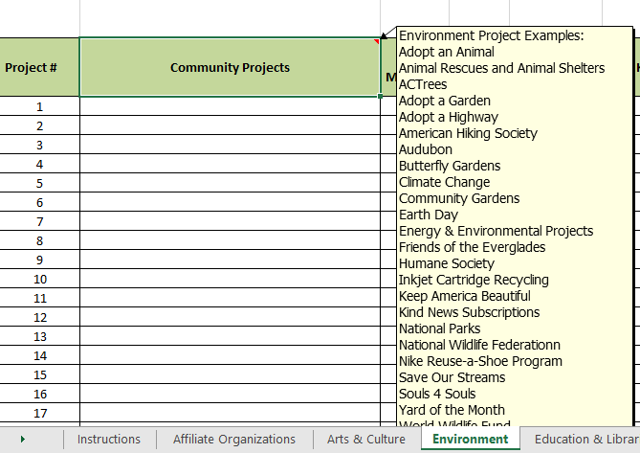

6. Do I have to write a narrative?
No, a narrative is not required on every project. A narrative is needed if someone cannot tell from the title what was done or if an explanation is needed to explain the number of hours. Remember, the people reading your report are not in your club and this information also goes to GFWC so some people reading the reports are not even in our state. Some projects won’t need any explanation and most projects can be explained in 2-4 sentences but you may have a few huge projects that involve your whole club and take months so these may take 2-3 paragraphs to explain. You should only have a few of these projects. Examples are Sebastian River’s Science Camp, Plant City’s Shoe Project, New Tampa’s annual fundraiser Night of 5000, St. Pete’s Pumpkin Palooza, Midtown’s Crawl 4 a Cause, Lakeland’s Eco Festival, etc. These are large scale projects that take months of prep work and all the members input. Even though most of these are annual projects, thorough explanations are needed because chairman change every 2 years as well as people at the GFWC level. They may have never heard of your project.

Example Narratives
Title of Project: Pop tabs collected at meetings and 10 pounds donated to Ronald McDonald House
This project does not need an additional narrative as the title has what (pop tab collection), who (our members), when (monthly meetings), who benefited (Ronald McDonald House), how much (10 pounds).

Title of Project: Miles for Moffitt
This project needs a short narrative. If you are from the Tampa area you may know of the Moffitt Cancer Center but people in other areas of the state would not know and people at the national level would not know. Also, what did your club do? Did you pass out water, did you participate as a team, did you fundraise, did you work a registration table? The majority of your projects will probably fall into this category, needing a short narrative.

Sample Narrative: 15 of our members volunteered at the Moffitt Cancer Center’s Miles for Moffitt by handing out water to the runners. We also raised $500 by selling luminaries to our friends and family before the event to be displayed at the event. 3 of our members ran in the race.

7. What is the GFWC Florida President’s Project for 2020-2022?
GFWC Florida President Dianne Forrester has chosen “Promoting Unity in Diversity with Love, Respect, and Kindness” for all as her theme for the next two years. Emphasis will be for all special needs from autism, Alzheimer’s, Arts for All, Special Olympics, Cancer patients, rescue animals, scholarships, diabetes, heart health, transplant programs, disabled veterans both physically and mentally, help for our first responders, and any other needs a community may have.

8. What is the GFWC Florida Director of Junior Clubs’ Project for 2020-2022?
GFWC Florida Director of Junior Clubs Candice Postel has chosen “Kicks for Kids” as her theme for the next two years. The purpose of her project is to get shoes to kids in need! There are children in every community who need a good quality pair of shoes that fit. Having the right shoes gives children confidence, a boost in self-esteem, and the opportunity to focus in school on the lessons instead of thinking about their hurting feet. Find children in your local community who are in need and get them shoes that fit.

GFWC Florida Junior Reporting & Awards Due Dates

December 15 -- Club Remittance Form and Dues sent to GFWC Florida Headquarters in Lakeland AND a copy of the form emailed to GFWC Florida Junior Finance Director at jrfinancedirector@gfwcflorida.org and FLJuniorsReports@gfwcflorida.org , to ensure easier verification for Honor Score credit. Please note your reports will be ineligible for judging if dues are not received on time.

January 8 (optional) -- Reports to Junior District Directors for assistance and review

January 15
GFWC Florida Juniors reporting form sent via e-mail by 11:59PM to FLJuniorsReports@gfwcflorida.org . Please copy the Director of Junior Clubs, at juniordirector@gfwcflorida.org and the Vice Director of Junior Clubs, at jrvicedirector@gfwcflorida.org on the email. Please note your reports will be ineligible for judging if not received on time.
-- Names, emails, phone numbers and addresses of current officers sent to GFWC Florida Corresponding Secretary at correspondsec@gfwcflorida.org .

February 1
All nomination forms are posted on the GFWC Florida website within the Members Center.
-- Juniors’ Special Project (Advocates for Children) Grant Application
-- Nancy Crawford Leadership Award
-- Charlotte Meeds Smith Award
-- Gail Hill-Smith Marketing Award
-- Teddy Hulse Junior to Junior Interaction Award
-- Joyce Johnston Junior to Juniorette Interaction Award
-- Judy Lutz Federation Interaction Award
-- Jennie June Croly Education Scholarship Application
-- Mary Ann Taylor Child Advocacy Award
-- Youth Leadership Awards
-- GFWC Florida Website, Newsletter, Yearbook, and Writing Contests

February 20-- GFWC Florida LEADS Application

March 1 -- GFWC Florida Scholarship Application

March 15 -- GFWC Media Campaign Contest

April 15 -- GFWC Florida Photography Contest

Fall Board -- GFWC Florida Scrapbook Contest

GFWC Florida Junior Awards
Clubs compete for awards on the state level in Community Service Program Areas (CSPs), and GFWC focus areas. Clubs are divided into categories based on the number of members in the club and the number of clubs which report. These categories may fluctuate from year to year and will be determined by the Junior Executive Committee.

Junior Awards Distribution at Convention
Five Community Service Programs up to 4 awards in each category
Membership up to 4 awards in each category
Leadership up to 4 awards in each category
Fundraising up to 4 awards in each category
Communications & Public Relations up to 4 awards in each category
Juniors’ Special Project up to 4 awards in each category
Director’s Project Awards up to 4 awards in each category

Mary Clark Point System
The Mary Clark Award was named after Mrs. Joseph (Mary) Clark, GFWC Florida Director of Junior Clubs. In recognition of the Florida Juniors’ outstanding community service, Mr. Arthur Yates of Yates Jewelers in Tampa, donated a silver tea service to Florida Juniors in Mary Clark’s name. This tea service is a revolving award and awarded to the most outstanding Junior Club in the state with a winner chosen each year. The first club to win the Mary Clark Award was the Ocala Junior Woman’s Club.

Five CSPs, Membership, Leadership, and Director’s Project (up to 4 awards each category)
1st Place......................10 points 3rd Place............................6 points
2nd Place..................... 8 points 4th Place............................4 points

Juniors’ Special Program: Advocates for Children (up to 4 awards each category)
1st Place......................16 points 3rd Place..........................12 points
2nd Place.....................14 points 4th Place..........................10 points

Fundraising, Communications and Public Relations (up to 4 awards each category)
1st Place........................8 points 3rd Place............................4 points
2nd Place......................6 points 4th Place............................2 points
Honor Score:
1-125 points…5 points 126-150 points…10 points 151-170 points…15 points 171+ points…20 points

The following items must be included in the specified report to earn the points. A monetary donation does not count as participation in a project:

- Participated in a project for 2020-2022 Director of Junior Clubs' Signature Project (reported on Junior’s Special Program tab) ...3 points
- Participated in a project specifically advocating for children during Advocates for Children Week (name of project must be included on Jr Special Program tab, row 10, and then the projects stats and narrative must be reported as well in appropriate area)...3 points
- Participated in a project for GFWC Signature Program: Domestic and Sexual Violence Awareness & Prevention (reported on Civic Engagement & Outreach tab)…3 points
- Participated in a project for the 2020-2022 President’s Project (reported on any tab)…3 points

Where Do I Report Projects?
Here is a list of just a few projects and which CSP/Focus Area they should be reported.
When deciding where to report a project, the first step should be to determine the intent of the project. If you painted a mural on the wall of a pediatric ward in the hospital, did you do it to decorate the wall or to cheer up the patients? If you wanted to decorate the wall, the project would be reported in the Arts & Culture. If you wanted to cheer up the patients, you would report this in the Health & Wellness. The following list is for guidance on where to report frequently done projects. This is only a guide, as only you know why the project was done. Your narrative will help the chair determine if it is reported in the correct Community Service Project (CSP).
ACTrees – Environment
Adopt an Animal – Environment
Adopt a Family – Civic Engagement & Outreach
Adopt a Garden – Environment
Adopt a Highway - Environment
Alzheimer’s Association—Health & Wellness
American Cancer Society—Health & Wellness
American Heart Association—Health & Wellness
American Library Association—Education & Libraries
American Mural Project – Arts & Culture
American Recycling Day, Nov 15 – Environment
Anti-Bullying – Health & Wellness or Junior Special Program: Advocates for Children
Art/Music Scholarships or Awards – Arts & Culture
Art/Craft Classes or Workshops – Arts & Culture
Autism – Health & Wellness
Big Sisters/Big Brothers – Education & Libraries, Health & Wellness, or Junior Special Program: Advocates for Children
Book Donations – Education & Libraries
Box Tops for Education—Education & Libraries
Breast Cancer Awareness/Prevention – Health & Wellness
Bullying and Children— Health & Wellness or Junior Special Program: Advocates for Children
Butterfly Gardens—Environment
Children’s Book Council—Education & Libraries or Junior Special Program: Advocates for Children
Children’s Home Society –Junior Special Program: Advocates for Children
Climate Change Awareness & Projects – Environment
Clothing Drives – Civic Engagement & Outreach or Junior Special Program: Advocates for Children
Clowns without Borders – Civic Engagement & Outreach
Club Socials—Membership
Club Strategic Planning—Leadership
Comfort Pillows—Health & Wellness
Community Gardens - Environment
Coupons for Soldiers—Civic Engagement & Outreach
Dance & Music Classes – Arts & Culture
Doctors w/out Borders— Health & Wellness
Dress for Success – Civic Engagement & Outreach
Drug Free America— Junior Special Program: Advocates for Children
Earth Day Network—Environment
Easter Seals—Health & Wellness
Emergency Medical Services for Children— Junior Special Program: Advocates for Children
Energy and Environmental Projects/Programs – Environment
ESO – Education & Libraries
Exchange Students/AFS – Education & Libraries
FEMA—Civic Engagement & Outreach
Financial Planning – Civic Engagement & Outreach
Flu Shot Clinics – Health & Wellness
Food Bank – Civic Engagement & Outreach (if you are feeding the hungry) Food Bank-Health & Wellness if it is healthy food being donated Friends of the Everglades - Environment
GFWC ESO—Education & Libraries
GFWC Florida Director of Junior Club Project (2018-2020): Book Heroes – Education & Libraries
GFWC Florida Director of Junior Club Project (2020-2022): Kicks for Kids – Junior Special Project: Advocates for Children
GFWC LEADS—Leadership
GFWC Signature Program: Domestic Violence and Awareness and Protection – Civic Engagement & Outreach
Guardian Ad Litem— Junior Special Program: Advocates for Children
Habitat for Humanity—Civic Engagement & Outreach
Health Programs – Health & Wellness
Heart Truth – Health & Wellness
Heifer Project—Civic Engagement & Outreach, Education & Libraries, Environment, Health & Wellness, Arts & Culture, or Junior Special Program: Advocates for Children
HOBY – Education & Libraries
Humane Society—Environment
Human Trafficking – Civic Engagement & Outreach
INMED Partnerships for Children — Junior Special Program: Advocates for Children
Identity Theft Resource Center—Civic Engagement & Outreach
Inkjet Cartridge Recycling – Environment
Inside Knowledge – Health & Wellness
Internet Safety and Cyberbullying— Junior Special Program: Advocates for Children
Keep America Beautiful—Environment
Kettering Foundation – Civic Engagement & Outreach
Kind News Subscriptions – Environment
Literacy Programs – Education & Libraries
March of Dimes— Junior Special Program: Advocates for Children
Mentoring USA—Education & Libraries
Nat’l Cancer Institute—Health & Wellness
Nat’l Foster Parent Association— Junior Special Program: Advocates for Children
Nat’l Heart Lung Blood Institute—Health & Wellness
Nat’l Highway Traffic Safety Admin.—Civic Engagement & Outreach
Nat’l Osteoporosis Foundation – Health & Wellness
Nat’l Safety Council—Civic Engagement & Outreach
Nat’l Wildlife Federation—Environment
Nike Reuse-a-Shoe Program—Environment
Operation Smile – Health & Wellness
Organ Donor Programs—Health & Wellness
Patriotic Activities, Flag Etiquette—Civic Engagement & Outreach
Physical Fitness – Health & Wellness
Plan USA—Civic Engagement & Outreach
Project Vote Smart— Civic Engagement & Wellness
Read Across America—Education & Libraries
Reading Rockets—Education & Libraries
Red Cross (Blood Donation) – Health & Wellness
Red Cross (Disaster Relief & Preparedness) – Civic Engagement & Outreach
Safe Kids USA—Civic Engagement & Outreach
Save Our Streams—Environment
Sew Much Comfort—Civic Engagement & Outreach
Skin Cancer Foundation— Health & Wellness
Shot @ Life – Health & Wellness
Special Olympics— Health & Wellness or Junior Special Program: Advocates for Children
Stop Medicine Abuse— Health & Wellness
Take Stock in Children—Education & Libraries
Teacher Appreciation—Education & Libraries
United Nations Foundations shot @life—Civic Engagement & Outreach
UNICEF— Junior Special Program: Advocates for Children
USO – Civic Engagement & Outreach
Very Special Arts—Arts & Culture
WHALE – Junior Special Program: Advocates for Children
Women in Military Service for America—Civic Engagement & Outreach
Women’s Inst. For a Secure Retirement—Civic Engagement & Outreach
Women for Women International—Civic Engagement & Outreach
Yard of the Month—Environment

If you are unsure on where a project should go, please feel free to contact the Vice Director of Junior Clubs at jrvicedirector@gfwcflorida.org, CSP Chairman, or your Junior District Director
Contact Information for Chairmen
- Arts & Culture, Chairman: Illene Chavez jrarts&culture@gfwcflorida.org
- Civic Engagement & Outreach, Chairman: Erin Williams jrcivicengagement@gfwcflorida.org
- Education & Libraries, Chairman: Betty Medina jreducation@gfwcflorida.org
- Environment, Chairman: Pam Graves jrenvironment@gfwcflorida.org
- Health & Wellness, Chairman: Lauren Yeatter jrhealth&wellness@gfwcflorida.org
- Junior Special Program: Advocates for Children, Chairman: Michelle Cerchio jradvocates@gfwcflorida.org
- GFWC Signature Program: Domestic and Sexual Violence Awareness & Prevention, Chairman: Carla Connelly jrdv@gfwcflorida.org
- Leadership, Chairman: Diania Pimenta jrleadership@gfwcflorida.org
- Fundraising, Chairman: Joanne Schiefer jrfundraising@gfwcflorida.org
- Communications/Public Relations and Junior Editor, Chairman: Elena Hatcher JrCommunications@gfwcflorida.org

Copy/Paste Directions
If your club plans to copy/paste from previous reporting spreadsheets because your club does some of the same projects each year, please follow the directions/guidelines below:

Do NOT click the entire cell like below which puts a double line around the cell.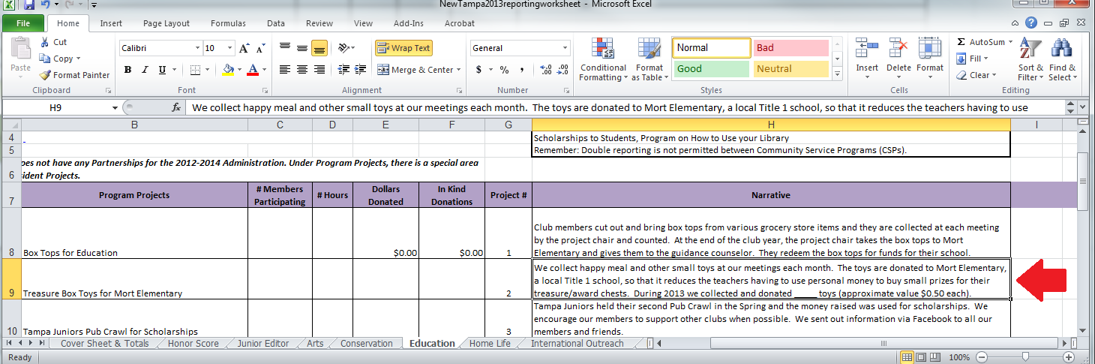

Instead, click within the cell and drag your mouse to highlight what you want to copy like the one below. Once it is highlighted you can right click and select copy or you can push Crtl+C to copy.
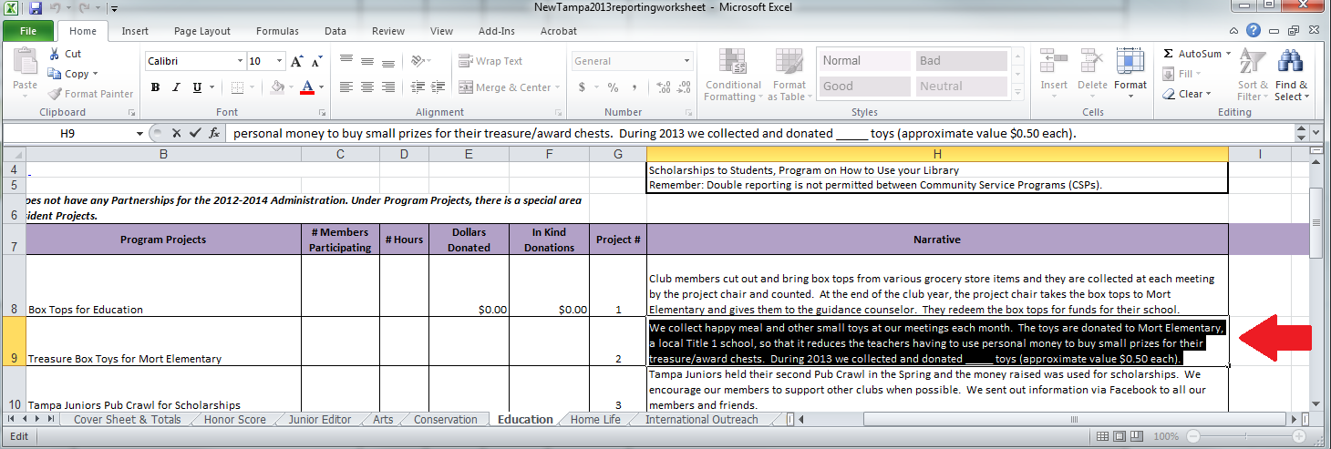
Then go to this year’s spreadsheet, click in the cell you want to put the info, and either right click and select paste or you can push Ctrl+V to paste.

If you follow these directions then you should be able to edit what you paste into the spreadsheet. In this example the text was changed from 2013 to 2017 and added in the members, hours and in-kind donations.
