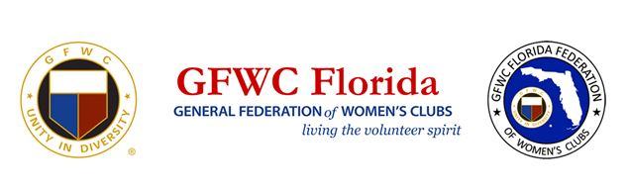

GFWC Florida Booster Contest
- To be eligible for an entry into the contest:
  - A Club must have a minimum of five (5) boosters between May 17, 2020 and May 1, 2022.
- Any category of paid booster will count.
  - That includes: Friends, spouses, GFWC FL Members, Fluffy, Fido and any other type of pet
  - Booster applications and payments must be received by GFWC FL HQ by May 1, 2022
  - Clubs will receive one (1) entry into the contest’s opportunity drawing for every five (5) paid boosters. Two winners of $250 each will be selected randomly at a live drawing at the GFWC Florida Annual Convention (May 20-23, 2022.)
  - Applications are available at the HQ table at Fall Board (September 24-26, 2021) and on the gfwcflorida.org website under Forms & Resources
  - So you’ll know your clubs starting point, the number of boosters per club from May 2020 - September 7, 2021 - will be posted on Florida’s website under Membership, Booster Contest.
Questions? Contact Terry Reese at secondvp@gfwcflorida.org

