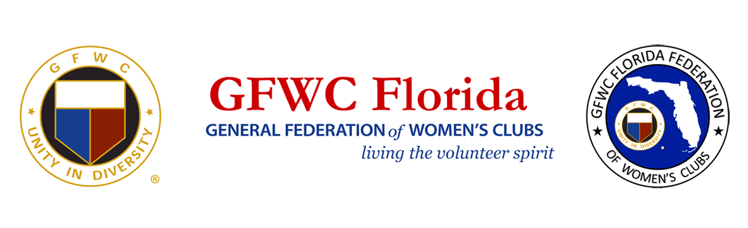
PRESS RELEASE
For Immediate Release
Inquiries
Karen Griggsby, GFWC Florida Media Relations
mediarelation@gfwcflorida.org
813-481-0419

Former Florida First Lady May Mann Jennings chosen as Top Ten nominee for Florida Women’s Hall of Fame

August 18, 2021, Lakeland, Florida – May Mann Jennings, former Florida First Lady and President of the Florida Federation of Women’s Clubs (1914-1917), has been chosen as at Top Ten nominee the Florida Women’s Hall of Fame. Her nomination is thanks in great part to the letters and emails from GFWC Florida clubwomen across the state. The women have now begun a letter writing campaign to encourage her selection by Governor DeSantis into the Florida Women’s Hall of Fame when he chooses three from the top 10 for induction in 2021.

May Mann Jennings (1872-1963) was one of Florida’s most influential women. An active member of civic and philanthropic organizations, she was a founding member Florida’s League of Women Voters in 1921. She served as assistant to her father, Austin Mann, when he served as state representative. As First Lady of Florida when her husband, William Sherman Jennings, served as Governor, she convinced the Florida legislature to create Royal Palm State Park in 1915. The park was operated by GFWC Florida until 1947 when it was donated as part of the Everglades National Park. Ms. Jennings championed causes for women’s suffrage, prohibition, better treatment of children and prisoners, education funding, historic preservation, Seminole Indian reservations, fence laws, and highway beautification. May Mann Jennings received a citation for “Mother of Florida’s Forestry” for her part in securing the legislative act that created what is known today as the Florida Forestry Service.
Women’s clubs throughout Florida have composed letters, emails, and cards showing support for the selection of May Mann Jennings. Clubwomen are also inviting the public to support their campaign. Correspondence to Governor DeSantis should be sent to:

Governor’s Appointments Office
The Capitol Building
Lower Level, Suite LL-10
Tallahassee, FL 32399-0001
Appointments@eog.myflorida.com

About GFWC Florida
GFWC Florida is a volunteer, non-profit 501(c)(3) organization comprised of 193 women’s clubs, junior women’s clubs and juniorette clubs across the state whose members are dedicated to community improvement by enhancing the lives of others in their local communities. Inclusive and unified in their diversity, the 8,400 members across the state attend to the needs of their communities through hands-on service projects, fundraising, education, leadership and friendship.

About the General Federation of Women’s Clubs
The General Federation of Women’s Clubs is a unifying force, bringing together local women’s clubs, with members dedicated to strengthening their communities and enhancing the lives of others through volunteer service. With over 80,000 members in affiliated clubs in every state and more than a dozen countries, GFWC members are community leaders who work locally to create global change by supporting the arts, preserving natural resources, advancing education, promoting healthy lifestyles, encouraging civic involvement, and working toward world peace and understanding.

******

