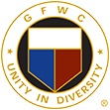

GFWC Florida
Marcia Bright
Woman’s Club to Juniorette Club
Federation Interaction Award

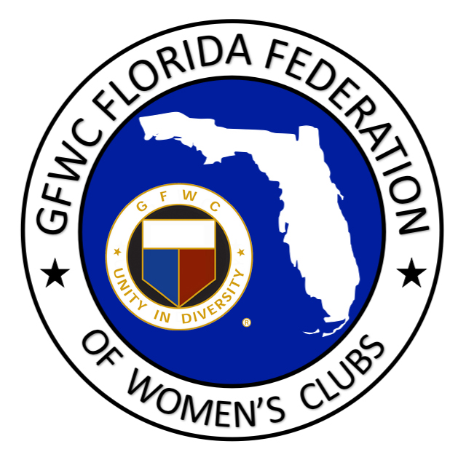

This award is named in honor of Marcia Bright, GFWC Florida President (1992-1994). This award recognizes outstanding federation interaction between a Woman’s and Juniorette club during the calendar year, January 1-December 31. Mrs. Bright’s commitment to the fostering of a relationship between a Woman’s and Juniorette club is the basis for this award.

WOMAN’S CLUB NAME: DISTRICT:

CONTACT PERSON: # OF MEMBERS:

PHONE: EMAIL:

JUNIORETTE CLUB NAME:

DISTRICT: # OF MEMBERS:

CRITERIA: The Woman’s and Juniorette club who desires to be considered for this award can
work together to complete this form, including the narrative in the box below, and e-mail it to the GFWC Florida Second Vice President AND GFWC Florida Juniorette Advisor. Two submissions are not necessary. The narrative should include the interaction that has taken place through club projects, programs and/or participation and support of one another. Also include how this interaction has strengthened relations, and recognition of the Federation within the community. Include any information you feel would be helpful in determining the award recipients. We are looking for activities that demonstrate your support of your Juniorette club and the Juniorette Program. Limit 2 pages, typed.
Please select SAVE AS and add your club name to the title of this document before submitting.

E-mail Nomination by February 1st to
GFWC Florida Second Vice President
secondvp@gfwcflorida.org
and
GFWC Florida Juniorette Advisory Committee Chairman
juniorettes@gfwcflorida.org

