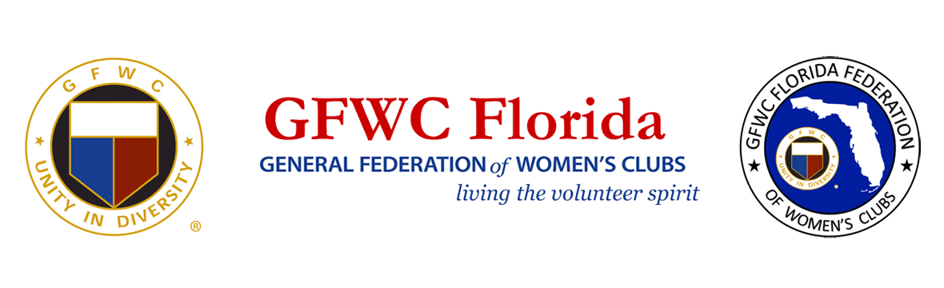
PRESS RELEASE
For Immediate Release

Inquiries:
Laura Connelly, GFWC Florida Communications
communications@gfwcflorida.org

General Federation of Women’s Clubs Provides Support for
First Responders and Families at Surfside, FL Condo Disaster

July 21, 2021 LAKELAND, FL – The motto of GFWC Florida President Dianne Foerster is, "Love, Respect and Kindness for all, under the GFWC Florida umbrella". The 7,500+ volunteer club women across the state had an opportunity to demonstrate their volunteer spirit during the past month as they came together to support the first responders working tirelessly at the condo collapse in Surfside, Florida.

Led by Elizabeth Fisher, a member of GFWC Miami Springs Woman's Club and state President's Project Chairmen, the GFWC volunteers sprang into action. Together they provided relief for 400 first responders and many anxious families.

Hydration and personal safety became a challenge for first responders working in wet, hot and humid conditions. The clubwomen delivered hundreds of neck gaiters, boot dryers, moisture-control socks, foot powder, blister relief items and t-shirts. They provided midnight meals, and returned daily with thousands of water bottles and snacks for first responders and anxious families waiting onsite.

The GFWC volunteers donated tents, tables, chairs and industrial fans, giving first responders an opportunity to replenish their strength during breaks. The store manager contributed two industrial fans when he learned where they were headed. These items will remain with the Miami-Dade Fire Department for future use. The clubwomen also provided kitchen items for 35 Surfside families who lost their homes and are moving into new permanent living quarters.

GFWC Florida President Dianne Foerster reflected on the actions of the GFWC volunteers during the past month. “I am grateful that GFWC Florida has made a small impact in the lives of so many during this tragedy. Thank you to all who helped GFWC Florida reach out to those who needed our hearts, our help, and our prayers”, said Foerster.

President’s Project Chairman Elizabeth Fisher also commented, saying, “GFWC Florida, your love and encouragement is so heartwarming. Thank you for showing love, respect and kindness to our first responders and our community during this incredibly difficult time.”

GFWC clubwomen across the country sent contributions to purchase the relief items. Donations are still gratefully being accepted. Checks can be designated for “Surfside Disaster Relief” and made payable to GFWC Florida, 4444 Florida National Drive, Lakeland, FL, 33813.

For information about the General Federation of Women’s Clubs, and how to contact a club near you, visit gfwcflorida.org.

******
About the General Federation of Women’s Clubs
The General Federation of Women’s Clubs is a unifying force, bringing together local women’s clubs, with members dedicated to strengthening their communities and enhancing the lives of others through volunteer service. With nearly 80,000 members in affiliated clubs in every state and more than a dozen countries, GFWC members are community leaders who work locally to create global change by supporting the arts, preserving natural resources, advancing education, promoting healthy lifestyles, encouraging civic involvement, and working toward world peace and understanding.

About GFWC Florida
GFWC Florida is a volunteer, non-profit 501(c)(3) organization comprised of 187 women’s clubs, junior women’s clubs and juniorette clubs across the state whose members are dedicated to community improvement by enhancing the lives of others in their local communities. Inclusive and unified in their diversity, the 7,500 members across the state attend to the needs of their communities through hands-on service projects, fundraising, education, leadership and friendship.

