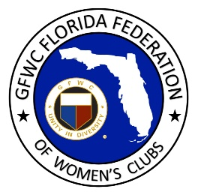
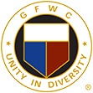
GFWC Florida
Women with Wisdom
Series

Veronica Fuchs, Northeast Miami Woman’s Club

Nominated by Helen Tarbatt, Northeast Miami Woman’s Club

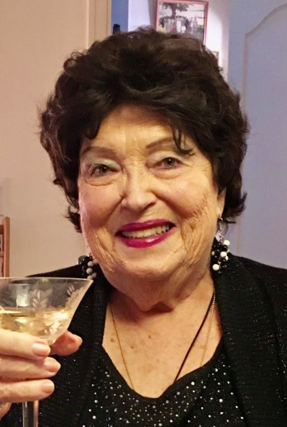

For Veronica Fuchs, her GFWC journey began in 1942 at the age of five when her musical mother brought Veronica and her siblings to sing, dance and perform shows at the clubhouse of Northeast Miami Woman’s Club, where her mother was Programs Chairman. Little did Veronica know she was performing in the club where she would someday serve as President.

Veronica remembers performing with her siblings in front of 200+ clubwomen. As the family grew, so did their performances. Eventually all eleven siblings were putting on shows at the clubhouse while their mother sang and played the piano. By age 17 Veronica and her brother won a trip around the world from a local radio station to sing for the armed forces.

Veronica’s father served as the first mayor of the village of nearby El Portal, where he helped the community ladies form a woman’s club which would later federate and become part of GFWC. Veronica’s mother and siblings also performed for the woman’s club in El Portal.

After obtaining a degree in music from University of Miami, Veronica’s dream was to be on Broadway. She got her start at a summer stock theater in Cleveland, Ohio, where the first person she met after traveling from Miami to Cleveland was Peter Fuchs. Peter was born in Germany, and as a holocaust survivor, he and his family moved to New York. He studied music at the Munich Conservatory before returning to New York where he performed in the winter, supplementing his income with summer theater performances. He went on to be an author, composer and orchestra conductor.

Peter and Veronica have been a married musical duo for 60 years, and much of that time has involved making and sharing music. Veronica did make it to Broadway, performing in 13 Daughters with Don Ameche and Make a Joyful Noise with Tommy Tune, and many other on- and off-Broadway performances over ten years. She recalls meeting Barbra Streisand during an audition. Although it wasn’t easy to work while raising a family, Veronica’s sister volunteered to serve as caregiver, allowing Veronica to travel and perform on the road. In 1968, Veronica and Peter decided to move to Miami and focus on family. They ran a travelling song and dance duet called “The Veronica and Peter Show” for 25 years, performing for the woman’s club and other groups.

Veronica was intrigued with the woman’s club and joined the same club her mother had belonged to, Northeast Miami Woman’s Club. She served as club President for ten years, and now serves as Vice President and Programs Chairman. Her son convinced her to learn Facebook Live, where her daily show, Grandmother Goose, is a hit with youngsters and their parents who are struggling to find quality content to entertain their children during COVID. She and Peter have turned their living room into a studio, complete with a green screen. They produce a daily Facebook Live musical event called “Stump the Maestro” as well as book reviews, online weekly trivia, What’s their secret? They’re having fun together, and that’s what counts!

Veronica has some advice for GFWC clubwomen. It’s up to us to develop our communities through volunteerism, and help them move forward. She never considered herself a leader, but she stepped outside her comfort zone, gave it a try, and learned new skills while serving others. At age 84, she continues to give to her community, and to serve as an inspiration for us all.

