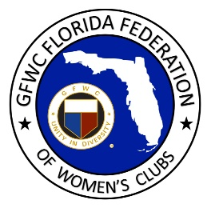
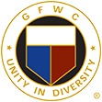
GFWC Florida
Women with Wisdom
Series

Sally Settle Barrow, GFWC Woman’s Club of Inverness

Nominated by Sandra Koonce, GFWC Woman’s Club of Inverness

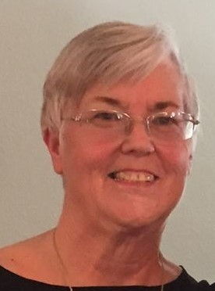

Sally Settle Barrow is a third generation GFWC club woman, published author and devoted special needs advocate. Born in a home in the muck lands of Lake Okeechobee, her heart was beating, but she was not breathing and it took the doctor 45 minutes to revive her. The outcome was a diagnosis of cerebral palsy.

There was little hope that Sally would speak or walk, but her parents never give up. Never accepting the term “disabled” to describe their daughter, they served as the catalyst that propelled Sally beyond her diagnosis. They gave her room to explore and taught her to be physically active just the same as other children. Sally did not require exceptional schooling and her peers treated her with respect and dignity, as if her disability did not exist.

Sally recalls being treated the same as everyone else and being unaware that she was any different. Her earliest indication that she was different came at age 11 when her mother took her to a speech therapist. After one visit, she never went back. Sally had periods where she struggled with bitterness over her differences from other children, but she never told anyone, not even her parents. She didn’t compare herself to others, she was just mad at herself.
Encouraged by her parents, Sally pursued her education and has lived a productive life. She earned a BA in Library Science and Humanities followed by a Master’s Degree in Library Science. She later obtained a certificate in Special Education and pursued a 36-year career in teaching.

Sally has learned to refer to CP as her constant companion. It motivated her to overcome challenges and bypass obstacles. When told she couldn’t do something, she was driven to accomplish the task, regardless of how long it took.

When she saw a TV evangelist whose birth experience resulted in Cerebral Palsy and his speech and tremors were more severe than hers, it changed her perspective on life. Sally observed how he was admired by other people in his church community.

Sally learned to become more comfortable with herself and was inspired to write a book! Her main character fell in love with the Everglades when visiting Miami after he returned from the Spanish American War in Cuba. This character was modeled after her doctor’s history and she dedicated her story to him. Published in 2003 and republished in 2007, the book is entitled In the Shadow of the Lone Cypress. The Lone Cypress is a real tree on the southwest corner of Lake Okeechobee and is two blocks away from where Sally was born in Moore Haven. Although the story is a historical novel, it is loosely based on her doctor’s life as she looked to him as a grandfather figure.

Since moving to Inverness when she retired 12 years ago, Sally joined GFWC Woman’s Club of Inverness where she has served as 1st Vice President and Program Chair for five years. Sally takes pride in organizing interesting programs and speakers on topics such as Special Olympics. Sally also served as club Historian for four years, was chosen as District 5 LEADS nominee in 2017, and her club’s Member of the Year in 2018.

Following in the footsteps of her mother and grandmother, both GFWC club women, Sally was raised in a family that valued community service. Sally served for twenty years as a Sunday school teacher; she set up three libraries in churches; served as the County Coordinator of Special Olympics for several years; has cataloged the books in the Old Citrus County Courthouse Historical Museum; and serves on the Heritage Council of Inverness; P.E.O.; as well as several other organizations.

Sally appreciates the opportunity for fellowship with her GFWC sisters, but her passion lies in the opportunity to honor her community by helping others. Sally is an inspirational role model to us all!

