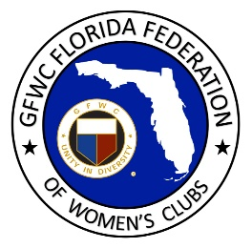
GFWC Florida
Women with Wisdom
Series

Norma Wood, GFWC Rotonda West Woman’s Club

Nominated by Kathryn Gallagher, GFWC Rotonda West Woman’s Club

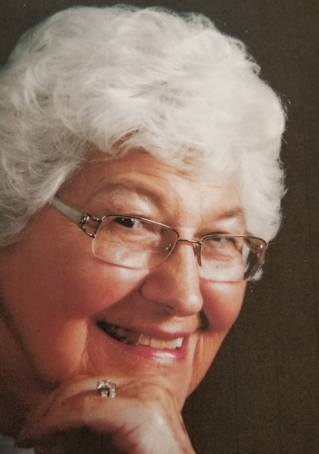

Norma Wood had a fascinating career as a civilian at Wright-Patterson Air Force Base near Dayton, OH. She served as the interface with community leaders, state and federal elected officials, distinguished guests including presidents, royalty, aviation heroes and entertainers; and was responsible for the many special arrangements that were required for each visitor.

At the time of her retirement Norma was Chief of Protocol for the Base Commander. She had previously served as Director of Arnold House Heritage Center, an historic landmark on the base which was the home of five-star General Henry H. “Hap” Arnold, the only five-star Air Force general. Built in 1840, the house was restored and converted to the period of the 1920’s when General Arnold was Base Commander. Norma took great pride in leading the renovation, and at the dedication she met not only General Arnold’s two sons, but also the niece and nephew of the Wright Brothers. Later, as Chief of Protocol, she made arrangements for the Base Commander to meet, greet and entertain dignitaries including Chuck Yeager and John Denver, whose father had been stationed at Wright Patterson.

One of her most interesting VIP visitors was the President of Senegal who stood 7’4” tall. This presented a problem because the Base Commander was only 6’4”. The AV department had a challenge when setting up the stage with microphones because of the difference in their height, and the constant adjustments required whenever either one of them approached the microphone! Each day was different, exciting, and full of interesting situations and Norma just loved going to work. One day on the base there was an emergency with a commercial airliner where they had to spray the runway with foam in case of fire during the emergency landing. The landing went off without a hitch with no damage to aircraft, and the passengers were all safe!

Norma’s various positions working on the base made her appreciate the sacrifices the armed forces made for our country. She is proud of her efforts and found great fulfillment in her work. Recalling an experience in 1973 at the end of the Vietnam War, Norma choked up as she described 30 prisoners of war returning from captivity to the base. Their family members were cordoned off where they could not be seen. Some of the returning soldiers had not seen their families for ten years. Norma will never forget the emotions that flowed when the families came from behind the curtain to reunite with their loved ones.

Her vision for the future of her club and GFWC Florida is to continue to give a part of herself as she gives back to her community, She is very proud to volunteer with such a wonderful group of women who are like family, and she enjoys their friendships and the volunteer work they do in their community.

Norma plans to continue working on club projects to support the local Food Bank, Alzheimer’s, a scholarship program and blood drives. Her top priority is educating our youth, and making a difference in their lives. She encourages all clubwomen to be themselves and be kind as they follow their passion to serve others.

We are so proud of Norma and her lifetime of service!

