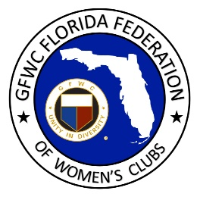
GFWC Florida
Women with Wisdom
Series

Laura Connelly, GFWC North Pinellas Woman’s Club

Nominated by Susan Luce, GFWC Clearwater Community Woman’s Club

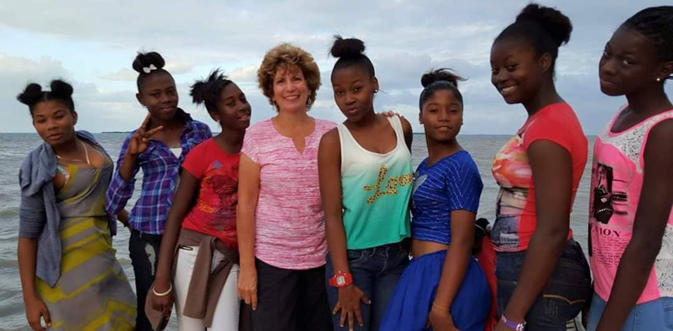

Laura Connelly was inspired by her parents who spent their lives volunteering and serving others. Throughout her young life and into adulthood, she followed her family’s commitment to volunteerism, filling her with the desire to reach out and serve. Laura has spent a lifetime mentoring and encouraging young women.

While she and her husband Bill were volunteering with Florida Sheriff’s Youth Ranch mentoring and tutoring teenagers, Laura became close to 15-year old Alexis, a young lady with a turbulent family life but lots of potential. After mentoring her for three years, Laura learned that Alexis would be relocated to a different Youth Ranch across the state due to a programming change. Alexis had finally adjusted to her new home and was doing well in school, and Bill and Laura couldn’t imagine her starting over again in a fourth high school. It was then that they opened their home, inviting Alexis to live with them for her senior year of high school. Eight years later, Alexis is part of their family. She went on to obtain a bachelor’s degree in education and master’s degree in social work, living with Bill and Laura during school breaks and over the summer. Bill walked her up the aisle when she got married, and Laura glows with pride when reflecting on the accomplishments of their “adopted” daughter. Alexis and Laura have designed many GFWC service projects for the young people at Florida Sheriff’s Youth Ranch as Alexis learns to live the volunteer spirit.

Laura’s “adopted” family also extends to the nation of Belize in Central America. Her first visit to Belize was in 2009 when she led a church mission trip there. She fell in love with the people and began visiting several times a year, leading service projects at a group foster home. After realizing the government only paid for students to attend school through 8th grade, Laura founded a non-profit, Belize Hope, in 2012. She recruited sponsors to help pay for promising students to attend high school, and recruited volunteers in Belize to help mentor the students. Her first recruit was Nilda Muschamp, a Belizean educator with a huge heart. Together Nilda and Laura ran Belize Hope for several years, but Laura felt the call to do more.

Laura founded a second non-profit, Fostering Success. She rented a home in Belize City and became foster mother to nine teenage girls who had previously been living in an extremely overcrowded group foster home. Laura moved to Belize in late 2014, bringing her dog and a promise from Bill to visit regularly. She hired two Belizean ladies to take turns living in the home with her to help honor Belizean cultural traditions for the girls. The girls blossomed in a stable home environment, learning values and life skills, doing homework and regular devotions. Laura’s goal was to raise them in a loving home and teach them to become self-sufficient.

Although Laura moved back to Florida at the end of 2015, she maintains regular communication with “her girls” and the Belize Hope students, visiting regularly and communicating often through Facebook messenger. Belize Hope was absorbed into PathLight and Laura became their Director of Operations, traveling to Belize for seven-ten days each month for the next three years to oversee the mentoring of 140 students and a teacher-training program before retiring in 2019. She has led countless mission trips to Belize, including several groups of GFWC clubwomen.

When Laura talked about GFWC to Nilda Muschamp, her first Belize Hope volunteer, the two hatched a plan to start a GFWC club in Belize. A few short months later, Nilda was the first President of GFWC Belmopan Women’s Club, and together they helped found GFWC Belize City Women’s Club and two Juniorette clubs. Many of the Juniorettes are part of PathLight’s high school sponsorship program!

Just before COVID shut everything down in March 2020, Laura returned to Belize with a group of GFWC Florida women. She hopes others may want to visit Belize with her when it’s safe to return. The 2020 group will be holding a Zoom reunion to celebrate International Women’s Day on March 8.

Belize will always be Laura’s second home. She treasures her relationship with her Belizean daughters, and loves being Nana and godmother to four Belizean children. Serving as an international missionary and volunteer has changed her life forever, and it shaped the lens through which she views the world.

Laura describes the incredible feeling when you think you are going to serve others, and you realize that they are making as much of an impact on your life as you are on theirs. She encourages GFWC club women to open their hearts and really get to know the people we are serving so that all our lives can be forever changed.

