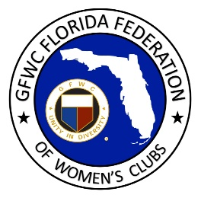
GFWC Florida
Women with Wisdom
Series

Joyce Johnston
GFWC Temple Terrace Woman’s Club and
GFWC Temple Terrace Junior Woman’s Club

Nominated by Anita Long, GFWC Temple Terrace Woman’s Club

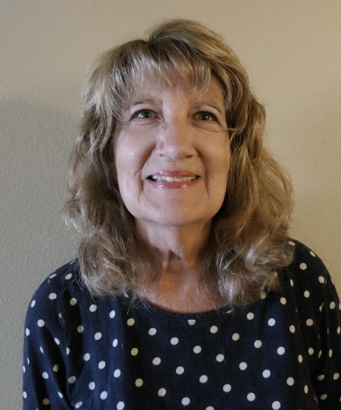

Joyce Johnston has spent a lifetime mentoring young ladies. A social worker with a passion for community service, Joyce was invited to a GFWC Temple Terrace Junior Woman’s Club meeting by her neighbor 41 years ago. She liked the dedication the club had for community service and the friendship among members.

A dual member of GFWC Temple Terrace Woman’s Club, Joyce discovered she really enjoyed working with the GFWC Temple Terrace Juniorettes. She has served as a Juniorette advisor for twenty-five years and has made a difference in many young lives. In addition to helping them develop a love for volunteering, Joyce teaches them life skills including commitment, organization and follow-through. She helps them develop the confidence to have open and frank one-on-one conversations with adults. She encourages them to celebrate each other rather than tear each other down.

As Juniorette advisor, Joyce builds close relationships with the girls, and they don’t end at high school graduation. Joyce is proud that she has attended graduations, weddings and new baby celebrations. She takes great delight in seeing her Juniorettes develop into independent young ladies who are not afraid to step up and become club and community leaders. Many of the Juniorettes consider her a second mother, affectionately calling her “Mrs. J”. Joyce speaks with tremendous pride about her three granddaughters who are now Juniorettes. Her commitment to fostering a relationship between junior and Juniorette clubs has led to an annual GFWC Florida award in her honor.

Joyce is also an active and dedicated member of her clubs, and she also serves as Vice President of GFWC Southern Region. She finds tremendous gratification in serving as a club woman. She also serves as financial advisor at her church.

Going forward Joyce would like to see more diversity within GFWC. She encourages us to be aware of the diversity in our own communities and work to ensure club membership is available for everyone. She encourages all clubwomen to have the confidence to accept a leadership role, and to mentor new members who may need some encouragement or assistance in learning about all that GFWC has to offer.

Joyce is grateful for the technology our club women have learned to embrace during the pandemic, and believes it is here to stay. She commends us for exploring and learning alternative ways to communicate and believes this will be a lasting change.

Joyce speaks with great pride about GFWC Florida, with our progressive approach and strong leadership that allow us to serve as a benchmark for other states.

Joyce, you are the consummate club woman. We are proud to know you and have you represent us!

