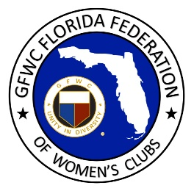
GFWC Florida
Women with Wisdom
Series

Jossie Azorin, GFWC Woman’s Club of Plant City

Nominated by Patricia Wolff, GFWC Woman’s Club of Plant City

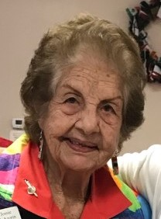

We celebrate Jossie Azorin and her 57 years of federated service to her community! Born in Cuba, Jossie’s first trip to the U.S. was a vacation with her husband in 1958. On their next visit they stayed for a month or two, admiring the culture and dreaming of a life in the United States. Little did they know that dream would soon become a reality.

The revolution in Cuba began when Fidel Castro came into power December 31, 1959. Jossie, her husband and his brothers had built a successful brick manufacturing business, and their life was very comfortable. In October of 1960 the Castro regime took possession of everything they owned including their home, several of their businesses, beachfront properties, subdivisions, and three condominiums.

On November 1, 1960, Jossie and her husband escaped from Cuba and moved to Miami. They later moved to Georgia to run a brick manufacturing company for two years before relocating to Plant City in 1963. Jossie and the Azorin family connected with friends in Tampa to start a brick and clay business in a new industrial park. Florida Brick and Clay has grown into a highly successful business, now run by the 2nd generation Azorin family.

Jossie is a well-known and highly respected fourth generation artist who was educated in the arts in Cuba. She has been painting for more than 70 years. Landscapes and still life are her favorite subject matter, and she draws inspiration from the places she visits. Her colorful flowers have found their way into many celebrity auctions and other local causes.

Jossie became a U.S. citizen in 1971. Fueled by a desire to help women and children, Jossie taught art in the schools for 38 years. In addition to learning art, Jossie’s students learned about life. She taught them to take pride in their work and in themselves. Her students learned to be good citizens, love their country, and respect their community’s laws. Jossie has found much gratification and inspiration in seeing her students grow up and become successful.

Jossie joined GFWC Woman’s Club of Plant City in 1964 and still remains an active and productive member. A good friend from church invited her to a club meeting, where she greatly admired the club’s involvement in community service work. She has also enjoyed the camaraderie and friendships with her club sisters. One of the things she most enjoys about being a club woman is painting beautiful, colorful outdoor canvases for door prizes to be given away at club events. Her paintings also adorn the walls in her club house, creating a warm, peaceful, loving atmosphere.

Jossie’s life experience showed her the importance of giving back and making a difference in the lives of others. She serves her community however she can and strongly believes in always being kind to others.

In addition to GFWC, Jossie serves as President of the Plant City Garden Club, past President of the Woman’s Guild of St. Clement’s Catholic Church, member of the Business and Professional Woman’s Club where she received the “Woman of Achievement Award,” founder of the Plant City Art Guild, and the Girl Scouts.

Jossie’s advice for GFWC Florida clubwomen is unity. She advises us to work together with our club sisters, believing that unity will help the club triumph no matter what obstacles may confront them. She encourages club women to not be afraid to bring new ideas forward, always work hard, make sacrifices where needed, be proud of your work, and let your faith guide you.

That advice has certainly served Jossie well for the past 57 years as a GFWC club woman. Jossie, you are a blessing to us all. We thank you for making a difference in the lives of so many!

