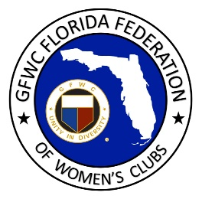
GFWC Florida
Women with Wisdom
Series

Jo Paladini, GFWC Palm Beach Gardens Woman’s Club

Nominated by Karen Kraatz, GFWC Palm Beach Gardens Woman’s Club

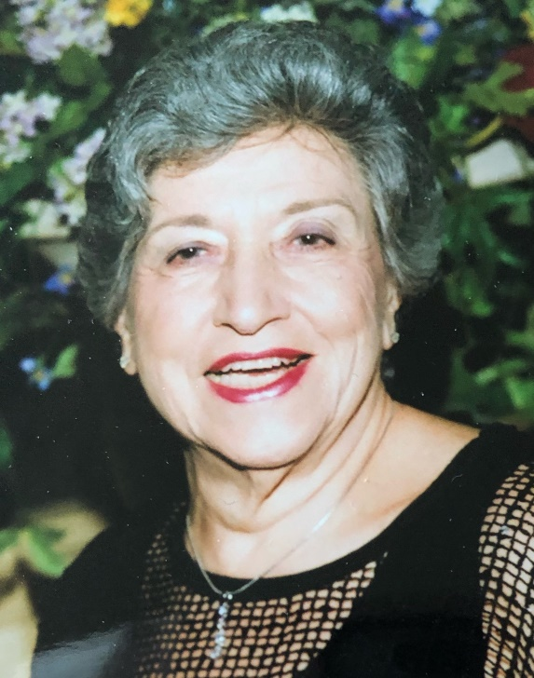

What does 65 years of federated service look like? It looks like Jo Paladini from GFWC Palm Beach Gardens Woman’s Club!

Jo joined GFWC Junior Woman’s Club of Paterson, NJ at the age of 24. As club President, she took that club to a top five ranking in the state of New Jersey for three years in a row. By age 30 she had moved to Franklin Lakes and joined GFWC Franklin Lakes Woman’s Club, where she happily volunteered for 20+ years until she and her husband relocated to Florida.

Out of state relocation – what’s at the top of your checklist? Connect with the closest GFWC club! Jo immediately joined GFWC Palm Beach Gardens Woman’s Club in 1982 and before she was unpacked, she was named Corresponding Secretary. Over the past 39 years Jo has been a passionate volunteer, serving her club, district and the Florida federation in many roles. While serving as District 10 Director, she helped found three new clubs. She was LEADS Vice-Chairman with Ann James, and a GFWC Florida Past President’s Hostess. She’s been an ESO member since 2001 and earned the Ninth Century Award.

After attending New York University for accounting and then marrying in 1954, she went to work in a CPA firm doing audits and tax returns, and then ran an accounting department at a Florida retirement and nursing home community. Her club appreciates Jo’s financial knowledge, tapping her to serve as Finance Chair, Parliamentarian and now Treasurer. She has also served as district liaison to her community’s VA Medical Center, where she communicated their needs to area clubs. A local hospital gratefully accepted her services as volunteer receptionist; she served as usher at a theater, and helped her club obtain 501c3 status.

Jo was married for 40 years before her husband died 26 years ago. Having seen first-hand the devastating consequences of Alzheimer’s, she facilitated a caregivers group for several years after his death. She speaks so proudly of her three children, six grandchildren and her first great-grandchild on the way! Having traveled much of the world, she still hopes to get to Africa on a safari.

Her advice for GFWC Florida clubwomen? Remember to have fun while you serve, and make serving others through GFWC your passion. That passion has certainly propelled Jo into a lifetime of community service and volunteerism. Thank you for being such a wonderful role model for the generations who come behind you, Jo!

