GFWC Goebel Figurines
Information from GFWC Women’s History & Resource Center
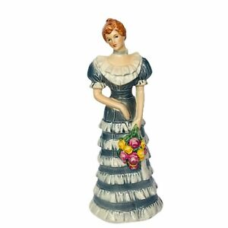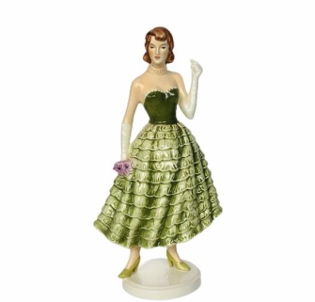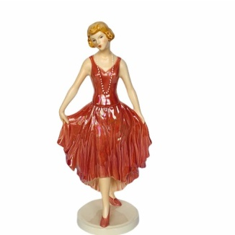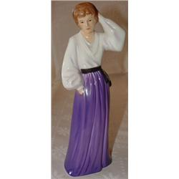

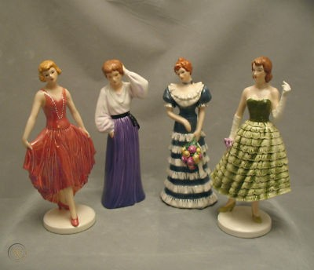

Series of four Goebel figurines depicting women’s costumes from each quarter century of GFWC existence, 1890-1990. The first figurine was issued in the 1982-1984 administration of Juanita Martin Bryant represents circa 1890-1914; the second edition represents circa 1915-1939 was issued in Jeri J. Winger’s administration, 1984-1986; third edition represents circa 1940-1964 was issued during Phyllis Vreeland Roberts’s administration, 1986-1988; fourth edition represents 1965—1990 and was issued during Alice Clark Donahue’s administration. Limited numbers were produced and the mold for each figurine was broken at the end of each administration.

