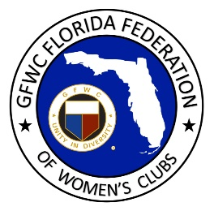
GFWC Florida
Women with Wisdom
Series

Esther Horne, GFWC Madison Woman’s Club

Nominated by Hunaid Qadir

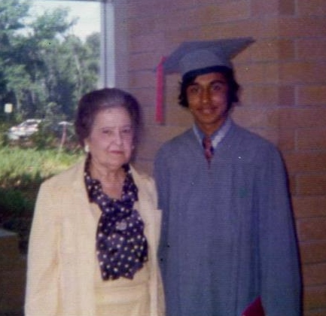

GFWC clubwomen understand the importance of volunteerism, but how often do we ponder its long-term effects? Are we making an impact on future generations? Will our passion for serving others be part of our legacy?

Mrs. Esther Horne, GFWC Florida President (1950-1952), would probably be pleased to know that she did exactly that. Late last year our GFWC Florida webmaster was contacted by a gentleman asking for information about Mrs. Horne, and the story that unraveled is a fascinating one.

Mr. Hunaid Qadir was a young international student with big dreams. Growing up in Pakistan in the 1960’s watching I Love Lucy and John Wayne movies, and attending a British missionary-run high school and learning to speak English, he frequently visited the U.S. Embassy as a teenager to read the New York Times and dream of life in America. It was there he found information on how to apply to American colleges and decided it was time to pursue his dreams. Preferring a small town in a warm climate where he could fully immerse himself in the local culture, Hunaid chose North Florida Junior College (now North Florida Community College) in Madison, Florida.
Eager with anticipation, Hunaid made the long journey from Pakistan to Madison in 1973 with $1000 USD in his pocket. Although he came from a comfortably middle-class family, this was an enormous sum of money in Pakistani rupees. It was his parents’ farewell gift to him because they knew that he was unlikely to return to Pakistan.

Madison was a small rural town with a population of 3,500 and only three traffic lights, located just south of the Florida-Georgia line. Following an exhausting series of flights that took him from Karachi, Pakistan to Tallahassee, his final leg of the journey was a bus ride to Madison. Arriving at the Madison bus terminal, Hunaid experienced the warmth of being in a small community when he was met by the Assistant Director of Admissions from the college. He was initially put up at a motel for students as he explored more permanent housing options. Hunaid preferred an off-campus apartment over a student dorm because it would allow him to more fully experience American life. When he eventually moved into an apartment complex owned by Esther Horne, he had no idea of the impact this would have on his life.

Mrs. Horne was the widow of Raeburn Horne, a well-known politician in north Florida who had served in the Florida House of Representatives and Florida Senate. She was unfailingly supportive of her husband’s political career even though it kept him in Tallahassee for long periods of time. She was asked to regularly entertain the governor, legislators and other society bigwigs in their beautiful Victorian style home. As a highly educated woman, however, Esther Horne was not one to define herself merely as a political spouse. She became active in the GFWC Madison Woman’s Club and rose to its leadership ranks.

After Raeburn Horne died in 1962 (long before Hunaid’s arrival in Madison) Esther Horne additionally took on the management of a small local finance company and an apartment complex. When Hunaid arrived in Madison, she was a very active 78-year old, working, involved with GFWC Madison Woman’s Club and serving on the boards of Florida 1st National Bank, the Hospital and the Garden Club.

The first few months of apartment living were challenging for Hunaid. His roommate had recently been released from prison for a drug offense and his late-night partying made it impossible for Hunaid to stay focused. When Hunaid mentioned this to Esther Horne, she generously invited him to become a boarder in a guest bedroom in her home. Thus began an unlikely yet close relationship.

In the following months, Esther Horne introduced Hunaid to the norms and behaviors of Southern society, and Hunaid helped Esther learn about day to day chores and errands. Not surprisingly, she came to regard Hunaid as the son she never had, and he, in turn, considered her as his adopted foster mother.

Hunaid shared a number of entertaining stories about Mrs. Horne and their time together. One of Mrs. Horne’s greatest fears was losing her driver’s license. Hunaid chuckled as he remembered how she changed her birth date on her license renewal form to avoid questions about her ability to drive! Her fear was understandable because Hunaid could see that Mrs. Horne was a terrible driver. So when he was not at school, he volunteered to be her chauffeur and drove her around in her Pontiac Bonneville. In this way, her world became his world.

They would go to the Wednesday night meetings at the Madison Woman’s Club, with Hunaid stopping in and socializing with the ladies for a while. He knew all the club members and heard all about their service projects for charity and their knitting. They attended events at her Country Club and services at the Methodist church. Hunaid also met Mrs. Horne’s nephew Mallory Horne who was the President of Florida Senate and took Hunaid as his guest to the legislature. Over time, Mrs. Horne’s friends became Hunaid’s friends and her family members became a part of his extended family.

When Hunaid graduated from North Florida Junior College with his Associate’s degree, he transferred to Florida State for his Bachelor’s degree just so he could be close to Esther Horne. He regularly returned to Madison on weekends and holidays for the next three years until his graduation from FSU. Hunaid would go on to earn a master’s degree from University of Miami, and then move to Atlanta to work for Hewlett Packard. Yet he continued to travel to Madison on holidays and spent Thanksgiving, Christmas and Easter with Mrs. Horne until her death in 1987 at the age of 92.

Today, Hunaid is semi-retired and lives with his wife in Athens, GA. The lessons he learned from Mrs. Horne about the importance of civic service and volunteerism continue to shape his life. Since moving to Athens, he has served on numerous civic associations and citizen committees and commissions. He is currently a member of the Athens-Clarke County Board of Elections.

After receiving a copy of GFWC Florida’s historical book, Lighting the Way, Hunaid was overcome with emotion. He read Chapter 9 with great pride as he realized the impact his foster mother had on clubwomen across the state during her term as GFWC Florida President, 1950-1952.

Hunaid described Esther Horne as a remarkably engaged woman who gave him unconditional love during a time when the south was still not fully integrated. He is convinced that it was her involvement with GFWC was responsible for her broad view of the world beyond small-town Madison. He believes it was GFWC and its focus on service work that gave her the courage to invite an international student into her home – something which changed his life.

To this day, Hunaid remains in touch with Melvin and Ann Horne who live in Cairo, GA and often visiting them whenever he travels to Florida to meet with college friends. On these trips, he unfailingly makes a detour to stop at Jasper so that he can lay flowers on Mrs. Horne’s gravesite. Once it is safe to travel, Hunaid looks forward to also visiting GFWC Florida headquarters in Lakeland to honor the memory of this trailblazer GFWC leader, his foster mother, Mrs. Esther Horne of Madison, Florida.

