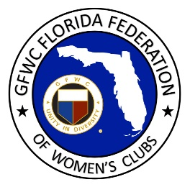
GFWC Florida
Women with Wisdom
Series

Doris Karlik, GFWC Palm Beach Gardens Woman’s Club
Nominated by Carol Renick, GFWC Palm Beach Gardens Woman’s Club
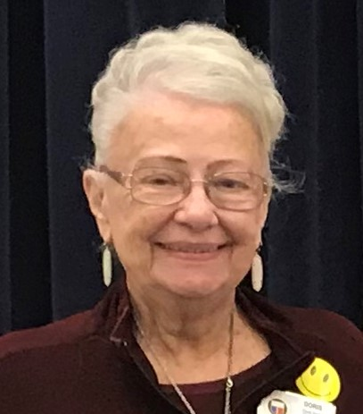
2021 is a year of celebration for Doris Karlik. She turns 90 on March 31 and she is also celebrating 50 years of federated service! A member of GFWC Palm Beach Gardens Woman’s Club, Doris was invited to attend a club meeting in 1971 by two neighbors, just a month after moving to Florida from Arizona. She has been a lifelong volunteer and contributes her stamina to staying busy and serving others.

Doris has served her club, district and state federation in many roles over the past 50 years. She served as District 10 President Project Chairman for Heifer International, and then District 10 General Director 1992-1994. Together with Junior District 10 Director Suzanne Valentage they formed four new clubs – two general, one junior and one Juniorette club. They received an award from GFWC, acknowledging them as the best district in the country! From 1996-2000 she served as GFWC Florida Awards Chairman, Conservation Chairman and Bylaws Committee member. Doris has been recognized as Outstanding Juniorette Advisor and one of the Top 100 Members in Florida.

The American Association of University Women (AAUW) has given Doris an opportunity to influence many lives during her 57 years as a member. Doris served as Corresponding Secretary and then Treasurer for the Scottsdale, AZ AAUW branch before moving to Florida. After serving as President of AAUW’s Northern Palm Beach County from 1996-1999, the group named their local scholarship program in her honor. 59 residents of Palm Beach County have received Doris Karlik Local Scholarship Awards ranging from $500 to $1,000 to help them complete their college educations; a total of over $60,000 in scholarships. Doris also served as state AAUW Vice President of Membership.
Doris is a woman of deep faith, and the highlight of her life has been serving as President of the Southeastern District of American Lutheran Church Women (ALCW), which includes six states and the Bahamas. A teacher by profession, Doris taught 5th grade for six years and 2nd grade for one year before relocating to Florida to become a substitute teacher for the Benjamin School.

Volunteering with GFWC Palm Beach Gardens Woman’s Club has made Doris more aware of what the community needs and given her a chance to make a lot of federation friends. She has shared knowledge between the various organizations with whom she serves.

Doris recalls District Director as one of her favorite federation roles. She enjoys getting to know new members, making sure they get involved and helping them find their niche. She encourages clubs to reach out to women moving into their community and let them know how wonderful it feels to serve the community with GFWC club sisters.

Doris credits GFWC Florida with working hard to ensure resources are readily available to all members. She encourages all GFWC Florida clubwomen to get involved, be concerned about your fellow members, check up on members to see how they are doing when you don’t see them at a meeting, and plan opportunities to get to know each other! She reminds us that members need to stay involved to be part of the group. With these personal touches, Doris believes membership will continue to grow.

Thank you for sharing your story with us, and for your 50 years of federated service!

