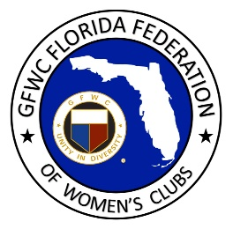
GFWC Florida
Women with Wisdom
Series

Frances “Dolly” Macintyre, The Miami Woman’s Club
Nominated by Shirley Pardon. The Miami Woman’s Club
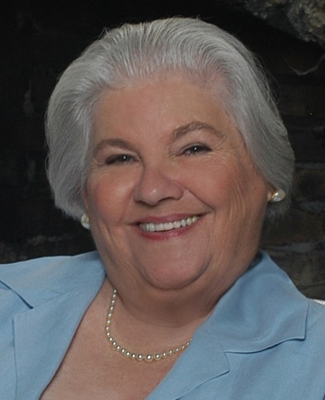
Frances “Dolly” Macintyre has spent a lifetime committed to historic preservation. The daughter of a career naval officer, she had a nomadic childhood, moving as often as four times a year so she and her mother could be with her father. In 1940, her father was transferred to Hawaii. Five days before the attack on Pearl Harbor he sent his family back to the mainland, a decision that likely altered the course of Dolly’s life.

Without ties to a hometown, Dolly settled in Miami in 1957 after attending college at University of Miami. In 1966 she became a charter member of The Villagers, a group formed to aid in the preservation of the historic Douglas Entrance, a structure originally built in the 1920’s as the main entrance into Coral Gables. This beautiful entrance was scheduled to be demolished to make way for a supermarket. Successful in their efforts to preserve the Douglas Entrance, the entrance was restored and The Villagers expanded their efforts to fundraising for historic properties and scholarships in the preservation field. Dolly is still an active Villager member, currently serving as Chair of the Saving Places Committee.

In 1972 Dolly was instrumental in founding Dade Heritage Trust (DHT), a group that works to preserve Miami-Dade County’s architectural, environmental and cultural heritage through education and advocacy. She served as the group’s first President and now serves as Secretary. She was awarded the Henrietta Harris Award in 2003, DHT’s highest award for service to the preservation community. To honor her many contributions, Dade Heritage Trust has established the Dolly Macintyre Resiliency Award that is awarded annually to an advocate for historic preservation.

Dolly served as a founding member of the Florida Trust for Historic Preservation, and received their Distinguished Service award. In 2012, she was awarded the Mary Call Darby Collins Award by Florida’s Department of State “in recognition of dedication and volunteer action that has forever changed the course of historic preservation in Florida.” It is the state’s highest honor in the field of historic preservation.

It was her passion for historic preservation that drew Dolly to join The Woman’s Club of Coconut Grove in 2000 and The Miami Woman’s Club in 2004. Both clubs needed to revitalize their historic clubhouses and their aging membership, and Dolly remains a member of both clubs. She brought her vast knowledge of historic preservation to both clubs, joining other members to help plan and find funding for preserving their clubhouses.

Dolly served as Secretary for The Miami Woman’s Club for several years, and President of The Woman’s Club of Coconut Grove from 2002-2004. In 2006, Dolly served as President of The Dade County Federation of Women’s Clubs, an alliance of women’s clubs in Miami-Dade County.

Dolly’s love of history and historic building preservation has connected her with like-minded volunteers. Although she joined both GFWC clubs to help preserve their historic buildings, she has been delighted with the unexpected bonus of fellowship. She has truly enjoyed the time spent working with club members on causes for which they all share a passion, and has delighted in watching her club’s membership steadily grow, along with their broadening support of community projects.

Dolly encourages GFWC clubs to pool their resources and work together to make their vision a reality. Her advice to all of us is to make friends with your club sisters, which will lead to a more enjoyable membership experience and better productivity in serving your community.

A proud parent, grandmother and great-grandmother, Dolly treasures the opportunity to spend quality time with her family every Sunday night via Zoom where they share and discuss poetry each has written during the week.

Dolly, thank you for inspiring us with your love of historic preservation and your many accomplishments as a renowned preservationist!

