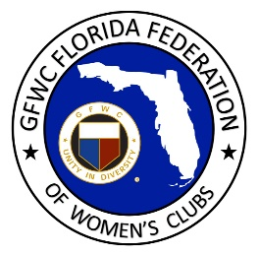
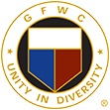
GFWC Florida
Women with Wisdom
Series

Catherine (Cissy) Wyninegar
GFWC Fort Walton Beach Woman’s Club
Nominated by Marianne Magnum, GFWC Fort Walton Beach Woman’s Club
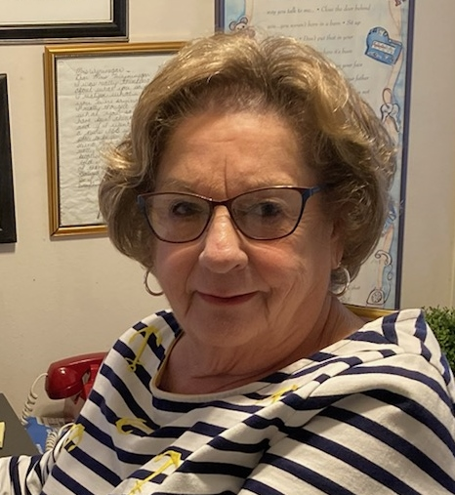

With the ratification of the 19th Amendment to empower them, about a dozen young women formed the GFWC Camp Walton Woman’s Club in 1921 with a lofty goal of improving the quality of life in their community. Among them were the great-aunts of Catherine (Cissy) Wyninegar, Agnes Gerlach and Josie Gerlach, and Cissy’s young mother, 18-year old Agnes Staff.

GFWC has always been part of Cissy’s life. She recalls her mom and great-aunts joining other clubwomen to chase wild cows and pigs off the streets, and erecting fences to beautify the community. The ladies helped build the first library, school and medical facility, and provided hot lunches to children who needed them. Agnes Gerlach’s report to GFWC Florida is included in the preface of Leading the Way, a book about GFWC Florida’s history. She recalls her mom dressing in hat and gloves to attend bi-monthly woman’s club meetings, and the book drive to start the library.

Cissy moved away from Ft. Walton Beach to pursue her education, obtaining a degree in Business from Florida State University. She began her career as a high school teacher. She is married to Noble Wyninegar, and as an Air Force family with four children, they lived all over the country. Cissy obtained a Masters degree in Public Administration, another in Educational Leadership, and became an accomplished teacher and administrator. She was honored with Teacher of the Year on two occasions.

When retirement brought Cissy and Noble back to Ft. Walton Beach, Cissy was delighted to join GFWC Ft. Walton Beach Woman’s Club where she has served in many leadership roles including club President. She is currently in her second term as District Director. Cissy played an instrumental role in her club’s Community Improvement Program entries and GFWC Ft. Walton Beach won first place and fifth place nationally for the Bud & Dorie Day Patriot’s Trail in 2016; and first place in 2020 with their Safe, Secure and Successful S3 Project (2020) serving homeless students in area schools.

GFWC Ft. Walton Beach Woman’s Club is still the backbone of service in their community as they prepare to celebrate their centennial year, and Cissy is filled with pride as she recalls the impact it has had on her life and the lives of her mother and great-aunts.

Her vision for the future of the clubwomen of GFWC Florida? She encourages visibility in the community with projects that carry the Woman’s Club name. With our strong history of hard-working clubwomen who came before us to make their communities a better place to live, it’s our turn to keep it going.

