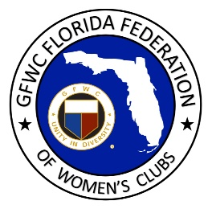
GFWC Florida
Women with Wisdom
Series

Alice von Suskil
Miami Springs Woman’s Club and
GFWC Woman’s Club of Hialeah

Nominated by Juanita Palazzolo, Miami Springs Woman’s Club

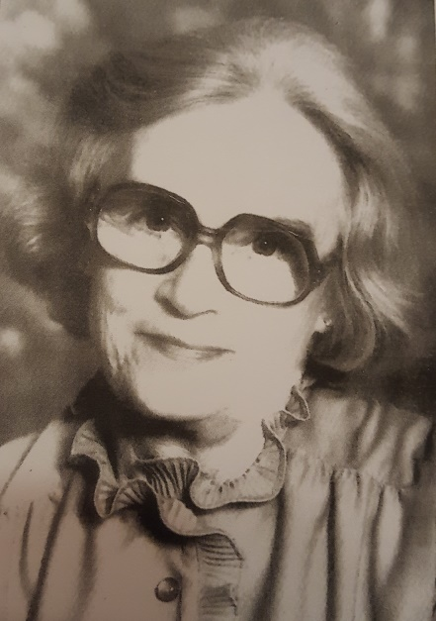

Alice von Suskil was an environmentalist long before it was popular. A native of New Jersey, she moved to Miami Springs in 1950 where she joined GFWC Woman’s Club of Hialeah and then Miami Springs Woman’s Club and served as President of both clubs.

Consistently described by those who remember her as a vivacious leader, one you want to follow, Alice was passionate about many things, but none more so than the environment. She was a trailblazer in many ways, bringing attention to causes that were not yet front and center in the public eye.

Long before anyone was recycling, Alice brought a recycling program to the Miami Springs clubhouse. She had large oil drums placed behind the clubhouse and labeled them appropriately for newspapers, clear glass, green glass, and so on. By the time the materials were ready to be picked up, Alice and the club members had to arrange special trucks to come and haul away 32 tons to be recycled!

In 1990 she joined two other forward-thinking residents to form a non-profit called “Save Our Water”. While in her 70’s she served on the Environmental Board and Ecology Board for the City of Miami Springs, working to tackle pollution, reduce CO2, and other environmental challenges. Alice initiated a Cancer Walk in Miami Springs in the early 90’s, long before Relay for Life came to Miami, and she was instrumental in starting the America Cancer Society Hope Lodge at Jackson Memorial Hospital in Miami.

As President of Miami Springs Woman’s Club, Alice was a natural leader who excelled at developing future leaders. Serving as liaison to Miami Springs Junior Woman’s Club, Alice helped the club push for organ donor information on Florida drivers licenses. Together with her daughter, a member of the Junior Woman’s Club, Alice participated in many of the junior club activities and mentored their future leaders.

Alice was a gifted mentor. She is consistently described as someone who motivated and inspired others to get involved, and to step forward and lead. Members remember how she made them feel good about volunteering, and about raising their hand to accept a leadership role.

Although she died in 2002, Alice’s presence is still very much felt in the Miami Springs Woman’s Club and by those who continue to devote themselves to protecting the environment in South Florida.

