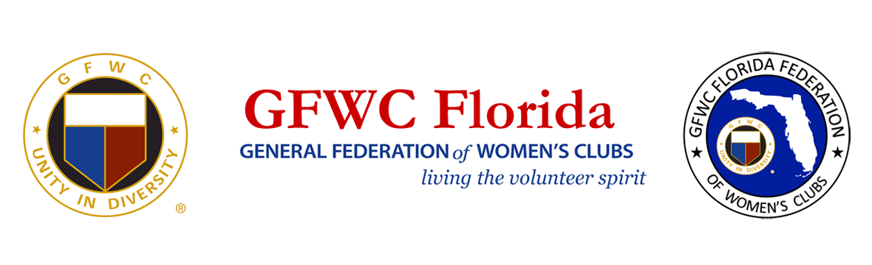
PRESS RELEASE
For Immediate Release

Inquiries:
Laura Connelly, GFWC Florida Communications
communications@gfwcflorida.org

GFWC Florida Celebrates Black History Month
February 1, 2021 LAKELAND, FL – GFWC Florida (www.gfwcflorida.org) will celebrate Black History Month by featuring the achievements of several of our Black clubwomen across the state on social media. Metris Batts-Coley, a member of The Miami Woman’s Club, has served in several GFWC leadership roles. She’s a member of Zeta Phi Beta Sorority, Inc. and the GFWC Florida Diversity Initiative Team. Metris met former First Lady Michelle Obama at the White House when she was advocating for mothers of murdered children. She loves to connect people, and she’s an advocate for fairness and equity. Metris operates a hotel that was converted into a quarantine and isolation shelter for the homeless, and she also consults for small nonprofits. She and her family adopted a village in Ghana and she helps women in Kenya sell jewelry to provide for their families. As one of her club’s first African American board members, Metris loves being a trailblazer, helping them break out of their comfort zone.
Several other Black GFWC Florida leaders will be featured during the month on GFWC Florida social media.
