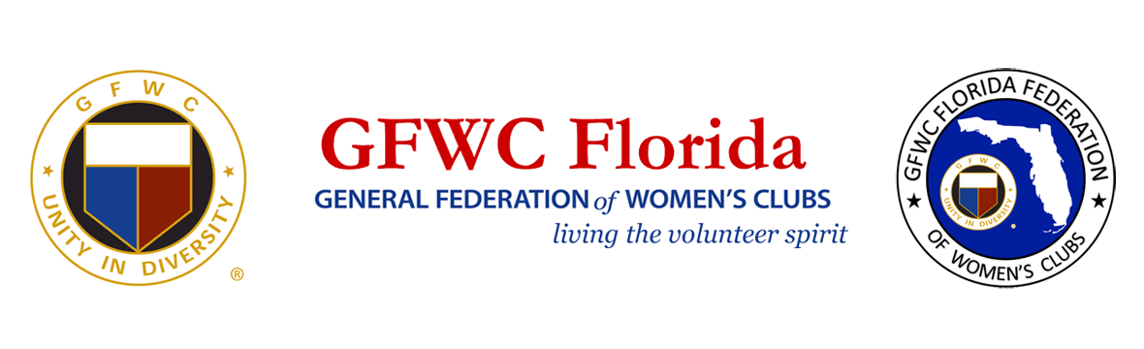
PRESS RELEASE
For Immediate Release

Inquiries:
Laura Connelly, GFWC Florida Communications
communications@gfwcflorida.org

GFWC Florida Celebrates International Persons with Disabilities Day

December 3, 2020 LAKELAND, FL – In the midst of COVID-19, the 8,400 volunteer clubwomen of GFWC Florida (www.gfwcflorida.org) are honoring their President’s theme, promoting unity in diversity under the GFWC Florida umbrella with love, respect and kindness for all. GFWC Florida President Dianne Foerster encouraged clubs to seek out those in their own communities who need help and support, with an emphasis on special needs and special abilities.
Since May, clubs have taken action, designing and participating in 381 President’s projects. Special needs classrooms such as serving those with autism have received supplies, funding, and encouraging gifts for teachers and staff working so hard in these unusual times. Scholarships and donations have flooded the state to support the efforts of the special needs community, Veterans, and those who are physically mentally or emotionally in need. Front line health care workers and first responders have received notes and gifts of encouragement and energizing meals, and front line wildlife rescue teams received supplies to continue to help winged and furry friends.
Projects to support special needs and special abilities will continue through May 2022.

******

