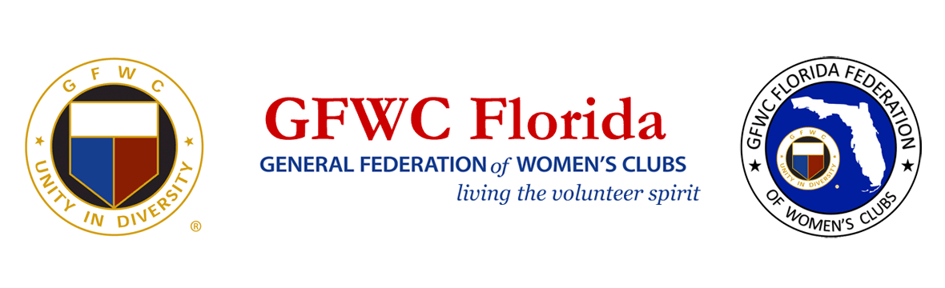

For Immediate Release
Inquiries:
Karen Griggsby, GFWC Florida Media Relations
mediarelations@gfwcflorida.org
813-481-0419

General Federation of Women’s Clubs (GFWC) Florida
is adding members statewide

November 14, 2020, Lakeland, Florida – General Federation of Women’s Clubs (GFWC) Florida has begun a recruitment campaign to grow its ranks of volunteers. Its 8400 members are distributed among 193 clubs statewide where members serve their communities through volunteerism.

GFWC clubwomen live in cities, suburbs and rural communities. They are professional women, students, stay-at-home moms and retirees; and they are united by a shared commitment to enhance the lives of others through volunteer service. The women perform hands-on tangible projects that make an immediate impact in the arts, civic engagement, education, environment, health and wellness and domestic violence prevention.

Benefits of membership include a varied volunteer menu, personal development, leadership training, support and encouragement from women with similar interests, and health and happiness gained from making a positive difference. Membership in GFWC can help open career doors, enhance a resume, build personal and professional skills and add purpose for retirees. Volunteers enjoy the camaraderie of a network of women with similar interests that yields fellowship, fun and lasting friendships.

Women seeking an opportunity to make a difference and give back to the community are invited to contact GFWC Florida 2nd Vice President/Membership Chairman Terry Reese, secondvp@gfwcflorida.org

About the General Federation of Women’s Clubs
The General Federation of Women’s Clubs is a unifying force, bringing together local women’s clubs, with members dedicated to strengthening their communities and enhancing the lives of others through volunteer service. With over 80,000 members in affiliated clubs in every state and more than a dozen countries, GFWC members are community leaders who work locally to create global change by supporting the arts, preserving natural resources, advancing education, promoting healthy lifestyles, encouraging civic involvement, and working toward world peace and understanding.

About GFWC Florida
GFWC Florida is a volunteer, non-profit 501(c)(3) organization comprised of 193 women’s clubs, junior women’s clubs and juniorette clubs across the state whose members are dedicated to community improvement by enhancing the lives of others in their local communities. Inclusive and unified in their diversity, the 8,400 members across the state attend to the needs of their communities through hands-on service projects, fundraising, education, leadership and friendship.

