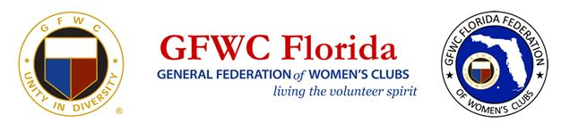

2020-2021 GFWC Florida
Membership Recruitment Grant Award Application

GFWC Florida is offering six (6) $50 awards to help underwrite membership recruiting efforts at the club level.

One award will be granted each month December 2020 thru May 2021. Applications must be received by the following deadlines:

Application Deadline | Winner Notified and Award Distributed
November 20, 2020 | December 2-7, 2020
December 15, 2020 | January 2-7, 2021
January 15, 2021 | February 2-7, 2021
February 15, 2021 | March 2-7, 2021
March 15, 2021 | April 2-7, 2021
April 15, 2021 | May 2-7, 2021

Please complete the following application form and return it to GFWC Florida’s Second Vice President by the appointed deadline.

District: Click here to enter text.

Name of Club: Click here to enter text.

First Name *: Click here to enter text. Last Name: Click here to enter text.
Address: Click here to enter text.

City: Click here to enter text. Zip: Click here to enter text.

Daytime Phone: Click here to enter text. Email: Click here to enter text.

I am the Club President ☐ I am a Club Membership Chairman ☐

*Only a member holding one of the above positions may apply for the GFWC FL Membership Grant.

How many dues-paying members does you club currently have? :Click here to enter text.

Goal (How many members are you trying to recruit): Click here to enter text.

What is your goal target date: Click here to enter text.

What is your Action Plan? Bullet point three to five activities you have planned and strategies for your recruitment project. Please provide a brief description of the need for the grant. (ie: brochures, advertising, invitations, printing)

1) Click here to enter text.

2) Click here to enter text.

3) Click here to enter text.

4) Click here to enter text.

5) Click here to enter text.

SUBMIT YOUR GRANT APPLICATION TO
Terry Reese
secondvp@gfwcflorida.org
OR
GFWC FL Membership Grant Program
C/O Terry Reese
9935 SW 76th Place Road
Ocala, FL 34481

Questions: 863-633-8077

Grant winners are chosen by the GFWC FL Membership Committee
Winners will also receive a certificate and recognition at GFWC FL’s State Convention in May, 2021

