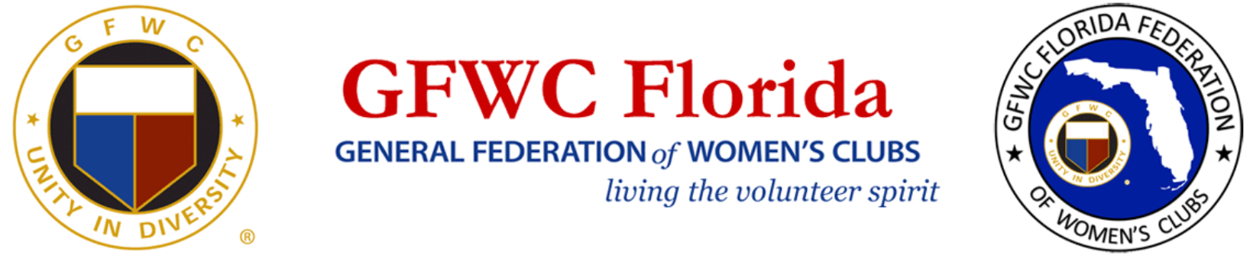

MARCIA BRIGHT WOMEN/JUNIORETTE AWARD

This award is open to GFWC Juniorette clubs that actively interact with GFWC Women’s clubs. Submit a two page (maximum) narrative outlining interaction between Women and Juniorette clubs to the GFWC Florida Second Vice President and the GFWC Florida Juniorette Advisory Committee Chairman.
REPORT DUE MAY 1st AT 11:59 PM (EDT)

Email reports to the following:

GFWC Florida 2nd Vice President: secondvp@gfcwflorida.org

GFWC Florida Juniorette Advisory Chair: juniorettes@gfwcflorida.org

