GFWC Florida
Juniorette Club
Information Form

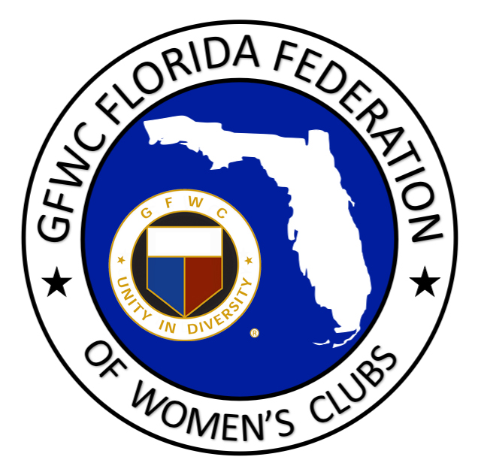

This information is needed to insure information is correct in the GFWC Florida Online Manual and for mailing of the Call to GFWC Florida State Meetings. Please return the completed form to:
Terry Reese AND GFWC Florida Headquarters AND Karin D’Amico
9935 SW 76 PL Rd 4444 Florida National Drive 5506 Terrain De Golf Dr.
Ocala, FL 34481 Lakeland, Florida 33813 Lutz, Florida 33558
secondvp@gfwcflorida.org gfwcfloridahq@gmail.com juniorettes@gfwcflorida.org

Club Information
Legal Juniorette Club Name: Click here to enter text.
Juniorette Club Mailing Address: Click here to enter text.
Address where you meet: Click here to enter text.
Sponsoring Club’s Name: Click here to enter text.
Sponsoring Club’s Contact Name: Click here to enter text.
Contact Phone Number for Sponsoring Club: Click here to enter text.
GFWC Florida District: Click here to enter text.
# of Juniorette club members: Click here to enter text.
Year club organized: Click here to enter text.
Club meeting day & time: Click here to enter text.Months of year club meets: Click here to enter text.

Club President Contact Information
Name: Click here to enter text.
Address: Click here to enter text.
Cell phone: Click here to enter text.
Home phone: Click here to enter text.
Email address: Click here to enter text.

Club Treasurer Contact Information
Name: Click here to enter text.
Address: Click here to enter text.
Cell phone: Click here to enter text.
Home phone: Click here to enter text.
Email address: Click here to enter text.

Club Advisor Contact Information
Name: Click here to enter text.
Address: Click here to enter text.
Cell phone: Click here to enter text.
Home phone: Click here to enter text.
Email address:: Click here to enter text.

