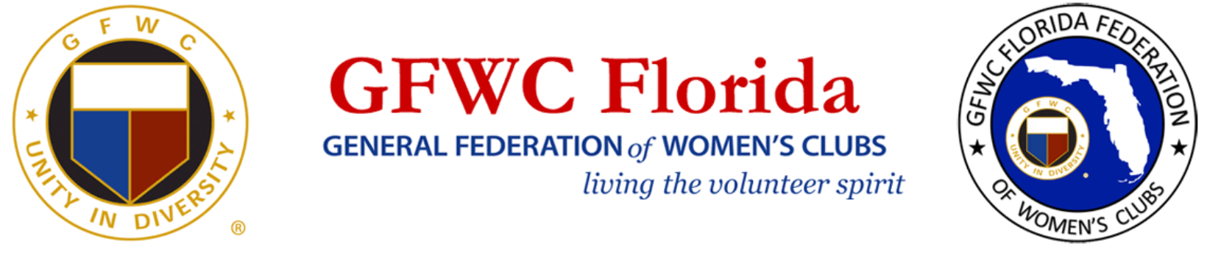

**GFWC FLORIDA JOYCE JOHNSTON**

**JUNIOR TO JUNIORETTE FEDERATION INTERACTION AWARD**

GFWC FLORIDA JUNIOR CLUB NAME:



DISTRICT: # OF MEMBERS:



CONTACT PERSON: 

EMAIL:



GFWC FLORIDA JUNIORETTE CLUB NAME:



DISTRICT: # OF MEMBERS:



Clubs that desire to be considered for this award must complete this form and a narrative (2 page maximum). The narrative should include the interaction that has taken place through club projects, programs and/or participation and support of one another. Also include how this interaction has strengthened relations, and recognition of the Federation within the community. Include any information you feel would be helpful in determining the award recipients. We are looking for activities that demonstrate your support of your GFWC Florida Juniorette club and the Juniorette Program.

***Nomination Due by May 1st 11:59 PM (EDT) to:***

**GFWC Florida Director Elect of Junior Clubs**

**jrdirectorelect@gfwcflorida.org**

**GFWC Florida Chairman Juniorette Advisory Chairman**

[**juniorettes@gfwcflorida.org**](mailto:juniorettes@gfwcflorida.org)