Your A
Yearbook Contest
Fall Board 2020
Bulletin

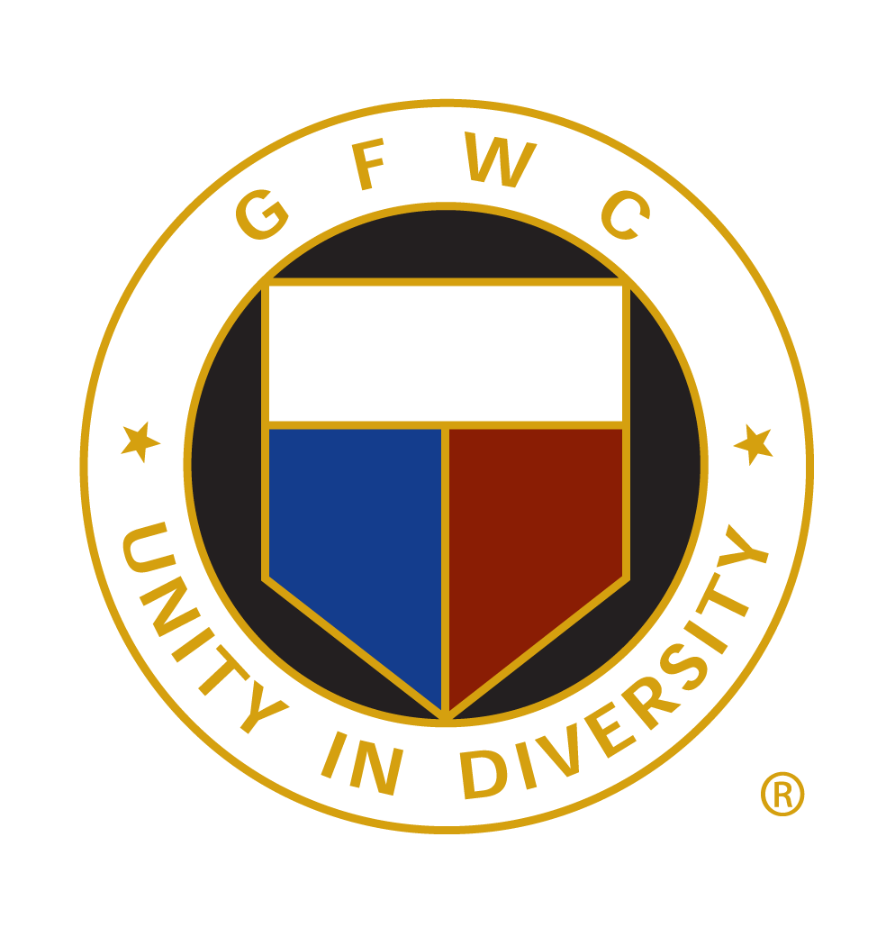

Helen Fornino, GFWC Newsletter & Yearbook Contest Chairman
23621 Turtle Lakes Lane Lutz, FL 33559-7350
813-948-0252 (home) 813-416-1947 (cell)
hfornino@tampabay.rr.com

GFWC FLORIDA STATE yearbook report & contest instructions
Submission Due Date: Emailed Date by February 1, 2021
(There is No National Yearbook Contest at this time)

email submission is preferred,
but you may also mail a flash drive or a hard copy of your 2020 club yearbook.

Submit the form at the end of this bulletin along with your copy of your 2020 club yearbook to GFWC Florida State Chair Helen Fornino (contact info above).

Google Drive is a source to email the file.
For assistance: State Communications Chair Laura Connelly: communications@gfwcflorida.org

SUGGESTED CONTENTS FOR YOUR YEARBOOK:
- GFWC emblem and your club’s emblem on the front page or cover.
- Name of your club and address.
- The year your club was founded and a brief history.
- Club board of directors.
- Mary Stewart’s Collect.
- Calendar of events.
- Clubs electronic addresses (website, email and Facebook page if you have one).
- Membership listing with pictures and contact information.
- Membership requirements and club application form.
- Community Service Committees and other standing committees.
- Clubs bylaws and standing rules.
- District officers and contact information.
- If you sponsor a Juniorette Club, mention of the Juniorette Club.
- Listing of GFWC Florida and GFWC National officers.
- If you have a clubhouse include the address and phone number.
- GFWC history and GFWC Florida history.
Some clubs use 3-ring binders with tabs, with either full-size pages or half-size pages. If your yearbook is not too large, consider emailing to members. Some clubs sell ads to offset the cost of printing.

