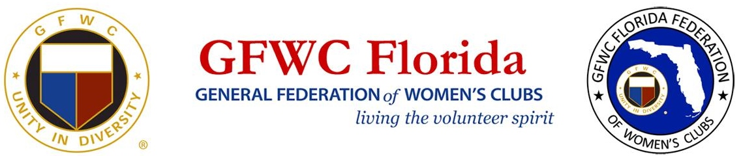
Club Member Survey

- How long have you been a member of our club? ______________________________
- Are you involved in a CSP committee? Yes_______ No________
  - If yes, which one? __________________________________________________
- Do you read our club’s monthly newsletter? Yes_______ No_________
  - Do you subscribe to the GFWC Florida Newsletter? Yes_______ No_________
  - Do you subscribe to GFWC’s News & Notes? Yes_______ No_________
  - Do you subscribe to GFWC’s Clubwoman Magazine? Yes_______ No_________
- Have you attended any of this year’s fundraising events? Yes_______ No_________
  - If yes, what event/s did you attend? ___________________________________
_________________________________________________________________
- The amount of fundraising by the club is (circle one):
  - Just Right
  - Too Much
  - Not Enough
- What type of events would you like to see us host in the future? __________________
________________________________________________________________________
- What type of volunteer opportunities would you like the club to explore? ________________________________________________________________________
- Do you follow us on social media? (Circle all that apply)
  - Facebook
  - Twitter
  - Linkedin
  - Instagram
- Did you attend a District Meeting? ___________________________________________
  - If no, why not? ___________________________________________
- Did you attend a State Convention? __________________________________________
  - If no, why not? ___________________________________________
- On a scale from 1 to 5, (1 being the least satisfied) how satisfied are you with the club? ________________________________________________________________________
- What could be done to increase your level of satisfaction? ________________________ ________________________________________________________________________
________________________________________________________________________
- How can we improve our General Meetings? ___________________________________
________________________________________________________________________
- How likely are you to renew your membership?(Circle one): Very Likely Unlikely Unsure

