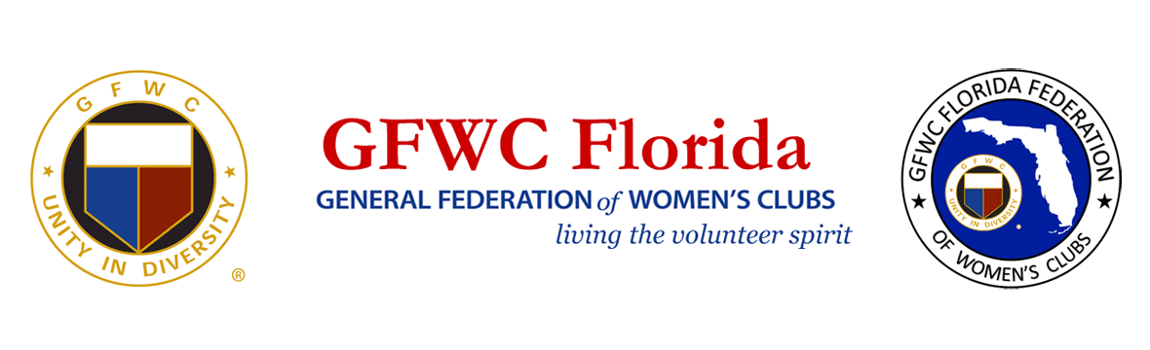
PRESS RELEASE
For Immediate Release

Inquiries:
Karen Griggsby, GFWC Florida Media Relations
mediarelations@gfwcflorida.org
813-481-0419

The Journey Continues - The Suffrage Movement and Beyond

General Federation of Women’s Clubs Celebrates the Contributions of African American Women during the Suffrage Movement

August 26, 2020 LAKELAND, FL – In the midst of COVID-19, the 8,400 volunteer clubwomen of GFWC Florida (www.gfwcflorida.org) used online meeting technology to mark the 100-year anniversary of Women’s Equality Day, commemorating the 1920 adoption of the Nineteenth Amendment to the United States Constitution, prohibiting states and federal government agencies from denying the right to citizens of the United States on the basis of sex.

African American women were in a difficult position when it came to their fight to gain the right to vote. Often excluded by white suffragists fearful of alienating Southern women, or more importantly, Southern men whose votes they desperately needed, many African American suffragists formed their own suffrage organizations. Their path was not an easy one.
GFWC clubwoman Josephine St. Pierre Ruffin co-founded the National Association of Colored Women (NACW) and used her GFWC membership to strengthen the voice of African American women fighting for the right to vote. In 1900 as she prepared to attend GFWC’s 5th biennial convention, her credentials were rejected when it was learned she was a black woman. On principal, she did not attend the convention. This forced GFWC to begin to confront the issue of racially integrated clubs.
During the Women’s Suffrage March in 1913, black suffragists were relegated to the back of the parade. Met with jeers and worse, the black suffragists persevered and completed the march with grace and dignity.

As they celebrate the 100th anniversary of women winning the vote, GFWC Florida clubwomen recognize that while much progress has been made, there is still much work to be done to fight bias, counteract stereotypes and create a diverse, inclusive member base.

Terry Reese, GFWC Florida Membership Chairman, described their evolving diversity goals. “A plan to attract diverse members within our Florida Federation is evolving. Florida’s leaders asked themselves, ‘How are we living our diversity?’ The first step in the strategic plan has been to start with printed recruitment materials and media posts that highlight Florida’s diverse membership. GFWC’s motto, ‘Unity in Diversity’ acts on the principle that everyone is created equal and those individuals can value each other regardless of race, intellect, talent or age.”
Metris Batts-Coley, 1st Vice President of The Miami Woman’s Club, acknowledges her experience as an African-American GFWC clubwoman. “Your exposure, your experience in your environment is your perception”, said Batts-Coley. She was recently selected as GFWC Florida’s sole nominee for a highly acclaimed leadership training program.
GFWC Florida is taking positive steps to ensure all members feel included and valued. A Diversity Initiative Committee has been formed to address how to develop a more diverse membership. Chairman Karen Griggsby shared the committee’s philosophy, “Together we can all make a difference”.
Just as African American women played an important role in supporting white suffrage leaders 100 years ago, GFWC Florida clubwomen continue to work together to increase diversity and hold each other accountable to ensure a fair and just culture that welcomes everyone to serve their communities together.

About GFWC Florida
GFWC Florida is a volunteer, non-profit 501(c)(3) organization comprised of 193 women’s clubs, junior women’s clubs and juniorette clubs across the state whose members are dedicated to community improvement by enhancing the lives of others in their local communities. Inclusive and unified in their diversity, the 8,400 members across the state attend to the needs of their communities through hands-on service projects, fundraising, education, leadership and friendship.

About the General Federation of Women’s Clubs
The General Federation of Women’s Clubs is a unifying force, bringing together local women’s clubs, with members dedicated to strengthening their communities and enhancing the lives of others through volunteer service. With over 80,000 members in affiliated clubs in every state and more than a dozen countries, GFWC members are community leaders who work locally to create global change by supporting the arts, preserving natural resources, advancing education, promoting healthy lifestyles, encouraging civic involvement, and working toward world peace and understanding.

******

