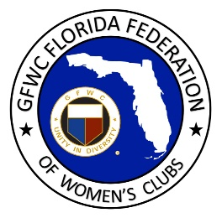
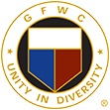
GFWC Florida
May Mann Jennings
Letter Writing Campaign

The Campaign continues! It is time for May Mann Jennings to be in the Florida Women's Hall of Fame!

May Mann Jennings, the nominee of GFWC Florida to the Florida Women's Hall of Fame, is again on the list of the top ten nominees sent to Governor Ron DeSantis for his 2020 selection.

Hundreds of clubwomen across Florida have participated in campaigns for the selection of May Mann Jennings to be in the Florida Women's Hall of Fame. It is time to continue the campaign! 2020 can be the year.

We need your help! Please find time, as individuals and clubs, to participate in this worthy endeavor. Talk to clubwomen, devise a strategy for your club to fully maximize this opportunity as we contact the Governor.

Clubwomen and clubs, please compose letters and emails for your support of the selection of May Mann Jennings. We need to move quickly with this campaign, so the Governor is again informed of our support of MMJ. Please write to or email the Governor with your support of May Mann Jennings. You will want to identify yourself, your club and GFWC Florida in your correspondence, and sign your name.

As we celebrate the 100th Anniversary of the 19th Amendment to the Constitution of the United States, it is important to acknowledge May Mann Jennings as a suffragist in addition to her other great accomplishments.

Letters to Governor DeSantis by postal mail can be addressed to:
Governor's Appointments Office
The Capitol Building
Lower Level, Suite LL-10
Tallahassee, FL 32399-0001

Email to Governor DeSantis can be sent to: Appointments@eog.myflorida.com

Thank you, Kelly Holmes for your work during the last administration to further the MMJ Project as the GFWC Florida nominee. This is truly an exciting time. Let's campaign! Let's campaign! We are GFWC Florida! The campaign continues.

Theresa A. Crockett
GFWC Florida
Public Policy, Legislation and Resolutions Chairman
theresac425@gmail.com

