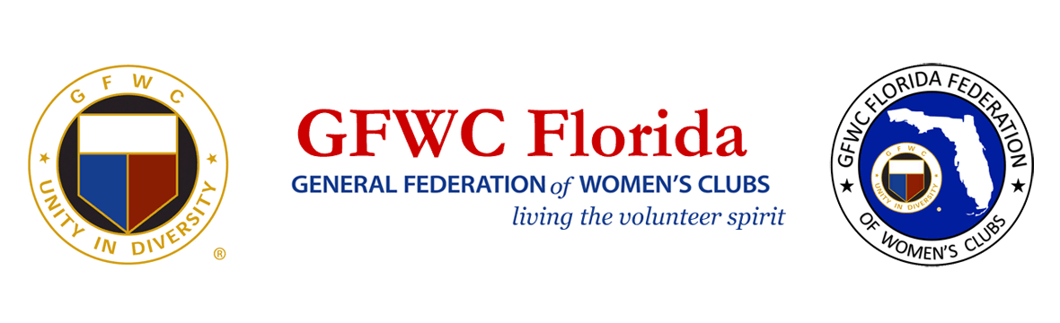
FOR IMMEDIATE RELEASE
Inquiries:
Karen Griggsby, GFWC Florida Media Relations
mediarelations@gfwcflorida.org
813-481-0419

July 24, 2020 – Lakeland, FL

General Federation of Women’s Clubs Celebrate 100th Anniversary of 19th Amendment
8,400 members of the General Federation of Women’s Clubs (GFWC) Florida will celebrate the 100th anniversary of the passage of the 19th amendment by hosting numerous events statewide.
Women were not given the right to vote; they fought for it, and GFWC clubwomen played a critical role. On June 14, 1914, GFWC approved a resolution stating, “The General Federation of Women’s Clubs give the cause of political equality for men and women its moral support by recording its earnest belief in the principle of political equality regardless of sex.” It affirmed that suffrage had become a mainstream cause for middle-class women.

Over the next few years, The General Federation of Women’s Clubs Magazine kept its members apprised of activities toward passage of a national amendment. Under the leadership of Susan B. Anthony, Elizabeth Cady Stanton, Sojourner Truth, Ida B. Wells Barnett and others, suffragists circulated petitions and lobbied Congress to pass a constitutional amendment to enfranchise women. This turning point for women’s rights culminated in the ratification of the 19th Amendment on August 18, 1920.

Women’s suffrage may not have become a reality without the historic support of the GFWC. Sue Allen, GFWC Florida Women’s History and Resource Center Chairman advises, “Teach our children to lead, educate them about the 19th Amendment, our history and its importance for all citizens. It’s time to exercise that right to vote now for our country’s future before we lose it.”

Women’s Equality Day, celebrated every August 26, commemorates the passage of women’s suffrage in the United States.

About the General Federation of Women’s Clubs
The General Federation of Women’s Clubs is a unifying force, bringing together local women’s clubs, with members dedicated to strengthening their communities and enhancing the lives of others through volunteer service. With over 80,000 members in affiliated clubs in every state and more than a dozen countries, GFWC members are community leaders who work locally to create global change by supporting the arts, preserving natural resources, advancing education, promoting healthy lifestyles, encouraging civic involvement, and working toward world peace and understanding.

About GFWC Florida
GFWC Florida is a volunteer, non-profit 501(c)(3) organization comprised of 193 women’s clubs, junior women’s clubs and juniorette clubs across the state whose members are dedicated to community improvement by enhancing the lives of others in their local communities. Inclusive and unified in their diversity, the 8,400 members across the state attend to the needs of their communities through hands-on service projects, fundraising, education, leadership and friendship.

