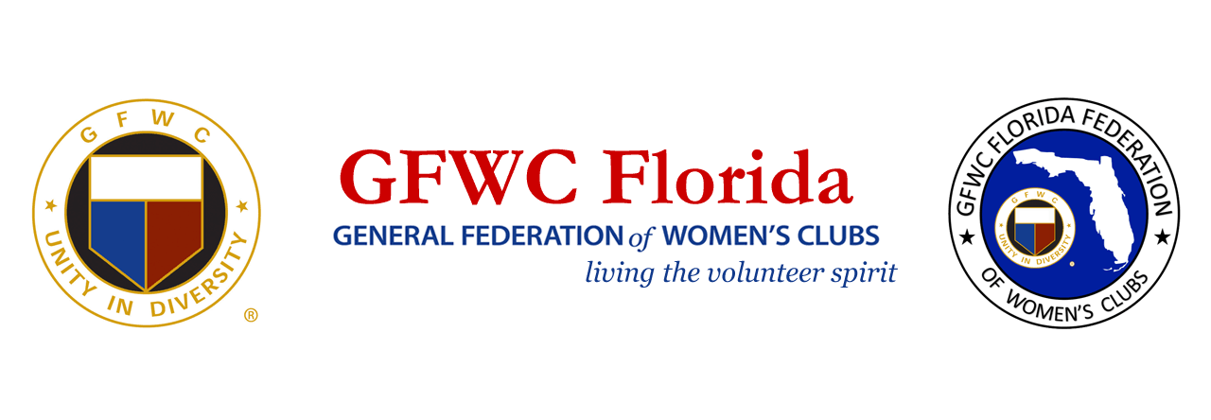
2019 Seven Grand Initiatives Results

- 3,502 trees planted by clubs/members during Arbor Day
- 50 projects done by clubs/members for women in the military, active or retired
- 5,001 pairs of shoes donated by clubs/members to Soles 4 Souls and Nike “reuse a shoe” program
- 1,078 Dr. Seuss books donated by clubs/members to local inner city programs
- 253 Dr. Seuss books donated by clubs/members to GFWC to distribute to Washington D.C. inner city programs
- 42 projects done by clubs/members on Martin Luther King Day, January 21, 2020
- 791 calls/emails /letters to US Congressmen on September 23, 2019 urging passing of Miranda’s Law
- 100 calls/emails/letters to US Congressmen on other days urging passing of Miranda’s Law
- 750 calls/emails/letters to US Congressmen on October 23, 2019 urging passage of 3D Gun Safety Act
- 85 calls/emails/letters to US Congressmen on other days urging passage of 3D Gun Safety Act
- 105 club/State projects planned to celebrate 100th Anniversary of Women winning the Right to Vote, August 2020
- 114 GFWC Florida Clubs donated to the Turning Point Suffragist Memorial.
- 272 members signed up for Legislative Action Center
- GFWC Florida became a member of the Million Dollar Club Capital Campaign
- GFWC Florida campaigned with a Resolution with the Florida Legislators for May Mann Jennings to be admitted to the Women’s History Hall of Fame – Florida.

