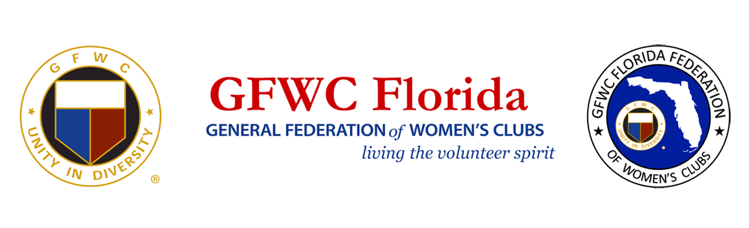
PRESS RELEASE
For Immediate Release

Inquiries:
(insert club contact name, email and phone)

GFWC Florida Women’s Clubs Volunteer Over 1.2 Million Hours in 2019,
a 50% Increase over 2018

May 18, 2020 LAKELAND, FL – In the midst of Florida’s stay at home order, the clubwomen of GFWC Florida (www.gfwcflorida.org) used online meeting technology to announce the unprecedented accomplishments of their 8,400 volunteer force. Participating in the online celebrations were clubwomen and guests from across the state and dignitaries from the General Federation of Women’s Clubs (www.gfwc.org).

GFWC Florida club women volunteered over 1.2 million hours in 2019, a 50% increase over 2018, and donated over $3.8 million in grants, scholarships, cash and in-kind donations.

GFWC Florida Past President Sharon Oliphant (2018-2020) was honored for leading the state in raising over $260,000 for Operation Smile to perform cleft palate surgeries on thousands of children worldwide (www.operationsmile.org).

Shannon Bailey, GFWC Florida Past Director of Junior Clubs (2018-2020), was recognized for her statewide Book Heroes project that donated over 104,000 books to needy children and families to promote literacy and help develop critical life skills.

After serving the community with GFWC for over 50 years, Dianne Foerster begins a two-year term as President through May 2022. “GFWC Florida club women have hearts for service”, said Foerster, “and our members are in every corner of their communities every day, living the volunteer spirit.” A member of the GFWC Brandon Service League, Brandon, FL, Foerster’s two-year President’s project encourages GFWC Florida clubwomen to focus on serving those with special needs and special abilities with love, respect and kindness. “I have invited our volunteers to make it personal to their community”, said Foerster, “as they identify service projects where they can make a difference for these very special residents.”

Serving alongside Foerster will be Candice Melton Postel, GFWC Florida Director of Juniors Clubs. A 16-year member of the General Federation of Women’s Clubs and a member of GFWC Plant City Junior Woman’s Club, Plant City, FL, Postel and a Junior Executive Committee will lead the 573 junior clubwomen in 30 junior women’s clubs statewide. Her Director’s project, Kicks for Kids, invites clubwomen across the state to donate new shoes for needy children, many of whom have never owned a new pair of shoes. “Together we are united in our passion for serving others in our communities”, said Postel, “and all communities have children who will benefit from this worthwhile project, which will allow children to attend school with the confidence and self-esteem needed to achieve academic success.”

About GFWC (insert club name)
- Include paragraph about your club, when and where you meet, website and/or Facebook page, and who to contact for more information (name and email).

About GFWC Florida
GFWC Florida is a volunteer, non-profit 501(c)(3) organization comprised of 193 women’s clubs, junior women’s clubs and juniorette clubs across the state whose members are dedicated to community improvement by enhancing the lives of others in their local communities. Inclusive and unified in their diversity, the 8,400 members across the state attend to the needs of their communities through hands-on service projects, fundraising, education, leadership and friendship.

About the General Federation of Women’s Clubs
The General Federation of Women’s Clubs is a unifying force, bringing together local women’s clubs, with members dedicated to strengthening their communities and enhancing the lives of others through volunteer service. With over 80,000 members in affiliated clubs in every state and more than a dozen countries, GFWC members are community leaders who work locally to create global change by supporting the arts, preserving natural resources, advancing education, promoting healthy lifestyles, encouraging civic involvement, and working toward world peace and understanding.

******

