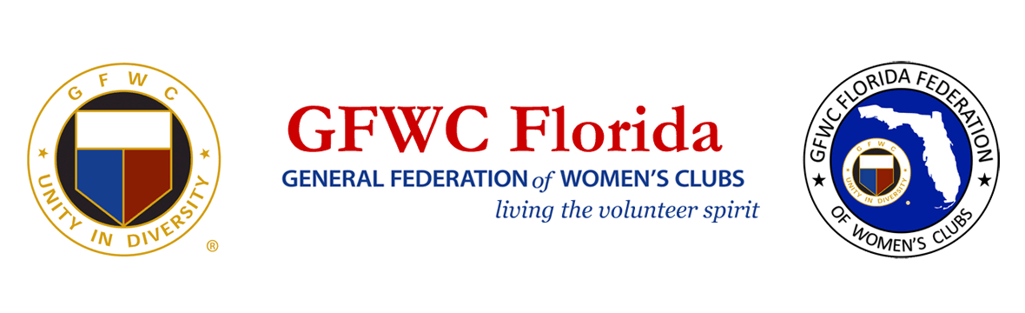GFWC Florida History
The GFWC Florida Federation of Women’s Clubs, now in its second century of community service, traces its history to the community interest found in Florida women in the late 1890s and during 1900. In 1883 the Village Improvement Association of Green Cove Springs (FL) consisted of 18 women’s groups. By 1891 the Housekeeper’s Club of Coconut Grove had formed. It joined the General Federation of Women’s Clubs (GFWC) in 1891, the first Florida club to do so. By 1900 several more women’s clubs had been established across the state.
On January 25, 1898 the FFWC was admitted into membership in the General Federation of Women’s Clubs. Immediately the FFWC began to widen its scope to include activities and projects on a state and national level. By 1903 the state and national organizations were joined into closer cooperation by the introduction of GFWC programs.
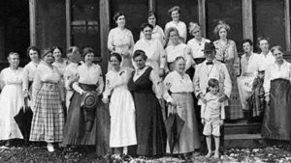
Early special projects of the clubwomen included forest conservation. During the administration of Mrs. Lawrence Haynes, a proposal to make a Forest Reservation on Paradise Key was endorsed; this later became the heart of Royal Palm State Park. By 1905-1906 a new Federation constitution was adopted and a Florida Federation pin was designed and accepted.
Early clubwomen worked on projects that led to the passage of the Child Labor bill, Compulsory Education bill, and Fire Protection for Schools bill; traveling libraries were established; assistance was given to Seminole Indians.
By 1914 the Florida Federation had branched into departments. A grant for the Royal Palm Park was secured and a lodge was built and equipped at the park. The FFWC was now divided into five sections or districts each led by a district vice-president. During the war years members devoted their efforts to war related projects. The first Florida Bulletin, the official publication of the FFWC, was published in ten issues per year at a cost to the member of five cents per capita.
In November 1922, Junior work was adopted as a division of the senior membership with Junior members reporting separately on their activities. The Florida Bulletin was renamed the Florida Clubwoman. For the first time the FFWC had extra money to invest. The Board of Directors placed it in government bonds for an Endowment Fund.
By 1930-1932 the FFWC had to face a shortage of funds due to the failure of one of its depositories; however, the Endowment Fund remained safe. Junior clubwomen gained separate status during the 1930-1932 administration. During the Depression years the clubs continued in their sponsorship of libraries, helped with school problems, beautified communities and assisted with welfare work.
In the World War II years federated clubwomen sewed for the Red Cross, were active in Bundles for Britain, helped with bond sales, and planted victory gardens. Travel was difficult due to gasoline rationing but all districts held meetings. FFWC President Mrs. Ralph Austin Smith used borrowed gas coupons to enable her to visit clubs throughout the state.
In the late 1940’s clubs transferred their efforts from wartime to peacetime projects and concerns. The Royal State Park was presented to the United States government in a ceremony on December 6, 1947. At the ceremony, attended by President Harry S Truman, Mrs. W. S. Jennings of the FFWC was cited for her foresight in securing the lands and the FFWC was cited for keeping the park open to the public. It became the Florida Everglades National Park. GFWC came to Florida for its convention for the first time in 1949 in Hollywood with Mrs. A. T. MacKay serving as FFWC President.
In 1950 sub-Junior groups of high school girls were formed and had their first state convention in Jacksonville in March. During the 1950’s the Arts department became more active and contests for poetry and short stories were introduced. “Pennies for Pines” was begun as a state project and the first of many federation-sponsored forests was planted. In 1952 FFWC President Mrs. Walter Jones saw the need for the establishment of a permanent headquarters and had plans for such begun. By 1956 the headquarters building was completed and was dedicated in Lakeland, Florida. The reading society, Epsilon Sigma Omicron, was also established as a part of FFWC at this time. At the request of the Broward County clubs, an additional district was added to the federation structure, bringing the total to 13.
During the 1960-1962 administration an additional district was again added, bringing the total to the current 14 districts. The GFWC Convention was again held in Florida, this time at Miami Beach, in 1961. At the 1966 GFWC Convention, former FFWC President, Mrs. E. D. Pearce, was installed as GFWC President, the first from Florida.
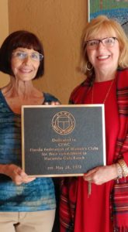
In the 1970’s the sponsorship of Hacienda Girls Ranch in Melbourne, Florida was adopted as a project. By 1972 funds had been raised to build the first cottage at the Ranch, named “Pratt Cottage” in honor of FFWC President Mrs. J. C. Pratt. In 1976 a second cottage was dedicated, the “King-Harris Cottage” named in honor of FFWC Presidents Mrs. Karl King and Mrs. E. Ross Harris. Trout Pond, the only recreational park for the handicapped in the United States at that time, was built by FFWC in 1971. By 1976 clubwomen had raised funds for a Tot Lot at the park for use by mentally retarded children. The playground was dedicated on April 17, 1976. In the late 1970’s clubwomen focused their interests in support of such projects as International Special Olympics, the Protect Every Child state -wide immunization project, and shoplifting prevention projects.
The 1980’s saw a continued wide variety of programs and projects offered to federation members, many of the projects and programs involving the youth of Florida. Leadership development was stressed and encouraged. High school sophomores were sponsored to the Hugh O’Brian Youth Leadership seminars (HOBY). Juniorettes were recognized as the future members and leaders of the federation and leadership training was a high priority for the young women. In 1983 the Juniorette category was officially accepted into the FFWC structure. Hacienda Girls Ranch was officially adopted as an ongoing project of the federation in April 1984. Funds were raised for the construction of a multipurpose building, Rainbow Building/Perkins Hall, in 1984.
Child abuse prevention and awareness was also stressed. Other major accomplishments of the 1980’s included the furnishing of a suite and a conference room at the Winn-Dixie Hope Lodge, a “stay-free” facility for cancer treatment patients at Shand’s Hospital in Gainesville, Florida; the furnishing of a playroom at the Hope Lodge in Miami; and the receipt of a $200,000 plus grant to furnish the kindergarten children of Florida with materials concerning energy conservation in the KEEP IT FLORIDA – Offalot energy education program. During the 1986-1988 administration of FFWC President Vi Thornburg, federation clubwomen traveled to Tallahassee on the first “Legislative Days” trip to view the Florida legislative process.
In the late 1980’s the federation was forced to give up its headquarters building when its property lease was taken back by the city of Lakeland. During the term of Mrs. Jimmie Smith, however, a new lot was purchased; a building was designed, built, and dedicated debt free.
The 1990’s also saw continuing community service performed by federated clubwomen. Arts were stressed in the public school curriculum, clubwomen rallied to help each other and others following the devastation of Hurricane Andrew and the “no name storm”; clubs supported local chapters of the March of Dimes, raised awareness of depression and other mental health disorders, supported cancer research and drug abuse prevention projects. Membership recruitment and retention became important issues. Dollars for Delegates was begun to aid in offsetting the expenses of delegates to state meetings; and a Membership Action Team (MAT) was established to encourage attendance at district meetings. In 1990-1992 the position of Director of Juniorette Clubs was established. In 1995 the letters GFWC were prefaced to the name, Florida Federation of Women’s Clubs, to help in club identity.
Other milestones in the 1990’s included the installation of Jeannine Faubion of Florida as GFWC President, the Centennial Celebration of GFWC Florida on May 5-9, 1995 and raising sufficient funds to construct and furnish the Board Room of the Canine Companions for Independence Southeastern Training Center in Orlando. The Juniorette program continued to grow and a Juniorette Annual Summer Meeting (JASM) was started to allow the young women to have a statewide meeting separate from that of the women’s clubs.
GFWC Florida entered the new millennium under the direction of President Bunny Sandlin. Clubwomen turned their attention to heart disease awareness and sponsored cardiopulmonary resuscitation (CPR) classes as well as provided monies and materials for Heart Camp for children at Boggy Creek Camp. With increasing costs of materials and other items members voted to increase GFWC Florida dues from $3.00 per capita to $5.00 per capita effective in 2003-2004. Clubs responded to the tragedy of September 11, 2001 with contributions to a special Emergency Relief Fund of the GFWC for use by the Red Cross and to “Operation Firefighter”, a fund to purchase a fire truck for the city of New York.
GFWC Florida President Linda Boyd, 2002-2004, has selected as her president’s project the mentoring of youth. She has also issued a “President’s Challenge” asking each member club of the state to select at least one “hands-on” project to meet the needs of its community. In 2002 the GFWC Florida also saw former GFWC Florida President Judy Lutz installed as GFWC President at the GFWC Convention in Kansas City, MO and former GFWC Florida President Jimmie Smith installed as President of the GFWC Southern Region Conference. In 2004, Florida hosted the GFWC Convention 2004 in Orlando with over 1,200 members worldwide in attendance.
In 2004 –2006, Charlyne Carruth’s presidency spotlighted “Operation Smile”. Members raised over $300,000 during the two years and sponsored an Op Smile Mission to the Philippines. During Mrs. Carruth’s presidency we also endured the 2004 year of the hurricanes with Charlie, Francis, Jeannie and Wilma affecting every clubwomen in the state. Over thirty clubhouses were severely damaged and GFWC Florida member’s homes affected. GFWC Florida and members assisted in money and support to those hit by the devastation.
Pat Keel became GFWC Florida’s President for 2006—2008 highlighting the American Cancer Society’s Scholarship Program. Again, members gave willing and over $320,000 was raised for cancer survivors to continue their education. Pat’s administration also produced the 1895 Society. This society raised money to preserve and protect GFWC Florida’s history and headquarters. A new roof was installed at headquarters and the building was painted inside and out. This society continues today to provide funding for our headquarters.
Linda Dennis, GFWC President 2008—2010, focal point was Heifer International, giving hope to underprivileged countries by providing a hand, not a handout, by, providing families with live stock, and education. Again, members dug deep and provided funding in excess of $300,000 for the project. Linda continued to lead while fighting her battle with ovarian cancer. It was a great loss to GFWC Florida when Linda passed away in January 2011.
2010—2012, brought about a change in process. President Teddy Hulse, choose membership, financial security and public relations as her project. Pushing the use of technology, the website was used to the fullest. All materials previously printed, including the “Florida Clubwomen” were now available on line. Workshops were provided on computer skills. Dues, remittance, ways and means merchandise and registration for meetings were payable via “Paypal”. Seven “Days of Service” were the highlight of the administration, allowing the members to be part of hands on projects. Money was raised for a headquarters bathroom remodel. New front doors and new furniture updated the look of headquarters.
April 2012, Pat Zazzarino was installed GFWC Florida President. Her project was providing college scholarships for deserving high school graduates and assisting with our schools. In her two years, twenty scholarships were awarded for not only graduating high school seniors but also women returning to school. During this administration, a complete bathroom remodeling of our headquarters was completed making it ADA accessible. These two years marked the loss of past presidents Jimmie Smith, and Vi Thornburg and the loss of Phyllis Wood the federation’s beloved parliamentarian.
The 2014- 2016 administration, lead by Carole Weaver, has chosen Canine Companions for Independence focusing on “the wounded warrior”. A day of service at CCI has been scheduled for this fall board.
Over 119 years since its inception the members of the GFWC Florida Federation of Women’s Clubs are still about the business of identifying the needs of the local community and then working to meet those needs through community service projects. As former GFWC Florida and GFWC President Jeannine Faubion wrote, “The history of the state would be incomplete without the immeasurable contributions of the thousands of club members, state officers and chairmen whose vision of a better community and state has been made into a reality by their untiring, unselfish work through the years…The gifts of service which they have freely given helped to make Florida what it is today.”

