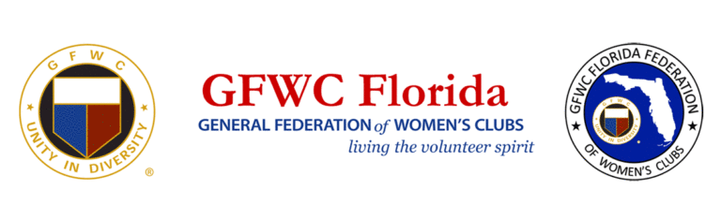
2019 Total Reporting Figures

Total - 8,407 Members in 187 clubs

Women’s Clubs - 7,511 members in 141 clubs
Junior Women’s Clubs - 573 members in 30 clubs
Juniorettes - 323 members in16 clubs

Total Projects - 112,889
Volunteer Hours - 1,228,035
In Kind Donations $1,275,786
Dollars Donated $1,463,455

ESO: Books Read 4,410; Hours of Reading 99,922
- GFWC Rotonda West Woman’s Club members read 2,086 books

Grand Bahamas Children’s Home: donations totaled over 1,400 books, toiletries and personal care items. GFWC Florida clubs will financially donate $1,485.33

Jennie Award Winner: Lucile Casey, GFWC Clearwater Community Woman’s Club

Day of Service:
- Very Special Arts - Day of Service Chairman Jeri Lyn Cancel helped us with the beautiful mosaic mural for Very Special Arts. We donated $1,200.00 to VSA in 2019, and this year will present them with $1,400.00
- Fisher House – we made spaghetti, salad and wrote cards of encouragement, and gave over $500.00 in gift cards.

Other donations made in 2020 from your contributions in 2019 are:
- Canine Companions for Independence - 2020- $2,000; in 2019 - $4,300
- Heifer International - 2020- $2,200; in 2019 - $2,100
- HOBY – 2020 - $7,800; in 2019 - $7,500
- Turning Point Suffragist Memorial - $389.75 additional (we already submitted a check for $1,000.00)
- GFWC Capital Campaign - $2,000
- March of Dimes - $800
- St. Jude Research Hospital - $1,220
- Shot @ Life - 2020- $ 2,200; in 2019 - $1,950

Director of Juniors Clubs Project: 2 year total for Book Heroes – 104,832 books donated and distributed

President’s Project – Operation Smile – 2 year total - over $260,000, will fund an entire mission trip

