GFWC Florida
Youth Leadership Award
Nomination Form

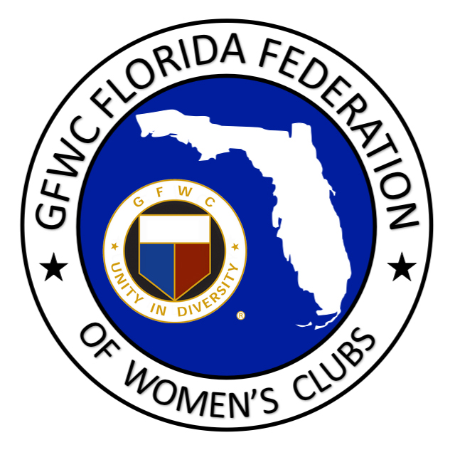

STUDENT NAME: AGE:

ADDRESS:

CITY, ZIP:

PHONE: EMAIL:

NOMINATING CLUB:

DISTRICT: CONTACT PERSON:

PHONE: E-MAIL:

SEND CHECK TO CLUB TO PRESENT AT A MEETING? (OTHERWISE CHECK WILL BE SENT DIRECTLY TO STUDENT)

FORMAT: Nominating club - Please e-mail the form above and in the box below type a one page essay reflecting your club’s reason for nomination (accomplishments, volunteer efforts, projects for school/community, recognition, outstanding achievements, heroic efforts, etc.) Include a brief explanation of their leadership style, how they have grown as an individual through community service, the leadership roles which afforded them this growth, how they influence others to grow and take leadership roles, and any other information that would enhance this nominee’s consideration. Nominees should have made a positive impact on the community, school, or youth, and be a positive role model for today’s youth. Please select SAVE AS and add your club name to the title of this document before submitting.

CRITERIA: Youth may be male or female and must be a current high school senior. Projects, service, and accomplishments must demonstrate leadership skills and can be drawn from throughout the student’s high school career. Each applicant must be endorsed by a GFWC Florida Federation Club, not by an individual. Each club may only endorse ONE nominee.

SELECTION: The nominees will be judged by the GFWC Junior Leadership Chairman and the GFWC Florida Director of Junior Clubs. The winner(s) will be announced at Spring Convention and financial awards and certificates will be given to the nominating club so that they can make a presentation in their community.

E-mail Nomination by February 1st to:
fljuniorsreports@gfwcflorida.org

