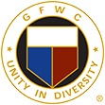

GFWC Florida
Teddy Hulse
Junior to Junior
Federation Interaction Award

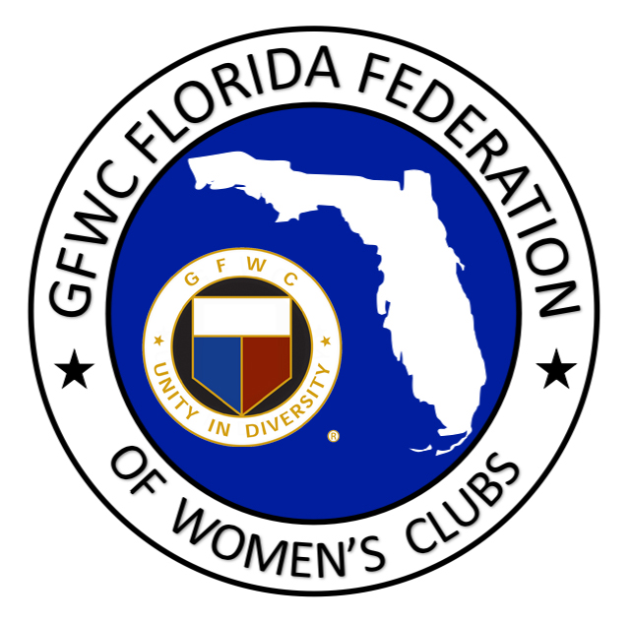

This annual Junior-to-Junior award is presented for outstanding interaction between Junior clubs who have worked together to serve the communities and members’ interests, and to further the objective of federation interaction. It was established in the 1992-94 administration, and renamed in 1998 in honor of Teddy Hulse GFWC Florida Director of Junior Clubs, to recognize the cooperative efforts of support for one another whether in a district, state, or other Junior club in the United States.

CLUB NAME: DISTRICT:

CLUB NAME: DISTRICT:

CLUB NAME: DISTRICT:

CLUB NAME: DISTRICT:

ONE CONTACT PERSON:

PHONE: EMAIL:

CRITERIA: The Junior clubs who desire to be considered together for this award can work together to complete this form including the narrative boxes below. It is judged by the GFWC Florida Director of Junior Clubs and GFWC Florida Director Elect of Junior Clubs. Only one submission is necessary. The narrative should include the interaction that has taken place through club projects, programs, and participation or support of one another. Also include how this interaction has strengthened relations, and recognition of GFWC within the community. Include any information you feel would be helpful in determining the award recipients. Limit: 2 pages, typed.

Please select SAVE AS and add your club name to the title of this document before submitting.

E-mail Nomination by February 1st to:
fljuniorsreports@gfwcflorida.org

