GFWC Florida
Juniors’ Special Program
One Voice for Children
NOMINATION FORM

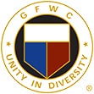
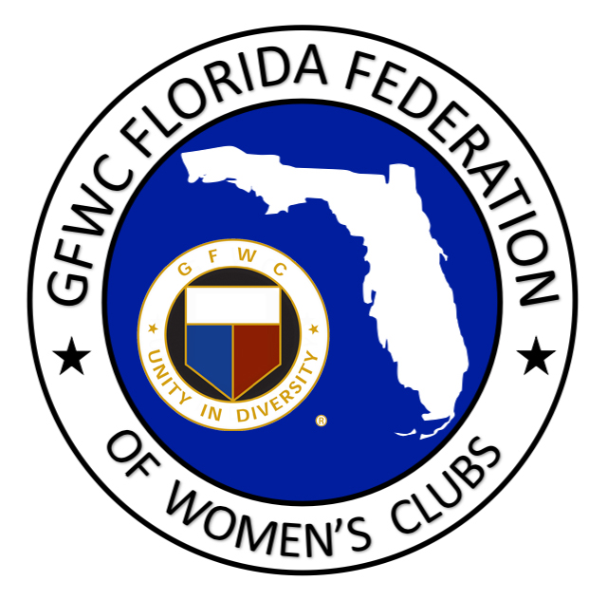

The GFWC Florida Juniors’ Special Program is “One Voice for Children”. Our objective is to encourage members and others to become active advocates for children by working to: protect children from harmful situations; encourage healthy lifestyles; and prevent substance abuse and youth suicide. This grant opportunity is being offered to GFWC clubs in an effort to collaborate our efforts to meet our objective and to become a stronger voice for children.

To qualify for the Juniors’ Special Program Grant, your club must utilize the GFWC Juniors’ Special Program: Advocates for Children Action Plan in deciding which project/program is needed in their community. Some project ideas for utilization of grant are given in the GFWC Juniors’ Special Program: Advocates for Children Action Plan. The areas of focus are outlined below:
- Bullying and Children
- St. Jude Children’s Research Hospital
- Kids and Cancer
- March of Dimes
- We Have A Little Emergency (WHALE)
- Emergency Medical Services for Children (EMSC)
- INMED Partnerships for Children
- National Court Appointed Special Advocate Association
- Child Abuse Prevention
- Child Welfare League of America
- Youth Suicide
- Child Identification
- Juniorettes

The grant recipient(s) is chosen from nominations sent in by GFWC Junior, Juniorette and Woman’s Clubs in good standing. The Juniors’ Special Program Chairman and Vice Director of Junior Clubs will judge them. The recipient(s) chosen require approval by the Junior Executive Committee based on funding available.

Criteria: Include application form and in the text box type a narrative (not to exceed 3 pages) explaining how this project/program will assist in the lives of neglected, abused or other at-risk children/families. Describe what involvement the club will play and with which organization. This involvement should include activities, plans, goals, accomplishments, etc. Applications must be e-mailed. Please review the requirements on the application for further details. Please select SAVE AS and add your club name to the title of this document before submitting.

We encourage you to partner with the GFWC Juniors’ Special Program: Advocates for Children specified programs, however it is NOT a requirement as long as your project meets the criteria.

E-mail Application by February 1st to:
fljuniorsreports@gfwcflorida.org
Rev 3/20

GFWC FLORIDA
JUNIORS’ SPECIAL PROGRAM (One Voice for Children)
GRANT APPLICATION FORM

Answer the following questions in regards to your application:

Nominating Club: District:
Contact Person:
Contact E-mail:
Project Title/Description:
Name of Organization Assisting:
Amount of funding requested (up to $1,000):

The following questions should be answered in your narrative.

- What is the overall mission of the organization you are assisting?
- What specific objectives does the organization (or your club) aim to achieve with the grant funds requested under this application?
- How does the organization (or your club) plan to achieve these objectives?
- How did you determine the need for this project?
- What other not-for-profit organizations are involved as partners in supporting this project and how?
- How many people will benefit from this project?
- Are any of the recipients of this grant on the organization’s decision making body? If YES, explain.
- How will success or progress of this proposed project be measured?
- How will you advertise GFWC’s financial support of this project?
- Will the project be able to be completed without this grant? If so, please explain what financial and in-kind contributions will be provided from other sources and how the grant will enhance the project.

Requirements for application consideration:
- E-mail completed application and narrative (not to exceed 3 pages typed) by February 1st of each year
- Assisting a not-for-profit agency
- Budget information (see below)
- If supplying additional material, no more than two items
- If awarded this grant, you must advertise on all written and public relations materials: “co-sponsored by GFWC Florida Juniors’ Special Project (One Voice for Children)” and use the logo.
- Applications for a project from the same club that has been funded two years in succession will not be considered. However, a club that has received funding in prior years can submit an application for a project that has not been funded in the past two years by this grant.

Budget Information:
- Include a complete budget (both income and expenditures) for the specific project proposed for funding application. (Agency’s budget no longer required.)
- Is the Organization: Not-for-profit?
- Incorporated?
- Tax-Exempt?

