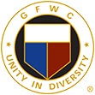

GFWC Florida
Mary Ann Taylor
Child Advocacy Award Nomination Form

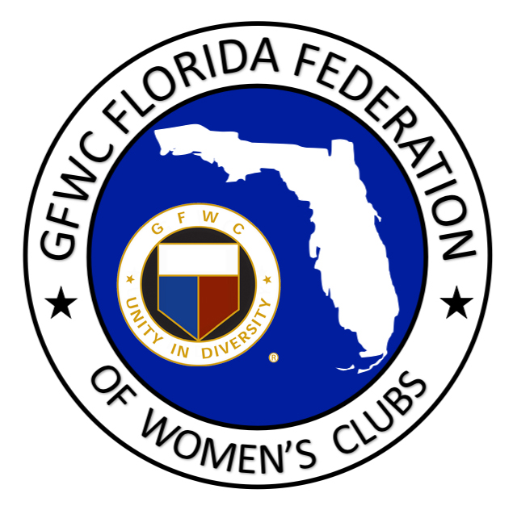

This award was initiated at Convention 2004 in honor of Mary Ann Taylor. Through her exemplary style of commitment to the GFWC Florida Federation of Women’s Clubs, Mrs. Taylor realized that everyone has a part in the lives of our children. She stressed through her club work the importance of Child Advocacy programs. She knew the significance of communicating the welfare of our children throughout the state of Florida and encouraged the GFWC Florida Juniors’ “One Voice for Children” which was established in 1994. Mary Ann Taylor gave of her time unselfishly while promoting child advocacy through the Juniors’ Special Project. The nominee will be an active member in good standing of a GFWC Florida Juniorette, Junior or Woman’s club. The award recipient is chosen from the nominations sent in by either a GFWC Florida Juniorette, Junior or Woman’s club. They are judged by the Junior Special Project Chairman, Vice Director of Junior Clubs and independent source(s). A financial award and trophy will be presented to a U.S. Child Advocacy program in honor of the winner. The recipient will be announced at GFWC Florida Convention.

NOMINEE NAME: DISTRICT:

NOMINATING CLUB:

CONTACT PERSON:

NAME OF THE U.S. CHILD ADVOCACY PROGRAM/GROUP (How the check should be made out):

PROGRAM/GROUP CONTACT PERSON:

MAILING ADDRESS FOR CHECK:

CRITERIA: This form including an essay (not to exceed 1 page) in the text box below must be e-mailed. In the narrative explain what this club member has done to be nominated and why she is deserving of this award. Describe her involvement with a Child Advocacy Program and what her role was in this program. This involvement should include activities, plans, goals, accomplishments, and achievements. Describe what you feel is most important about the role she plays and why her role in this program is important. The nominee must have worked with this organization in a volunteer capacity and cannot be employed by the organization. The nominee cannot be the prior year’s winner for work with the same Child Advocacy Program. Please select SAVE AS and add your club name to the title of this document before submitting.

E-mail Nomination by February 1st to:
fljuniorsreports@gfwcflorida.org

