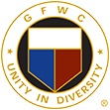

GFWC Florida
Judy Lutz
Federation Interaction Award

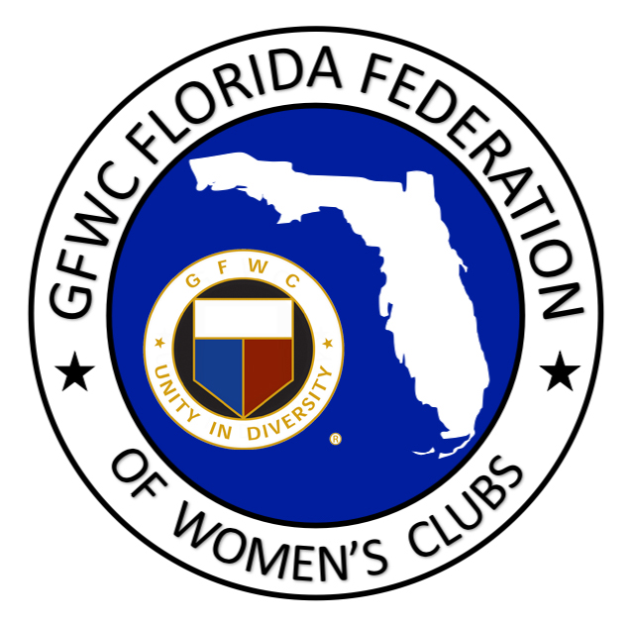

This annual General/Junior award is presented to a General and Junior Club who have worked together to serve the communities and members interests, and to further the objective of Federation Interaction. It was established in 1984 in honor of Judy Lutz for her outstanding leadership in uniting the clubs of Florida.

JUNIOR CLUB NAME:
DISTRICT:

WOMAN’S CLUB NAME:
DISTRICT:

CONTACT PERSON:

PHONE: EMAIL:

CRITERIA: The General and Junior clubs who desire to be considered for this award can work together to complete this form including the narrative box below and e-mail to the GFWC Florida Second Vice President and the GFWC Florida Director Elect of Junior Clubs. Two submissions are not necessary. The narrative should include the interaction that has taken place through club projects, programs and participation or support of one another. Also include how this interaction has strengthened relations, recognition of the federation within the community and any information you feel would be helpful in determining the award recipients. Limit: 2 pages, typed. Please select SAVE AS and add your club name to the title of this document before submitting.

E-mail nomination by February 1st to:
GFWC Florida Junior Clubs
fljuniorsreports@gfwcflorida.org
and
GFWC Florida 2nd Vice President
secondvp@gfwcflorida.org

