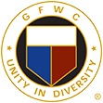

GFWC Florida
Joyce Johnston
Junior to Juniorette
Federation Interaction Award

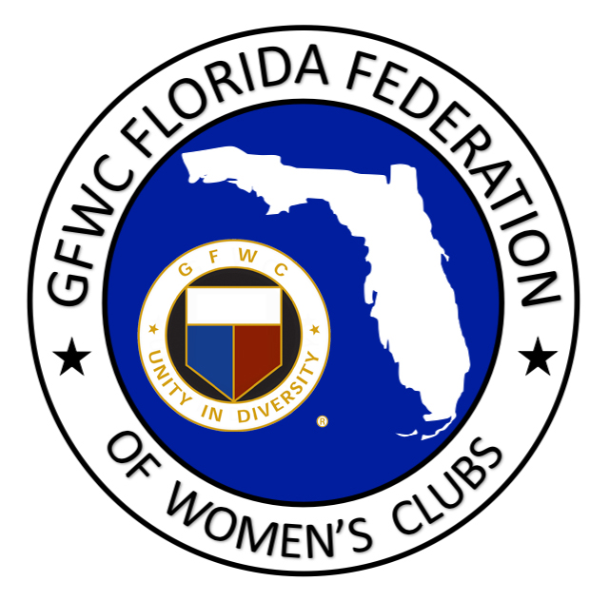

This award is named in honor of Joyce Johnston, 1992-94 GFWC Florida Director of Junior Clubs. This award recognizes outstanding federation interaction between a Junior and Juniorette club. Mrs. Johnston’s commitment to the fostering of a relationship between Junior and Juniorette clubs was the basis for this award.

JUNIOR CLUB NAME: DISTRICT:

CONTACT PERSON: # OF MEMBERS:

PHONE: EMAIL:

JUNIORETTE CLUB NAME:

DISTRICT: # OF MEMBERS:

CRITERIA: The Junior and Juniorette clubs who desire to be considered for this award can
work together to complete this form including the narrative in the box below and e-mail to the GFWC Florida Director Elect of Junior Clubs AND GFWC Florida Juniorette Advisor. Two submissions are not necessary. The narrative should include the interaction that has taken place through club projects, programs and/or participation and support of one another. Also include how this interaction has strengthened relations, and recognition of the Federation within the community. Include any information you feel would be helpful in determining the award recipients. We are looking for activities that demonstrate your support of your Juniorette club and the Juniorette Program. Limit 2 pages, typed.
Please select SAVE AS and add your club name to the title of this document before submitting.

E-mail Nomination by February 1st to
GFWC Florida Juniors
fljuniorsreports@gfwcflorida.org
and
GFWC Florida Juniorette Advisory Committee Chairman
juniorettes@gfwcflorida.org

