GFWC Florida
Jennie June Croly
Education Scholarship Application

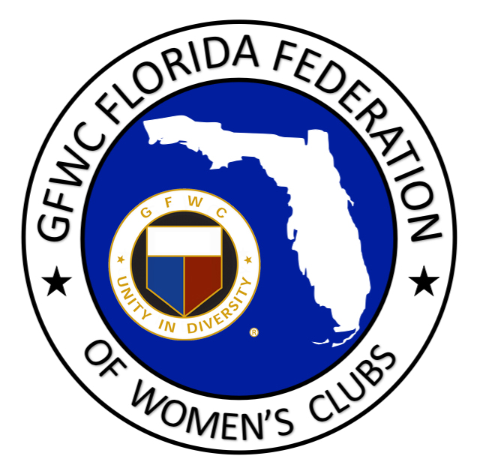

The Jennie June Croly Scholarship was established during the 1990-1992 Administration. The scholarship was named in honor of the founder of the General Federation of Women’s Clubs, Jane Cunningham Croly, who wrote under the name of Jennie June. It is given to a Junior member to assist in her educational financial needs. The award is judged by the GFWC Florida Junior Education Chairman and a member of the Junior Executive Committee.
CLUB NAME: DISTRICT:

NAME:

ADDRESS:

PHONE: EMAIL:

COLLEGE/SCHOOL ATTENDING:

CURRENT GPA, IF APPLICABLE:
COLLEGE MAJOR/PROGRAM:

APPLICATION INSTRUCTIONS:
- Complete the above information;
- Page 2 of this application will be an essay (1 page max) addressing “Why I want a degree or professional certification” (ie. Hygienist, Beautician, other trade certifications).Express why you are pursuing this, how it relates to your life, and what you have chosen for overall goals and objectives upon completion;
- Page 3 of this application will be a resume and detailed listing of work history, club work, college activities, community involvement, and awards/honors you have received.
- Page 4 of this application will be a letter of endorsement from your club;
- Include a copy of your most recent college/program transcript. If enrolling and/or beginning a new program include your letter of acceptance;
- This application and your transcript/acceptance letter must be e-mailed by February 1st to the e-mail addresses below.
- Please select SAVE AS and add the applicant name to the title of this document before submitting.

ELIGIBILITY REQUIREMENTS:
- Currently enrolled in college or have been accepted to a professional certification program and be able to show proof of enrollment by September 30th of award year;
- Be a GFWC Florida Junior member in good standing;
- Be involved in community service through Junior work;
- Complete the application according to the instructions.
E-mail Nomination by February 1st to fljuniorsreports@gfwcflorida.org
Essay:

Resume:

Letter of Endorsement:

