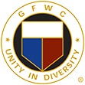

GFWC Florida
Charlotte Meeds Smith Volunteer Award

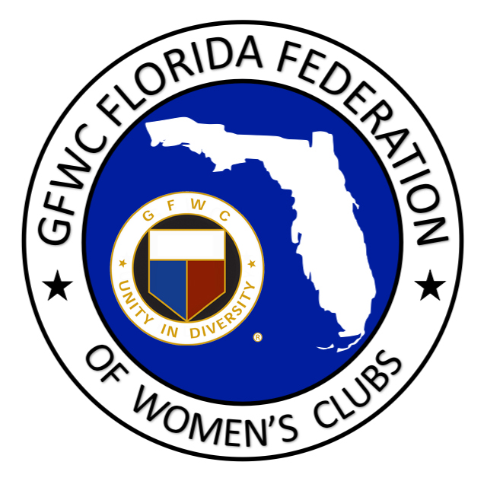
NOMINATION FORM

This annual Junior award was initiated at Convention 1991, in honor of Charlotte Meeds Smith, GFWC Florida President 1942-44, who had unselfishly given volunteer time and energy for worthwhile causes while promoting the GFWC Florida Federation throughout her community and state. This award is to recognize one outstanding Junior who has given unselfishly of her time and energy for worthwhile causes, to help others, and to make this world a better place.

This award is determined from applications sent by Junior Clubs. They are judged by the Junior Executive Committee. Please do not submit more than one nomination per club.

Nominees may not be a member of the Junior Executive Committee.

NOMINEE NAME: DISTRICT:

NOMINEE’S EMAIL ADDRESS:

NOMINATING CLUB OR JPC MEMBER:

CONTACT PERSON: PHONE:

CONTACT’S ADDRESS:

CITY/ZIP:

CONTACT’S EMAIL:

ONE WORD THAT DESCRIBES NOMINEE’S OVERALL ATTITUDE:

CRITERIA: Complete the above information and in the box below type a one page narrative about the nominee. It is suggested to include some of her achievements and involvements with the GFWC; achievements and involvements in her community; how she deals with these involvements in relation to her personal responsibilities at home and/or career; other volunteer organizations she is involved with; any impact she has made in the GFWC; any impact she has made in her community; any impact she has made in a community project or program; how she applies her leadership skills; her commitment level; club, district and state positions held; current position(s) held; insight to her future GFWC goals, etc. Only accomplishments in the previous calendar year may be included. Service activities that are directly related to her job may not be included. Each club can nominate one individual. Please select SAVE AS and add your club name to the title of this document before submitting.

E-mail Nomination by February 1st to:
fljuniorsreports@gfwcflorida.org

